Who Are You?

Full Name: ___________________ But please call me: ___________________

1. What part of history interests you the most (time period, country, ethnic group etc.)?
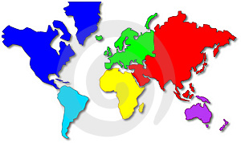
Why?

2. List two places you would like to travel

3. List a goal you would like to complete in this class and how you plan to achieve it.

Goal:

What are you going to do to get it:

4. What do you like about school? What IRRITATES you most about school?

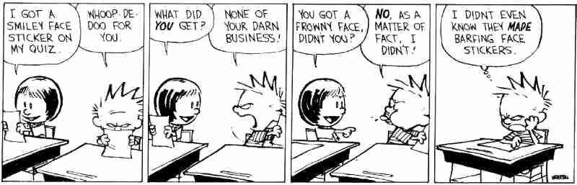
Like:

Dislike:

5. The following is a list of possible type of assignments. Put an (+) beside assignments you like and an (-) beside ones you don’t like.

 | Paragraphs |  | Worksheets |  | Oral  Presentations |  | Group  Work
 | Simulations  (acting out  historical  events/trying foo  food |  | Creative  Projects |  | Posters |  | Reports

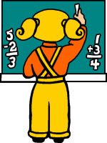
6. Three things that help me learn

1.
2.
3.

7. Things that make it hard for me to learn

8. What do you do in your free time? (Hobbies, extra-curricular, sports etc.)

9. Name a significant/important/admired adult in your life and explain why you chose this person.

10. What is your favourite….
Book:

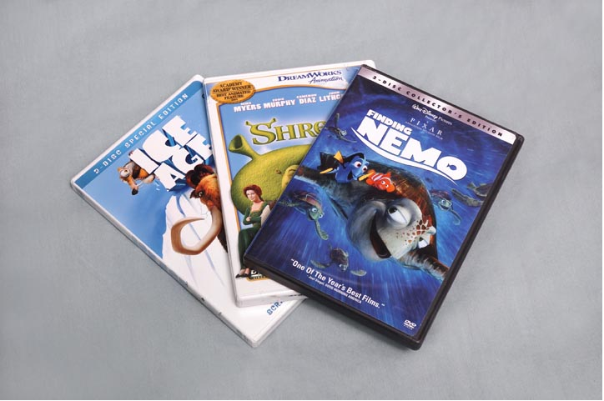
Movie

TV Show:

Music:

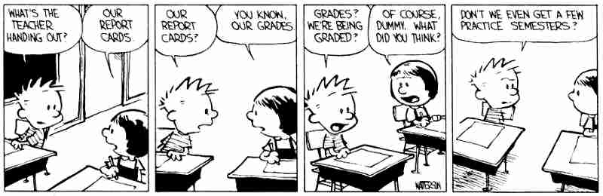
11. Do you have any additional information about yourself that I should be aware of?

12. What do you need to ask me about the course? Expectations that I have?

