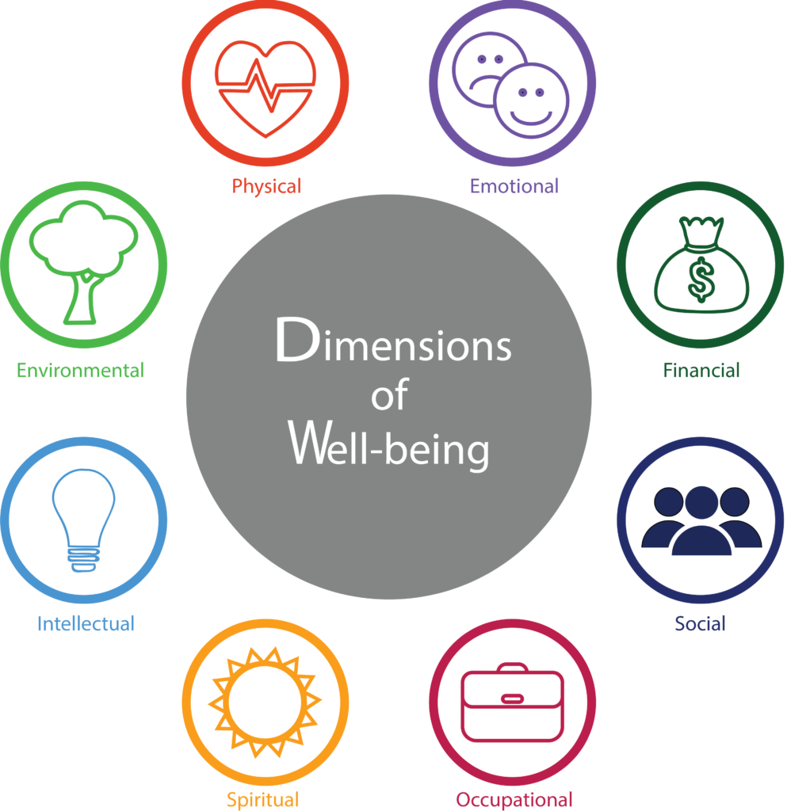
Mr. Fitton Wellness 11-12 – Your Road to Wellbeing 6

“Wellness is the complete integration of body, mind, and spirit - the realization that everything we do, think, feel, and believe has an effect on our state ...” – Greg Anderson

Introduction: Wellness 11-12 is intended to be a group exploration of social, emotional, physical and mental wellbeing with concrete steps to move you in a positive direction. Prepare for field trips, hands-on activities, self-studies, simulations, & exciting course work!
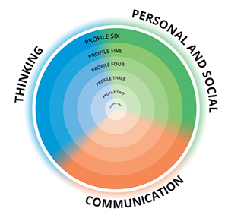
Course Objectives: Students will be able to:

*Develop their own “why” statement of purpose *Learn and Apply Pillars of Wellbeing
*Learn tools to assist with anxiety, depression, fear and other areas
*Develop an understanding of what it means to be healthy and have positive wellbeing
*learn to help others *learn foundations of CBT *Learn strategies to thrive

Core Competencies Learning Outcomes (Students will learn to:)

1. Thinking The Thinking competency encompasses the knowledge, skills and processes we associate with intellectual development. It is through our competency as thinkers that we take subject-specific concepts and content and transform them into a new understanding. We will develop thinking skills, habits of mind, and metacognitive awareness (think about our thinking).

2. Communication The Communication competency encompasses the knowledge, skills and processes we associate with interactions with others. Through our communication, we will acquire, develop and transform ideas and information, and make connections with others to share our ideas. The communication competency is fundamental to finding satisfaction, purpose and joy.

3. Personal and Social The Personal and Social competency is the set of abilities that relate to our identity in the world, both as individuals and as members of our community and society. Personal and social competency encompasses what we need to thrive as individuals, to understand and care about ourselves and others, and to find and achieve our purposes in the world.

WELLNESS 11/12 BIG IDEAS
Implement mind relaxation techniques, self-regulation techniques and fuse ancient traditions and modern day neuroscience research. |  | Holistic wellness is the inter-connectedness of one’s mind, body, self-care techniques, community, kindness, generosity and social setting. |  | Examine and experience Indigenous Peoples’ practices surrounding wellness, the mind, and self-care. |  | Examine neuroplasticity, mental health diagnoses/ perspectives, and the nature of the brain and nervous system and its function. |  | Wellness is connected to self-care practices, building resiliency, lifestyle choices, and an awareness of the mind and body connection.
Materials – Bring EVERY day: Binder w/dividers; Paper; Pencil; ***A Journal ***

Late Policy – Assignments to be turned in at the beginning of class. If you have continuous late assignments, we will work on them together at lunch and develop a plan to help you get things in on time.

Attendance: Regular attendance is the most important predictor of success in any course.
Besides – you’re not going to want to miss all the fun! This is truly a course for and about YOU.

Contact info: jfitton@sd67.bc.ca Website: www.mrfitton.weebly.com
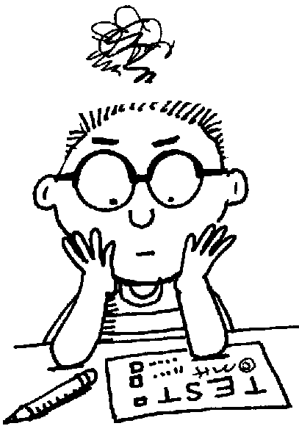

Assessment and Evaluation
-Conducted on an ongoing basis.
-Criterion referenced (students know in advance how they will be marked); Formative and Summative. We will develop some of the criteria together as a class.
-Quizzes, Projects, journals, written assignments, discussions, simulations, creative projects, student-choice, volunteer work.

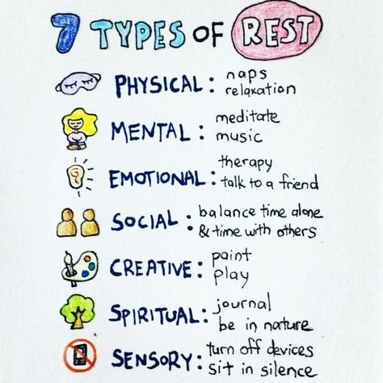
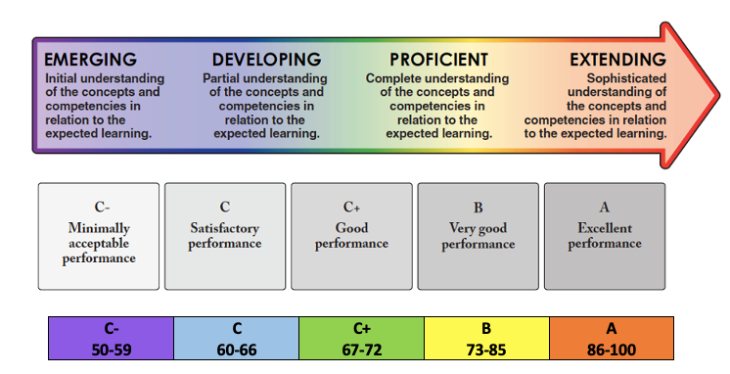
Mark Breakdown - BC Ministry of Education Proficiency Scale.

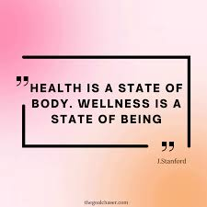

Wellness 11-12 - We few, we happy few, we band of brothers!
“It turns out that the simple act of scribbling down 3–5 things you’re grateful for at the end of the day can significantly improve your well-being in as little as two weeks.”.” – Dr. Laurie Santos

OPTIONS FOR STUDY – You Get To Choose:
Unit 1: Happiness – We will examine “Positive Psychology” through Ted Talks, Articles, Gratitude Journals, and will learn about how to rewire our minds via the “Tetris Effect.” Get ready for activities and practical suggestions. You’ll even take an authentic YALE University course. Yep – you get to go to an Ivy League American University.

Unit 2: Cognitive Behavior Therapy - The Gold standard in therapy is this amazing process of rewiring your brain. Let’s learn about cognitive distortions & how to take control of any ruminating and negative thoughts. Challenge your thinking!

Unit 3: Finding Your Why – Let’s visit modern sensation “Simon Sinek” as he guides us through finding our “Why” / Purpose. Get ready to know yourself deeply and engage in thoughtful conversations. You will become unstoppable!
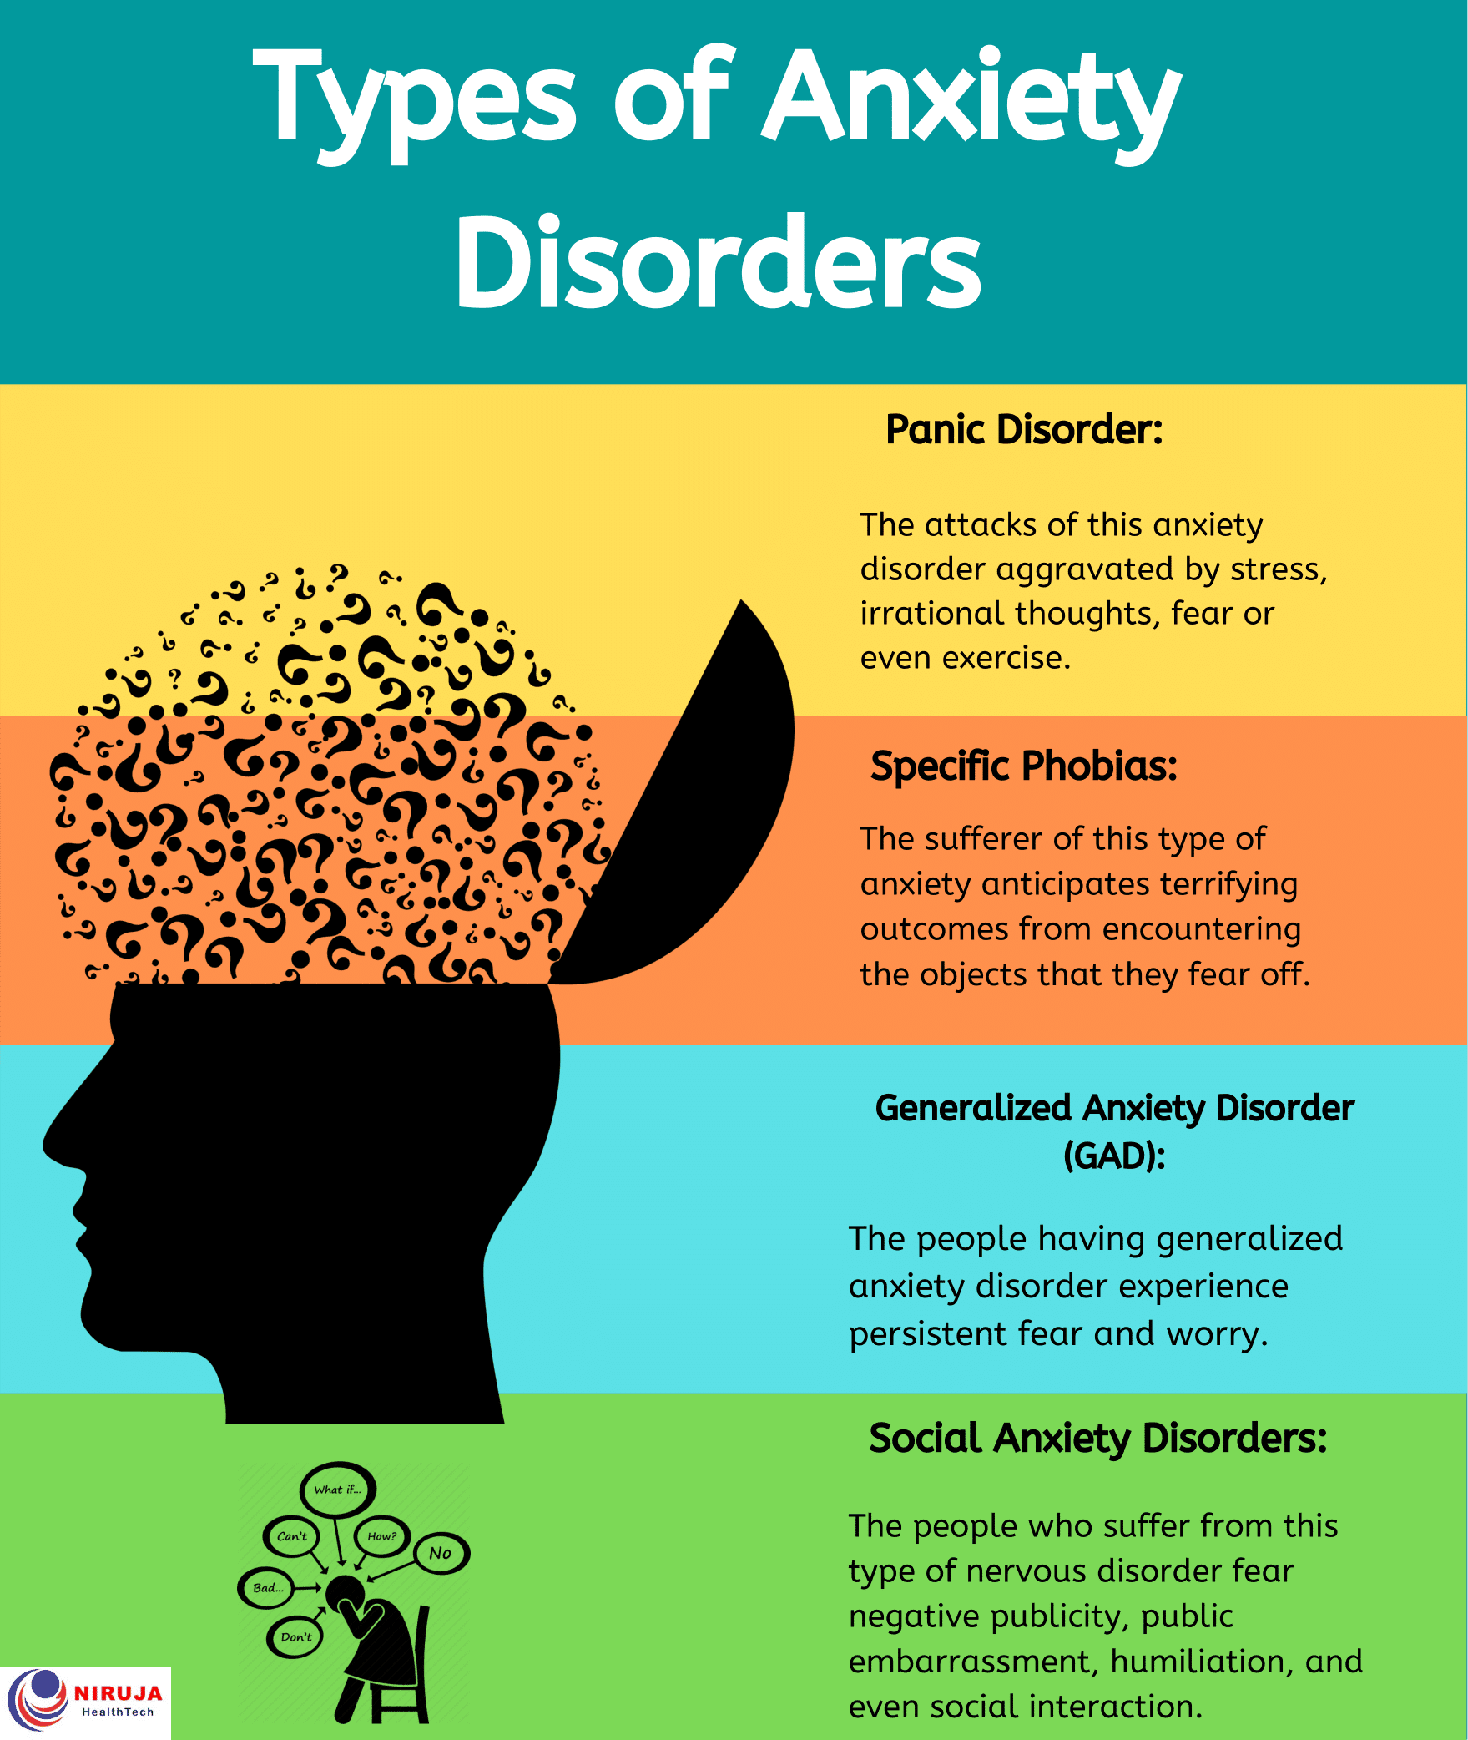
Unit 4: Fear, Anxiety, Depression and Disorders - We will examine major disorders and delve into research. We will examine the difference between being anxious and feeling depressed and being diagnosed with G.A.D or Depression. We will learn strategies to help ourselves and others while looking at clinical research. We will also look at “The Tools” used by major celebrities and some readily accessible ways to help combat anxiety and depression.

Unit 5: Emotions – We will examine the fact that most humans can name only 3 emotions as they are feeling them. According to Brene Brown – there’s almost 30 times that many. Let’s learn them in order to enhance our E.Q. Daniel Golman will introduce us to Emotional Intelligence -something that may be more important than IQ. Even if it has a dark side…. To Study: “Atlas of the Heart” Ted Talks on Emotional Intelligence.

Unit 6: Sleep – Some of us are great at it, some of us struggle. In this mini-Unit, we will learn how to develop good “sleep hygiene” to look younger, feel younger and help out brain become more powerful. Stay tuned for the secrets to a better night of sleep! Guided sleep meditation and progressive muscle relaxation will help you get those zzzz’s.

Unit 7: Growth Mindset – Perhaps the key to overall wellness is adopting a growth mindset. We will examine, Grit by Angela Duckworth and Various Works by Carol Dweck – included will be several guest speakers!

Unit 8 - Self-Care/ Learning to Love Oneself and, Play – A fun unit where we look at ways to bump up your dopamine level and support yourself in times of need. We will look at neuroscience and how to ensure we stay young at heart! Guest speakers will include professionals from physiotherapy, massage, chiropractic, psychology, etc.
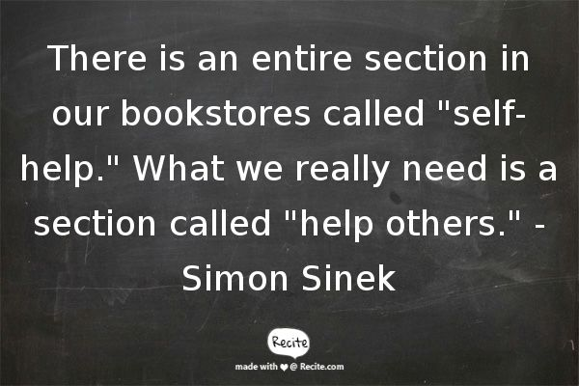
Unit 9: Help Others / Help a Friend Tool Kit. – As a way to develop our own love of self, we will reach out and help others. From random acts of kindness, to class acts of volunteerism, get ready to make someone else’s life better. Let’s brainstorm some places we want to help (Soupateria, SPCA, Canadian Food for Children – who do you want to support?)

Unit 10: Physical Health and Nutrition – Guest speakers include dieticians, nutritionists and personal trainers who can help up maintain our mental health through the most powerful tool recognized by science – exercise and nutrition.

Unit 12: Indigenous Healing Connections – We will learn about Indigenous Healing Practices and engage in field trip to the forest and meet with some local elders.

Unit 13: Wellness Through Film. Chris Hemsworth will help us on our wellness journey through the series “Limitless” on Disney plus. As well as other films, youtube videos, documentaries – we will examine how to be well!
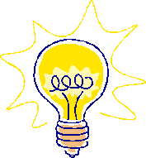
Congratulations, you are now a self-actualized guru with skills to help others and yourself!!

