There’s a gap between what Victims of Crime want and what the Criminal Justice System Delivers
What if the Victim was the central figure in the criminal justice system? Not the offender.
The Five Needs of Victims
(Taken From Ruth Morris’ Book – Penal Abolition: The Practical Choice)
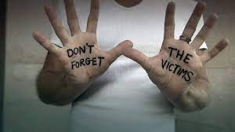
Safety – Physical, Emotional and Psychological.
Answers – Why me? (If there’s a guilty plea, they get no answers; accused may not testify so they get no answers; can’t ask questions)
Recognition of Wrong – Victims want people to recognize the harm done to them
Restitution – Want to be made whole again

Significance – They want society to be better so no one else will have to suffer (ie: MADD Canada; Alexa’s Team; Amber Alert all are ways to make a tragedy have significance.)
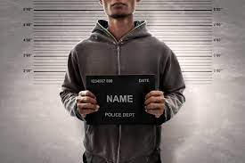
“We don’t need a system that reacts – we need a system that considers” – Dr. Melissa Munn
If we are Victim Centered, then we also need to view the offender as a person; not as a criminal.
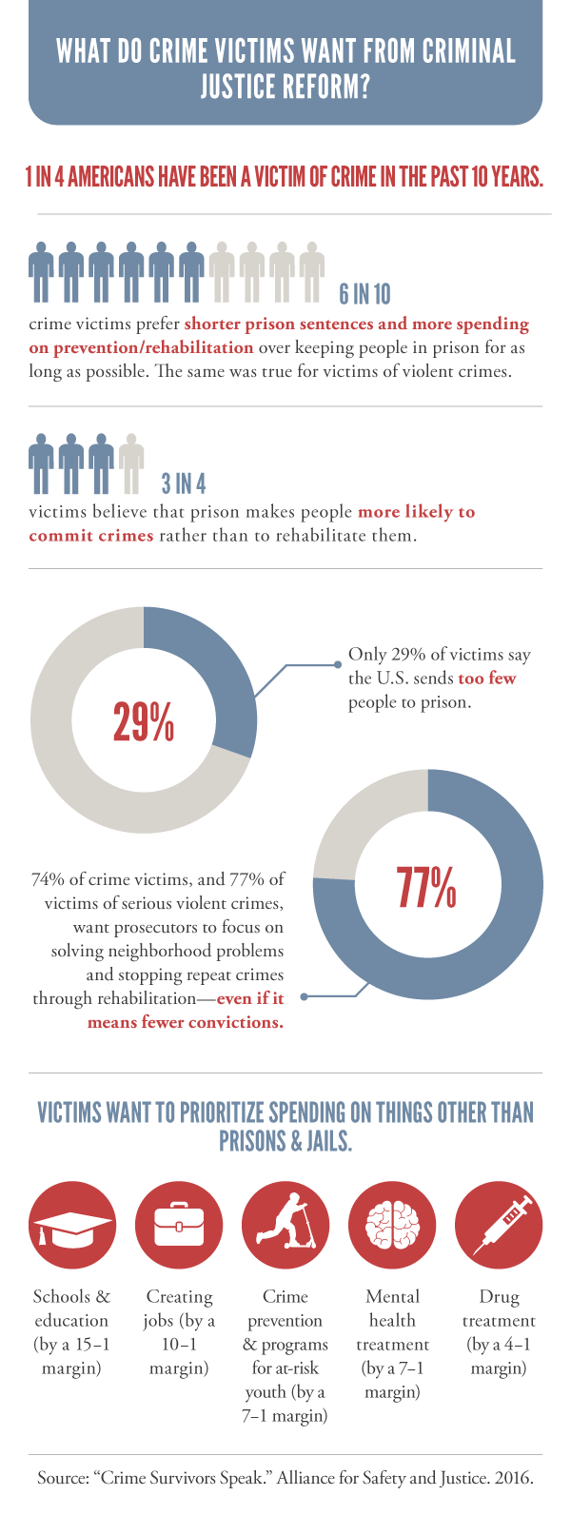
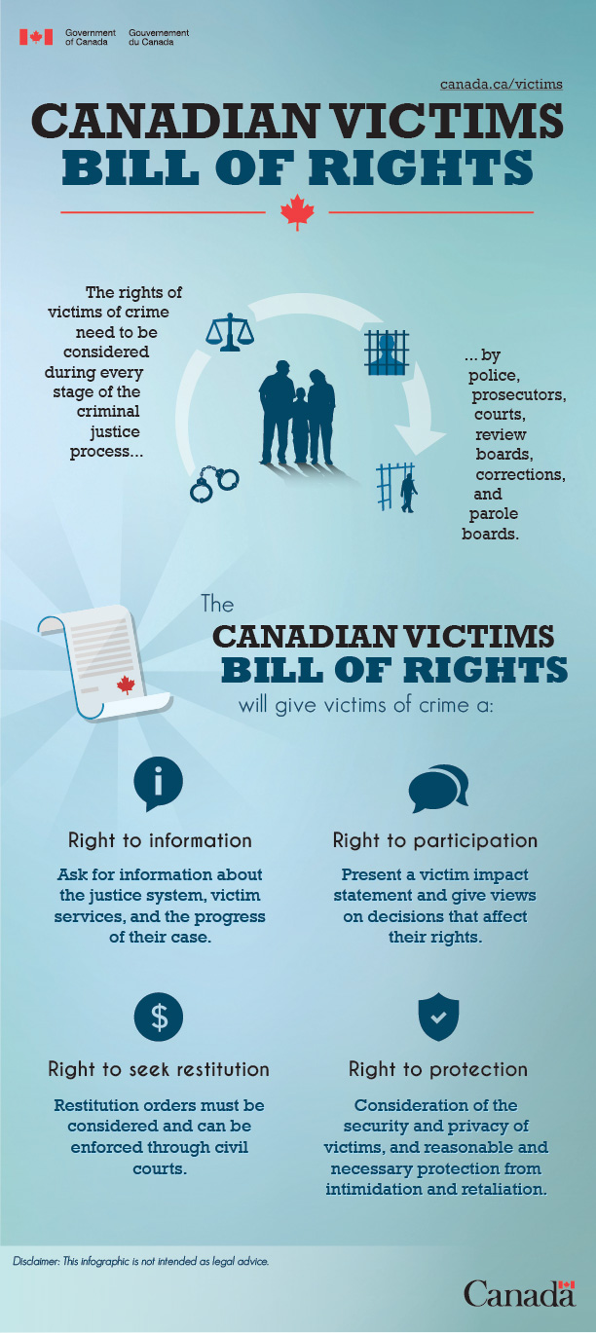

ACTIVITY: Let’s Look at some legal scenarios or case studies through the lens of a Victim and see if it changes our sentencing. What if we took incarceration right off the table as an option? What would you do instead?

