History Through Film 12 Name ___________________________

“THE UNTOUCHABLES,” Prohibition and the Great Depression

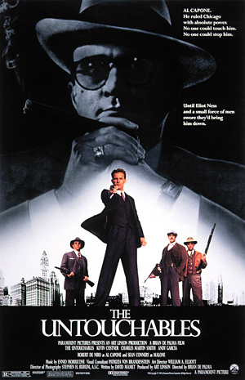
“The Untouchables”, 1987. Directed by Brian de Palma. Starring Kevin Costner, Robert de Niro, and Sean Connery

PRE-FILM ASSIGNMENT:

Consider what techniques directors use to juxtapose “good” vs “bad” in film. Consider colours, symbols, music, etc. Write some of your ideas down here:

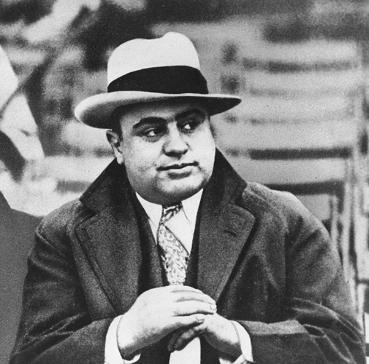

History Through Film 12 Name ___________________________

THE UNTOUCHABLES – BLOG ASSIGNMENT

In your blog please choose 2 of the following items to discuss in paragraph form. Remember, this is a grade 12 elective, and your responses should reflect a grade 12 level of writing/thought. Remember, others will be reading your blog.

1. How are music, symbols, imagery and acting used to portray the “good” and the “bad” in the film. Discuss 2-3 specific items/events from the film in your discussion.

2. Explain any possible symbolic meanings behind the use of the colour red throughout the film.

3. Read up on Elliot Ness and the Untouchables – the film is definitely untrue in many regards (Ie: Malone and Ness never met, Ness was a drinker, Ness was a womanizer). Does the historical inaccuracy of the film detract from its enjoyableness? See the link below or google “Mental floss – Untouchables” or any other source.
https://www.mentalfloss.com/article/80310/11-rapid-fire-facts-about-untouchables

4. Give your overall rating out of 10 for the film and explain in detail. Justify your beliefs with references to acting, cinematography, scenes, lines, etc.

5. The violence and death scenes were effective in developing plot, in portraying the era with accuracy and in creating an emotional response. Agree or disagree?

6. Create your own discussion topic and write about it.

When done, comment on three other blogs, minimum and be sure to engage in a “back channel” chat discussion.

