English 9 Name: _______________ Novel: _____________________

During the 3 weeks of this novel study you will be responsible for completing any two of the activities below for your novel.

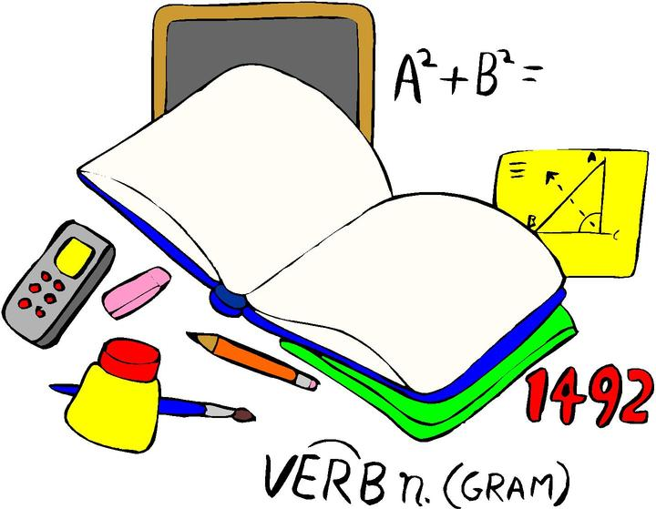Part A: Literary Luminary (5)
Pick a passage from your novel that you think is powerful, interesting or significant. Carefully copy the quotation onto a separate piece of paper and record the page number it came from. Underneath the quote, and in a minimum of 3–5 sentences, explain why you think it is powerful. For example, you could consider how it reflects a theme of the novel or how it develops a character, advances of the plot or is it just a powerful image or literary device (metaphor etc.)?

Part B: Connector (5)
Pick a passage from your novel that you can make a connection to and record it on a separate piece of paper. Underneath the quote, explain your connection with as many details as you can. Your connection should be at least 2-3 sentences long. Consider connections with experiences you have had (or the experiences of people close to you), things you have read or viewed, connections to history, current events or even something that has happened at Maggie.

Part C: An Image (5)
Draw or describe a powerful image from your novel. Underneath your drawing/description, explain (in 2-3 sentences) why the image is important or powerful.

Part D: Tracking Empathy (5)
Throughout your novel, record 5 examples where a character (main or anyone else) demonstrates empathy or a lack of empathy. Instead of quoting the incident, you may paraphrase it (describe it in your own words). Underneath the incident, explain in a sentence why it is an example of empathy/lack of empathy.

Part E: Character (5)
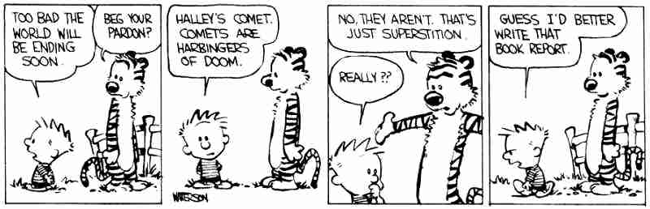On the paper doll template on the back of this sheet, keep track of both physical features of your main character, their personality traits and their likes/dislikes by drawing them on the doll. When representing their personality traits, consider using symbols. For example, if your character is evil, maybe draw devil horns on them. Be Creative! Label your choices on the doll with quotes from the story that prove whatever you are adding. You must have a minimum of 5 separate entries. If you like, you may make your own drawing rather than using the template.
