Tips for the Business Letter. (Check off as you complete)

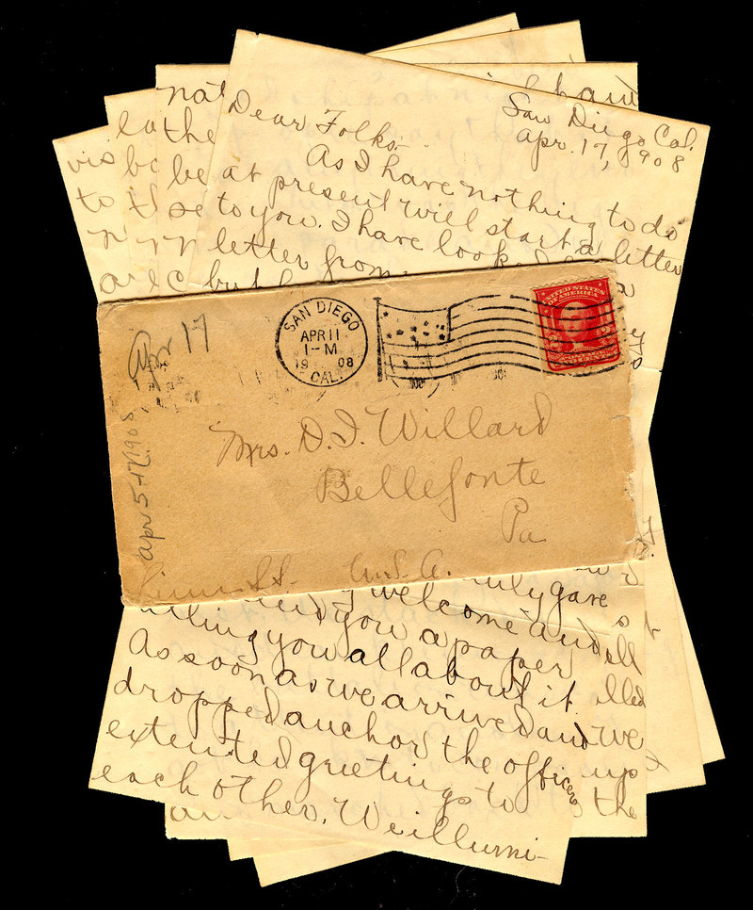
Step One: Read the question carefully to find out what kind of letter you are writing (request, complaint, thanks or application)

Step Two: Re-read the information in the scenario. This time focus on details important to the task you are addressing in the letter

Step Three: Go back to the question and on the top left hand corner of paper record the address provided for you on the exam. Skip two lines and write the date. Use today’s date. Skip two lines and record the address of the organization you are writing to. Skip 2 lines and write a salutation.

Step Four: Write the body of your letter. It should be at least 2 paragraphs, but preferably three. Here is a reminder of what goes in each paragraph:
Paragraph 1: State the purpose of your letter (what do you want and who are you)
Paragraph 2: Details that elaborate on what you want and convince the person they should give it to you (ie: why is it a good cause, how will they benefit, what exactly do you want). Use details, don’t assume the marker has read the dialogue; your letter should stand alone. Usually you will also need to provide a course of action (what do you want done?)
Paragraph 3: Suitable closing that includes how you can be reached for further contact (if suitable)

Step Five: Thank them for their time

Step Six: Complementary closing (Sincerely,)

Step Seven: skip four lines and print name (name you were given). Sign name in space between closing and printed name.

Step Eight: Re-read letter and verify that the tone is FORMAL.

