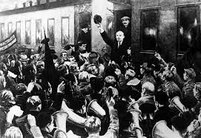

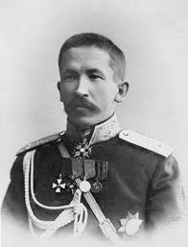

KORNILOV AFFAIR – KORNILOV TRIES TO TAKE POWER, HE FAILS

LENIN COMES TO PETROGRAD

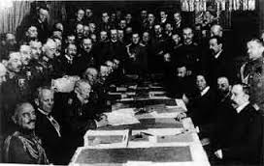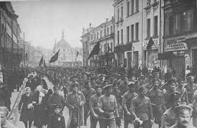

TREATY OF BREST-LITOVSK

BOLSHEVIK REVOLUTION

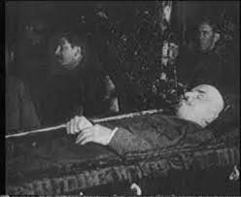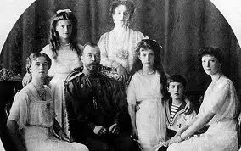

TSAR AND FAMILY MURDERED

LENIN DIED

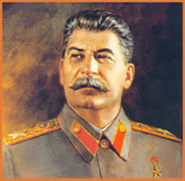

STALIN TAKES OVER

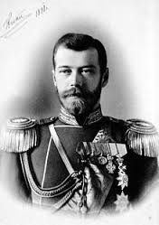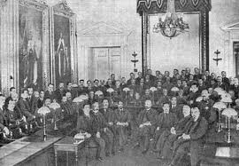

PROVISIONAL GOVERNMENT ESTABLISHED IN RUSSIA

NICHOLAS THE SECOND ABDICATED