English 11 Name: _____________

Characteristics of a Good Theme Statement

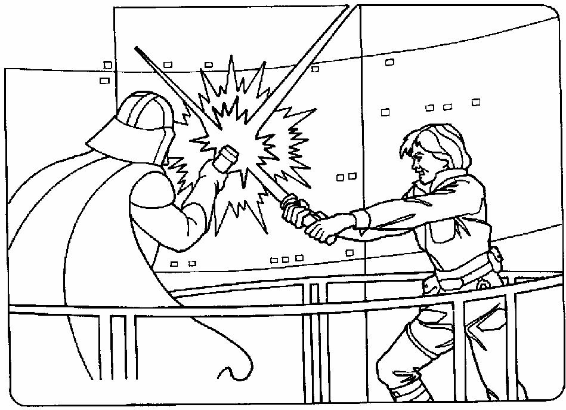
Definition: the underlying message or main idea of a story

Theme = the me(ssage)
1. Should be a complete sentence. "Good and Evil" (for example) is not a theme statement. It's just an announcement of the topic of the work. To ensure it is a full sentence start with “The theme of ________ by ________ is that
2. Should say what in particular is the author saying about the topic (what about love). Be detailed and specific
3. Should not describe events of the plot or character. The statement "Luke defeats Darth Vader" is not a theme statement but a plot summary. Instead of describing what the characters do, discuss what they represent ("Good will always defeat evil").
Good Theme Statements | Poor Theme Statement
The theme of “The Most Dangerous Game” by Richard Connell is that people should display more compassion. | Hunting People
The theme of “Button Button” by The Twilight Zone is that in life people will be faced with difficult dilemmas and should make the right choice or there will be drastic consequences | That people are mean
The theme of “Gentlemen Your Verdict” by Michael Bruce is that murder can be justifiable and even moral in certain circumstances | Morality
The theme of “Gentlemen Your Verdict” by Michael Bruce is that a person’s values help them make decisions | This story is about a man who sacrifices 15 to save 5.
4. Should reflect the values of the entire story, not just one or two episodes or lines. Look at the end of the story to make sure that the story's outcome matches what you think the theme is.
Ways to find theme
Pay attention to:

1. Character learns something or changes in a significant way 2. Ending
3. Scene described in detail /major plot event 4. Title
5. Symbolism 6. Conflict/Setting

Story | Theme
Your Choice: | Theme:  Line(s) To support:

