TERM PAPER CHECKLIST AND MARKING RUBRIC. Name:
The following checklist is designed to guide you through each of the items related to essay presentation and writing. The number on the far right side of the page signifies the value of the section.

This should help you with the structure and format of the term paper for History 12.

However, please note that the grading of the paper will be based on two rubrics. First, the mechanics and format will receive a grade based on the checklist below. Second, the Ministry of Education 6-Point Scale located on the reverse of this page will grade the level of writing, inclusion of relevant details, quality of argumentation and depth of analysis. You will receive 26 marks for the checklist. Then, you will receive a mark out of “6” on the 6 Point Scale. This grade will be multiplied by 8 to give you a grade out of 48. These two grades will be combined to form your overall term paper score out of 74.
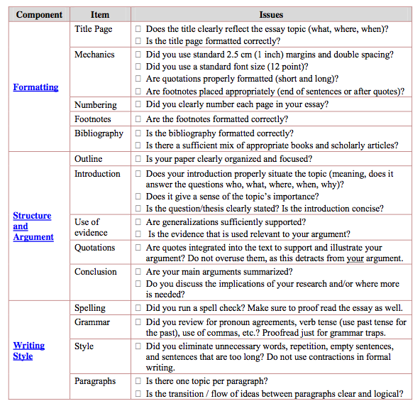

/4
/2

/4

/2
/3
/5

/2
/2

/2

/26

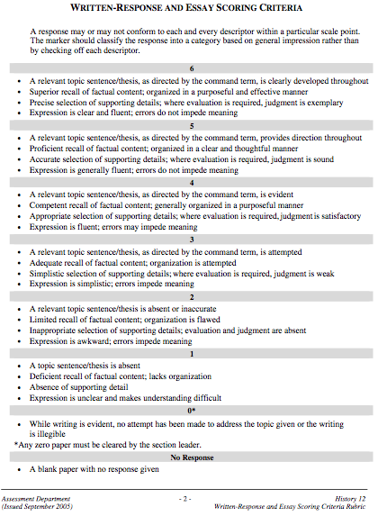

Teacher Comments: /74 (Checklist = 26
6 pt Scale = 48)

