Law 12 Name:
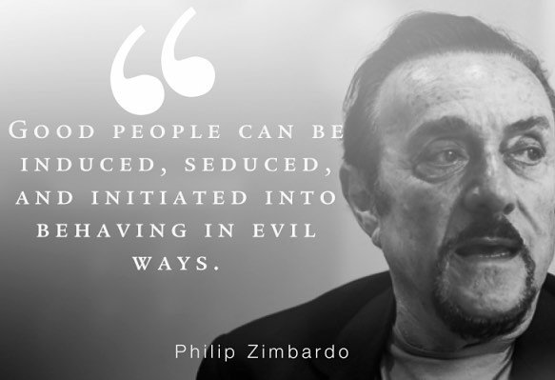
Corruption Unit Synthesis Assignment:
Option one: Video/Podcast Response to the following questions
Option two: Blog or written response to the following questions
Task: Students will synthesize the Dr. Philip Zimbardo Ted Talk "The Psychology of Evil" with the documentary film "The 7-5." You should have a thesis, analysis and conclusions.
PART ONE:
Using Specific Examples/Quotes from the Ted Talk, explain how Dr. Zimbardo would respond to/ react to the film "The 7-5." Use quotes/situations/specific examples from "The 7-5". *** Take two-three events from “The 7-5” and have Zimbardo comment on them. Then justify the comment he would make with quotes from his talk. (This is analysis)
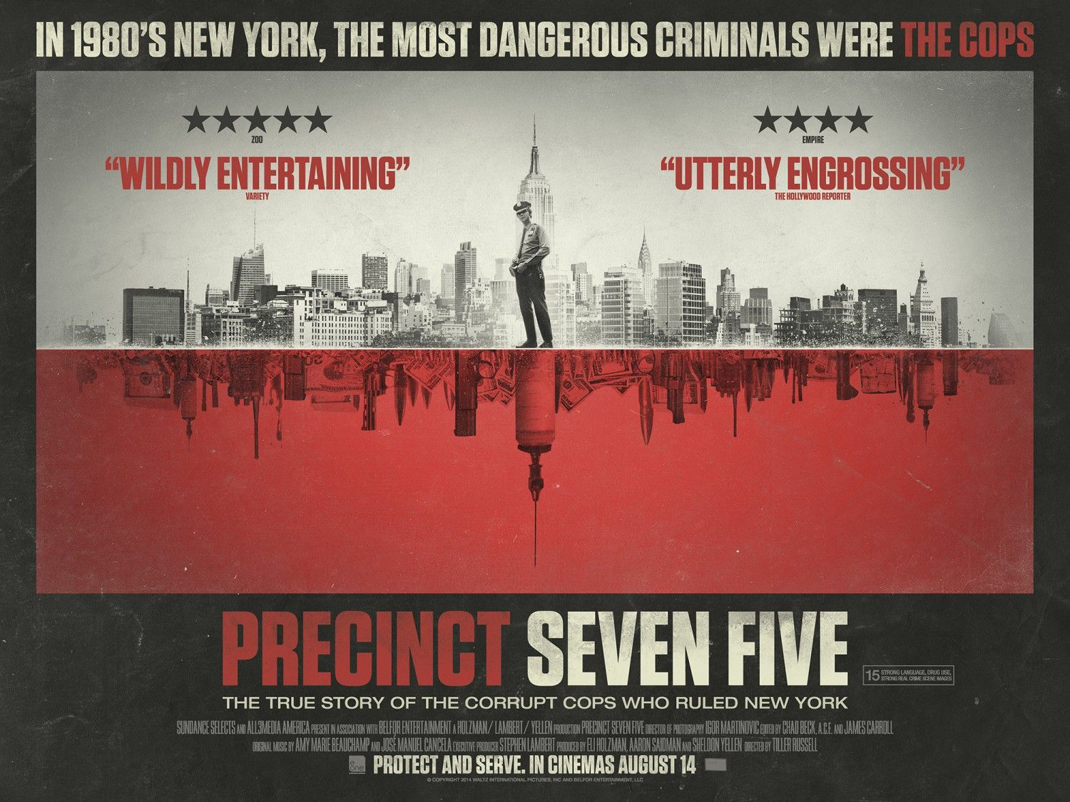
Suggested items students may discuss:
-Conditions that made corruption possible in the 7-5
-Advice on how the NY City police could prevent corruption
-What made some police corrupt during this time
-Dr. Zimbardo could reflect on a specific situation or statement that was made in the film
-Anything else that students would like to include
PART TWO – SEPARATE / AFTER YOUR SYNTHESIS, ON THE REAR OF THE PAGE:
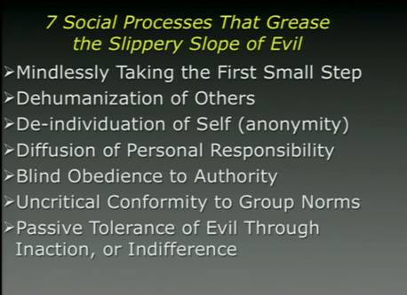
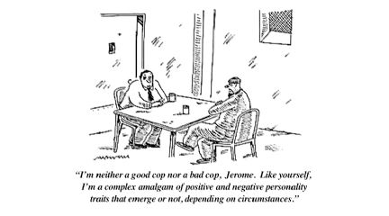
​Students explain what they believe to be the 2 most egregious offences that occurred during the film (use detailed and specific examples). Then explain which ones are the worst two. Justify your response with thoughtful analysis. (BASICALLY, WHAT IS YOUR OPINION)
PART THREE:
Once complete, students must view or read at least three other student responses and comment thoughtfully on them. Thoughtful comments include: adding your own response to their response, asking a poignant question and offering a response, agreeing/disagreeing and stating why.

SYNTHESIS GRADING RUBRIC - This is a first-draft response and will be assessed as such.

6 -The six response is superior.
Demonstrates an insightful understanding of the texts/films.
The response shows a sophisticated approach to synthesis, including pertinent references / quotes.
The response has incredibly detailed examples.
The writing / video / podcast style is effective and demonstrates skilful control of language.
Despite its clarity and precision, the response need not be error-free.
-PART 2: Excellent justification of worst two offenses
-PART 3: Detailed, thoughtful and insightful comment on other student work

5 -The five response is proficient, demonstrating a clear understanding of the texts/films at an interpretive level.
The response clearly synthesizes the concepts within the texts/films.
References (quotes/paraphrasing) may be explicit or implicit and convincingly support the analysis or argument.
The response has included mostly detailed examples
The writing / video / podcast is well organized and reflects a strong command of the conventions of language. Errors may be present, but are not distracting.
- PART 2: Very good justification of worst two offenses
- PART 3: Detailed and engaging comments on other student work

4 -The four response is competent.
Understanding of the texts /films tends to be literal and superficial.
Some synthesis is apparent but mainly from one text/film.
The response may rely heavily on paraphrasing or just retell parts of the texts/films without synthesizing.
References are present and appropriate, but may be limited.
Some details / examples but could describe in more detail.
The writing / video / podcast is organized and straightforward.
Conventions of language are usually followed, but some errors are evident.
- PART 2: Clear justification of worst two offenses
- PART 3: Comments on other students work in a relatively meaningful way

3 -The three response is a pass.
Understanding of the texts / films may be partially flawed.
An attempt at synthesis is evident. References are not clearly connected to the topic or may be repetitive.
The response may be somewhat underdeveloped and emergent; needs more time.
Some examples, but not enough to show understanding of text/film
A sense of purpose may be evident, but errors can be distracting.
- PART 2: Has incomplete or simplistic justification of worst two offenses
- PART 3: Comments on students work but off-topic at times or not necessarily contribute to education

2 -The two response is inadequate.
While there is an attempt to address the topic, understanding of the texts / films or the task may be seriously flawed.
A response that makes reference to both texts but refers only fleetingly to one of them is inadequate.
The response may be seriously underdeveloped.
Errors are recurring, distracting, and impede meaning.
- PART 2: Lists two worst offences.
- PART 3: Ineffective, off-topic comments on other student work, does not assist with class education

1- The one response is unacceptable. Although the response mentions both texts/films, it is too brief to respond to the topic or there may be a complete lack of control in the film / writing/ podcast. Does not include worst two offenses. Does not attempt to contribute to the education of others through commenting.

0 -The zero reflects a complete misunderstanding of the texts / films and/or the task, or is a restatement of the questions. Exclusive reference to only one text / film does not constitute synthesis.

