Communications 11/12 Name: ________________________
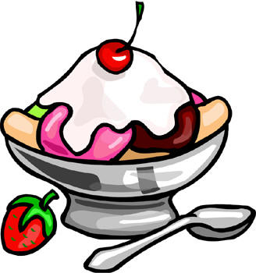
Descriptive Writing: The Ice Cream Sundae

Assignment: Your job today is to make an ice cream sundae and then to write a 7-10 sentence descriptive paragraph about the experience you had (making, eating or both). Try to think on a deeper level with this assignment; don’t just simply describe your sundae. Try to make connections/metaphors to the outside world and society while describing your experience. Please attach this sheet to your paragraph.

Brainstorm (Write down words, images, feelings, associations, sounds, tastes and emotions that come to your mind while making and eating your ice cream sundae):

Name your creation (be creative):

Simile or metaphor that describes eating/making or observing your sundae

Personality (if your ice cream sundae was human, what kind of personality would they have?)

Sophisticated Vocabulary (replace at least 5 of the words you brainstormed with more sophisticated ones to use in your paragraph)

Symbol/metaphor (what larger idea does your sundae represent? Connect it to life etc.)

*These are some past student examples of the assignment

The Explosion of Taste
When its slides into my mouth. The little bubbles pop. The fizzy soda is adventuresome, exploring every little taste bud dancing around my tongue. It has the ambition to make every one of my taste buds explode with intense taste. I imagine that I am going to melt into the cracks of the floor. I am guilty for drinking such a tasty beverage, yet I get a sense of approval. The liquid announces itself as it drifts down my throat with its spotted taste. The feeling makes me want to charge up and blurt out yipee, it’s cruel because it makes me crave another gulp but it’s all gone.

The Minty Hippo
The mess of chocolate heaven as it drizzles down the milk ice crystals and the crunchy prehistoric dinosaur sprinkles stick in the Sunday like an archeological dig in the Middle East. The spoon comes in contact with the frozen sugar milk. Within seconds I devour the mess. The bowl sits empty on the floor and I cower like a baby with brain freeze.

Sundae Paragraph

The Frozen Explosion. I had declared it. It was my attention demanding, rock filled, melting glacier. Overflowing with color, the rose-red juice of the cherry peak ran with the rivers of chocolate syrup, pooling artistically in the bottom of the bow. The smooth peanuts and werthers chucks crunch beneath my teeth, while the chilly blend of ice cream slips around my tongue, bewitching my taste buds. As I take another heart-stopping spoonful, a brain freeze strikes and numbs my mind almost painfully, revealing the cruel side of this taunting fragment of heaven. A whip cream cloud floats on top of my delightful dish. I mix it into the others ingredients, staining the pure, white cotton. Taking one more bite, I realize: This is more than a sundae, it plays twin to life it self. Soft, easy and sweet but laced with abrupt crunches and hard pieces that must be overcome in order to enjoy it. But as the revelation ends, so does my sundae, the Frozen Explosion. Staring at the last few drops in the bottom of the bowl, I wonder, would it taste the same? Will my craving be soothed?

