Stalin Video – A&E “Red Terror” Name: ___________
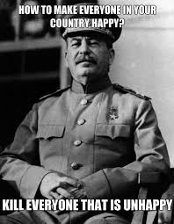
Questions
1. How did Josef Stalin’s childhood affect his real life? Why do you think he changed his name from Josef Dzhugashvili to Josef Stalin? (Also, see Page 56 of Dimarco Text)

2. Stalin is described as a man of action, not a man of ideas. Examples?

3. Why did Lenin find Stalin useful?

4. Why eventually did Lenin not trust Stalin?

5. What were the “collective farms”?

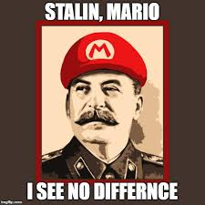
6. Why were the collective farms a failure? How did Stalin’s agricultural policies contribute to the famine? (Also, see Page 131 of Howarth Text)

7. What role did the propaganda have in the Soviet Union under Stalin? How did Stalin use propaganda to strengthen his regime?

8. Describe Stalin’s “reign of terror.” Did most soviets believe that Stalin was responsible?

9. Why did so many Soviets mourn the death of Stalin?
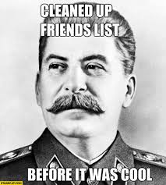
Summarize the Five Year Plans:

First Five Year Plan (____________to____________)
“command economy” - ___________________________________________________________

MAJOR GOALS:

1929 ‘Collectivization’ -__________________________________________________________________
Kulaks - ________________________________________________________________________
Women - ______________________________________________________________________
Education - _____________________________________________________________________
Results of the First Five Year Plan:

Second Five Year Plan (______to______)
Focus: _________________________________________________________________________

Purges:________________________________________________________________________

Results:________________________________________________________________________

Third Five Year Plan? ___________________________________________________________________

