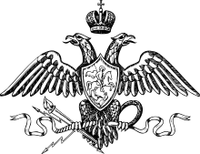

OKHRANA
File # 3316
Joseph Vissarionovich Stalin

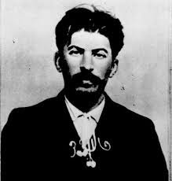
Person of interest: Joseph Vissarionovich Stalin

Other names referred to as: Iosif Dzhugashvili

DOB: December 18, 1878

Age: 33

Height: 165 cm

Hair Colour: Black

Gender: Male

Place of Birth: Gori, Russian Empire

Arrest Reason: Revolutionary Activities: Joseph Stalin is primarily an interest to OKHRANA police for his involvement in organizing the labour strikes in 1898. Stalin has proven to be a radical Marxist, with no regard for our laws or way of life. If left to his own free will, he will become a threat to the Tsar’s Empire and therefore must be stopped.

Background
Joseph Vissarionovich Stalin was born in the town of Gori on December 18, 1878 to Besarion Jughashvil and Ekaterine Geladze. Stalin’s parents owned a shoe shop; however, Stalin’s father was an alcoholic and was not a good businessman and therefore, the family lived in dire poverty. In September 1888, Stalin enrolled in Gori Church School, where he learned how to speak Russian. He did quite well in school and in 1894 Stalin applied to the Orthodox Spiritual Seminary in the town of Tiflis. It was at this school, that Stalin was introduced secretly to the writings of Karl Marx. He was deeply influenced by Marx’s works such as the “Communist Manifesto,” and “Das Kapital,” and he became a political activist fighting to abolish the monarchy. Stalin was expelled from school from school inn 1899 for his radical political activism. In 1900, he joined the political underground and encouraged workers to strike, which often lead to bloody clashes with the authorities. Stalin also joined the militant Marxist Social Democratic Movement, led by Vladimir Lenin. Stalin’s disruptive behavior escalated, and he repeatedly got arrested for criminal activities.
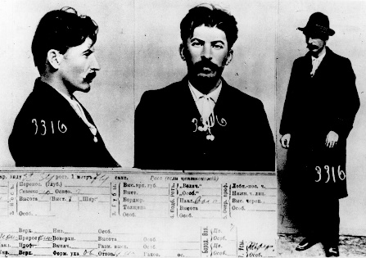

Stalin’s Rise to Power
In 1912, Lenin was exiled to Switzerland, while Stalin was exiled to Siberia in 1913 for four years. Prior to his exile, Lenin appointed Stalin in 1912 to serve on the first Central Bolshevik Party. Although his involvement initially was short-lived due to his own exile, Stalin resumed his participation in 1917 upon his release from Siberia. With Czar Nicholas II having abdicated his throne as part of the February Revolution, the provisional Government took over leading Russia. The Bolsheviks, led by Lenin, seized Petrograd, the capital of Russia, on October 25, 1917 and thereby assumed power over all of Russia.
During the Civil war (1917-1921) between the Red Army (Bolsheviks) and the White Army (anti-Bolshevik groups), Stalin moved through the political ranks, becoming the Secretary General of the Central Committee of the Communist Party in 1921. With the White Army’s defeat, and with his newfound power, Stalin was able to appoint allies to government jobs, thereby growing a base for political support. In 1924, Lenin died and Stalin, who defeated his political rival Leon Trotsky, became the leader of the Communist Party.

Significance to the Revolutionary Movement
Joseph Stalin played an instrumental role in the Russian Revolution. He helped organize one of the first major strikes against the Tsar and ultimately became one of the high-ranking officials of the Bolsheviks. Stalin was ruthless in his desire to gain power and he was soon known as willing to use brutality to gain power. He was a feared leader, who outmaneuvered his rivals. After Stalin became the leader of Russia, he wanted to bring Russia into the industrial age within five years. To do this, he seized assets such as farms and factories and he reorganized the economy. He also shut down religious institutions, confiscated church lands, and banned music and literature that could influence the masses against him. He also was responsible for heavy censorship over the news outlets. Any farmers or landowners who opposed him were shot or sent to prison. Stalin’s plan proved disastrous, leading to inefficient production of food and materials. Stalin, wanting to maintain an appearance of success to outside eyes, exported food to other countries thereby leaving rural people to starve. Hundreds of thousands of Russian people starved to death. Any protests immediately lead to a crackdown leaving protesters bloodied, dead or sent to remote prison camps, known as gulags. Stalin also expanded the secret police and encouraged citizens to spy on each other and turn in anyone who stated anything negative about Stalin or how he ruled the country. Stalin also created a cult-like persona by rewriting history textbooks, giving himself a prominent role in the revolution. He had statues and drawings of himself, and even had his name inserted in the national anthem.

Family
Wives  Ekaterina Svanidze (1885–1907, married 1904–1907)  Nadezhda Sergeevna Allilueva (1901–1932, m. 1919–1932) | Children  Yakov Iosifovich Dzhugashvili (1907–1943)  Vasily (1921–1962)  Svetlana Iosefovna Allilueva (1926–2011)

Deaths attributed to Stalin
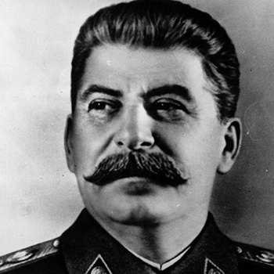
It is believed that Stalin is responsible from eight million to twenty million deaths during his reign. The actual number is unclear as many bodies were just put in mass graves with no annotation.

References
Hingley, R. (2020, December 02). Joseph Stalin. Retrieved December 11, 2020, from https://www.britannica.com/biography/Joseph-Stalin
History.com Editors. (2009, November 12). Joseph Stalin. Retrieved December 11, 2020, from https://www.history.com/topics/russia/joseph-stalin
How Joseph Stalin became the leader of the Soviet Union. (n.d.). Retrieved December 11, 2020, from https://dailyhistory.org/How_Joseph_Stalin_became_the_leader_of_the_Soviet_Union

