SS9 Dictator Comparison Assignment Name:
This assignment will allow you to take what you learned about Napoleon and compare him to another totalitarian leader in the modern era (last 100 years). You will have a chance to research a leader of your choice to compare and then you will represent your knowledge in a method of your choice (see below for examples)
1. What are the qualities that make an effective leader?
2. What Social, Political, Economic and Military factors result in Dictators being able to rise to power?
3. What Social, Political, Economic and Military factors result in the downfall of Dictators?
4. What tools do Dictators use to maintain power (we will focus on propaganda).
Choose one leader/dictator from the list below to compare to Napoleon
Adolf Hitler (Germany) Fidel Castro (Cuba)
Benito Mussolini (Italy) Kim Jong-un or Kim Jung Il (North Korea)
Joseph Stalin (Russia) Pol Pot (Cambodia)
Saddam Hussein (Iraq) Bashar al-Assad (Syria)
Muammar Qaddafi (Libya) Donald Trump (United States)
Mao Ze Dong (China) Mahmoud Ahmadinejad (Iran)
Hosini Mubarak (Egypt) Than Shwe (Burma/Myanmar)
King Abdullah (Saudi Arabia)
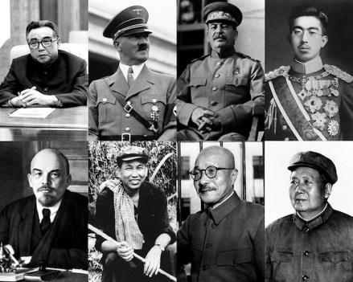
Use the following chart to record your notes as you complete your research
Areas to compare | Napoleon | Your chosen dictator: ___________________  Similarities to Napoleon | Differences to Napoleon
Personality Traits/

Leadership style
(How they rose/maintained their power?

Vision or “slogan”
Examples of propaganda
Historical Impact on their country or world (then and now
Outcome of their leadership and what led to their downfall

Other

Share your finding – select one method to show your research (see me if you have another idea)
Pamphlet Venn diagram Graphic organizer matrix Poster
Newscast Vlog Instagram Infographic Interview Facebook Page

Online Resources:
WorldBook: http://www.worldbookonline.com/student/home
http://www.worldbookonline.com/student/search?st1=dictators&searchprop=WBS&btntype=ar

GALE:
http://go.galegroup.com/ps/searchWithin.do?limiterFieldValues%5BAC%5D=y&_limiterFieldValues%5BAC%5D=on&standAloneLimiters=LI&_limiterFieldValues%5BLI%5D=on&actionCmd=DO_LIMIT_SEARCH_RESULTS&stw.option=withinResults&prodId=GPS&userGroupName=67sbo&searchType=AdvancedSearchForm&searchId=R1&tabID=T003&topicId=&inPS=true&sort=&searchResultsType=SingleTab&limiterFieldValues%5BDA%5D=

http://www.telegraph.co.uk/news/worldnews/asia/northkorea/10558478/Other-dictators-at-30-how-Kim-Jong-un-compares.html

http://williamdietrich.com/trump-vs-napoleon/

