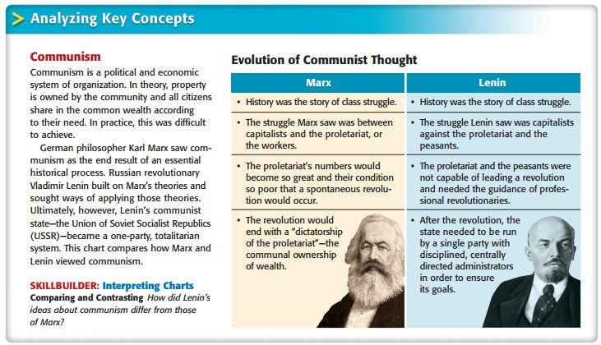
MARXISM AND COMMUNISM

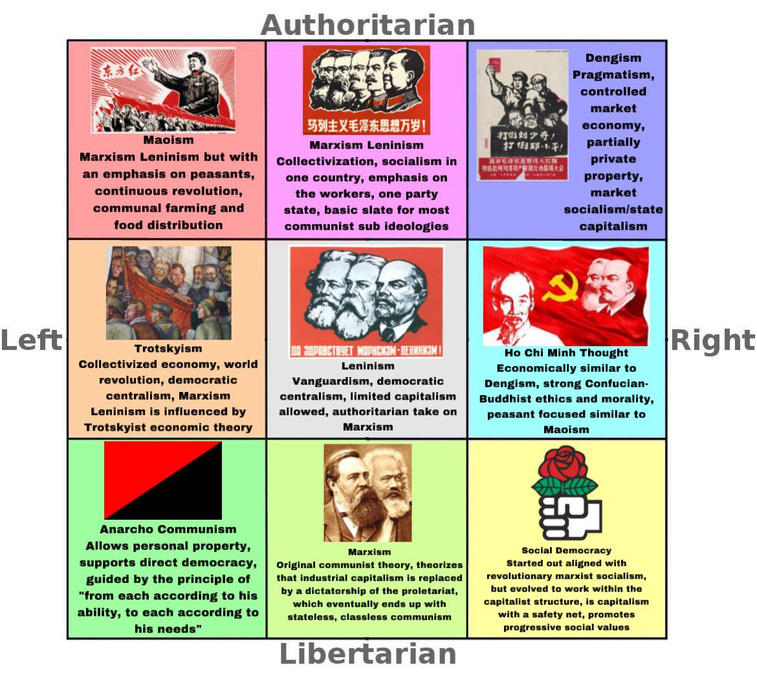
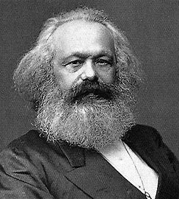
“From each according to his ability, to each according to his needs” – MARX’s ten beliefs were:
-Land ownership should be abolished.
-Income tax should depend on what you earned. The more you earned, the more you should be taxed. The less you earned, the less you should be taxed.
-All rights to inheritance should be abolished.
-All property of emigrants and rebels should be confiscated.
-Centralization of all credit - state is in charge of the national bank, state capital, and the economy.
-All means of communication and transport to be centralized by the state.
-All land that was not being used would be brought under cultivation and this would help in the improvement of soil.
-He wanted all people to have an equal obligation to work and that an industrial and agricultural army be established.
-The combination of agriculture and manufacturing industries, making town and country indistinguishable through equal distribution of the population all over the country.
-Free education for all children in public school and that child labour in factories be abolished. He believed educated children would be better for society.

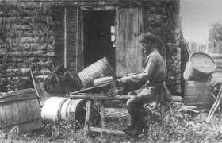
At the start of the Century – the conditions in Russian were ripe for communism:
Of all the major states in Europe, Russia placed first in: illiteracy, economic backwardness, oppression of minorities, political despotism, social inequality.
Marxism | Leninism
Sought to change the world through his ideas | One fixed and limited goal: seize power in Russia and reshape it according to communist principles
Primacy of Economics over Politics | Primacy of Politics over economics
Saw revolution as inevitable and would spontaneously after the rise and fall of capitalism | Attack the existing social and political system; a small group of committed revolutionaries could seize power
Reactive in Approach (it’ll happen) | Active in approach (Make it happen)
BOTH BELIEVED IN THE INEVITABLE VICTORY OF COMMUNISM THROUGHOUT THE WORLD.
