History 12 Name ___________________________________
Mr. Fitton
RUSSIAN REVOLUTION – CHAPTER QUESTIONS

Guiding Questions for the unit
1. What are the conditions that cause citizens to overthrow their government.
2. How was a small group of revolutionaries able to seize power.
3. What are the resonating impacts of Communism and the "Russian Experiment" on the world today!

H = Howarth Textbook D= Dimarco Textbook

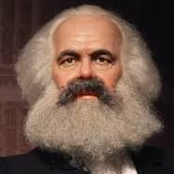
The Background: Russia before 1917

- According to Karl Marx, what would revolutions in industrialized countries result in? (H 13)

- Compare the industrial progress of Russia to that of both Germany and the UK. (H 14)

- Bloody Sunday (1905). Describe the event & explain why it was a dress rehearsal for 1917. (internet search)

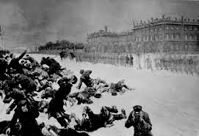

- What was the “Duma” and why was it ineffective? (H 15 & 32, D 38 & 40)

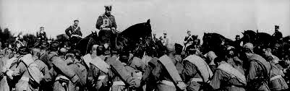
- Why was Russia’s army so demoralized in WWI? (D 39-40)

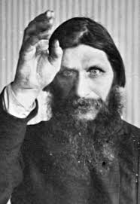
- What role did Rasputin play in governmental policy? (H 31 & D 40)

Russia Heats Up: The March Revolution 1917

- Identify the causes and results of the March Revolution. (H 32 & D 40-41)

- Write notes on the “Provisional Government” (H33 & D43)

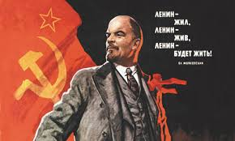
- Explain the terms of Lenin’s “April Theses”. (D 44)

- What was Provisional Government leader Kerensky’s mistake? (D 45)

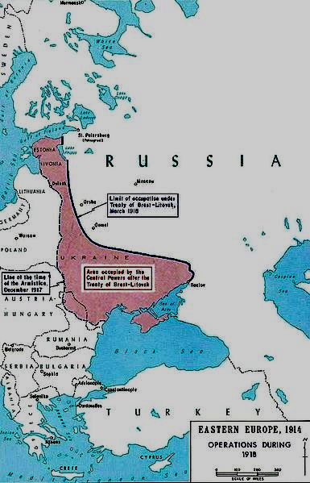
Communism Wins: The November Revolution 1917 (Lenin in power)

- What terms were agreed upon in the Treaty of Brest-Litovsk? (H 54)

- What were the reasons for Allied Intervention in the Civil War? (H 55)

- Explain why the “Reds” would defeat the “Whites”. (D 50-51 & H 55)

- Define “Cheka”. (H 55)

- What was the Russo-Polish War and Treaty of Riga 1920? (D 30)

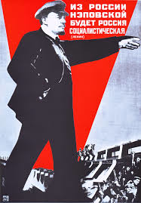
Communism Survives and Thrives: Lenin’s Economic Policies

- Explain “War communism”. (H 55 & D 52)

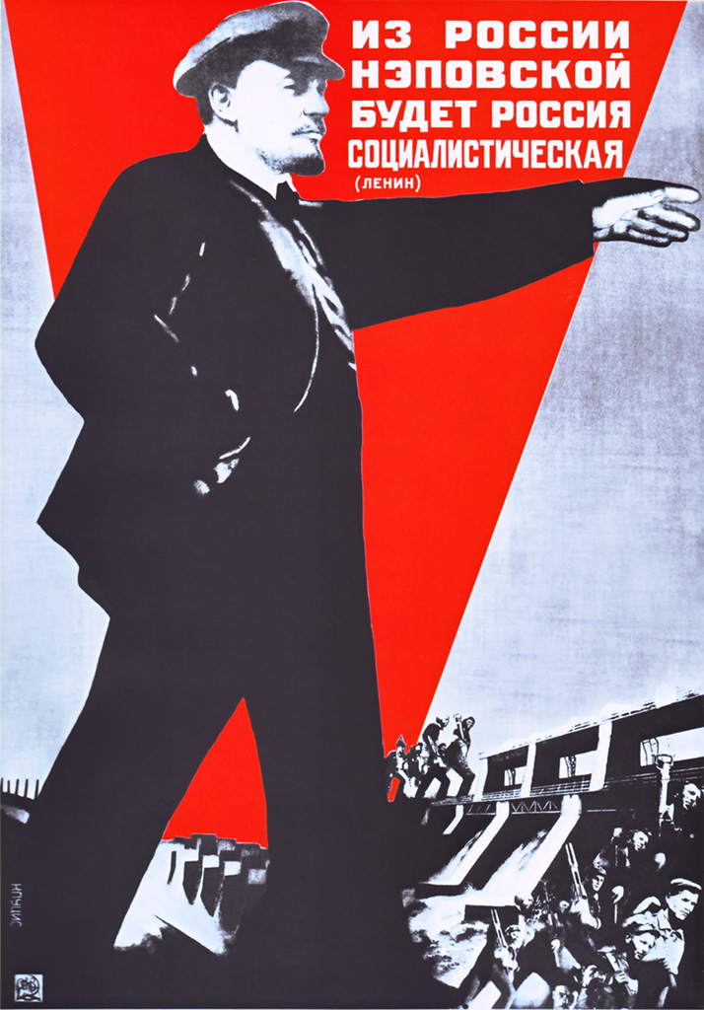
- Explain the “New Economic Policy” (H 56)

- Describe “Comintern” and its purpose. (H 59)

- Provide brief notes on both Stalin and Trotsky. (H 34 & 54-56)
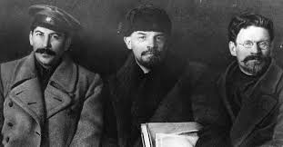  Stalin | Trotsky

