English Names: _____________________
_____________________
Rules For Using Dialogue:

1. A speaker's exact words (also called dialogue) must be surrounded by quotation marks.

Example: "I love flowers," said Ben.

2. Opening quotation marks (example: ") are used to mark the beginning of the speaker's words, and closing quotation marks are used the mark the end of the speaker's words (example: ").

3. Commas and periods are always placed inside the closing quotation marks.
Example: "I like chips," said Dakota. Austin replied, "I love pretzels."

4. Use a comma to introduce a quotation after a dialogue tag.

Example: Tyler replied, "Blue is my favorite color."

5. If dialogue is split or separated, use quotation marks to surround each part that is spoken.

Example: "Yes," said Tim, "I love cheese pizza."

6. If a quotation is not split or separated, don't close the quotation until the speaker is finished. This could sometimes involve numerous sentences.

Example: "Please write your name on your paper before you begin. Once you finish, bring your paper to the front of the room and place it on my desk," said Mr. Lezard.

7. Every time a new person speaks, you must start a new paragraph.

Example:
“Hi,” said Jared. “How are you?”
“I’m great,” replied Kiana. “How have you been?”
“Oh, you know, getting by.” Kiana had been sullen and withdrawn ever since her hampster had died. Jared was getting worried that Kiana was not dealing well with the death.
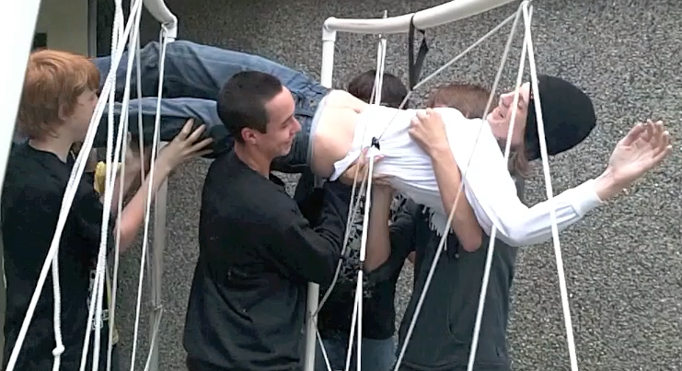
Now you try:

1. Jordon said, That's my coat.

2. Regan asked, Did you plant beans and peppers in your garden?
“I wish these weren’t made out of barbed wire,” said Mr. Dutchak.
“You’re a baby,” taunted Kevin who shoved him into the rope.
3. Is the pizza here? asked Rayce

4. This beach, said Shania, is more beautiful than ever.

5. Help! Shouted the Comm 11/12 class. We can’t live a whole class without our cellphones!

6.
ASSIGNMENT:
GROUP
MEMBERS:

Please complete the dialogue assignment explained in class. Your group must submit the finished story with a minimum of 5 well-used examples of dialogue. They should reveal that you are capable of adhering to the rules learned in the sheet above. You should insert them into a small story. You will practice this skill in your next composition as well.

_________________________________________________________________________________________________________________________________________________________________________________________________________________________________
_________________________________________________________________________________________________________________________________________________________________________________________________________________________________
_________________________________________________________________________________________________________________________________________________________________________________________________________________________________
__________________________________________________________________________________________________________________________________________________________________________________________________________________________________________________________________________________________________________________________________________________________________________________________________________________________________________________________________
_________________________________________________________________________________________________________________________________________________________________________________________________________________________________
_________________________________________________________________________________________________________________________________________________________________________________________________________________________________
_________________________________________________________________________________________________________________________________________________________________________________________________________________________________
_________________________________________________________________________________________________________________________________________________________________________________________________________________________________
___________________________________________________________________________

