English Names: _____________________
_____________________
Rules For Using Dialogue:

1. A speaker's exact words (also called dialogue) must be surrounded by quotation marks.

Example: "I love flowers," said Gary.

2. Opening quotation marks (example: ") are used to mark the beginning of the speaker's words, and closing quotation marks are used the mark the end of the speaker's words (example: ").

3. Commas and periods are always placed inside the closing quotation marks.
Example: "I like chips," said Myles. Harjot replied, "I love pretzels."

4. Use a comma to introduce a quotation after a dialogue tag.

Example: McKenzie replied, "Blue is my favorite color."

5. If dialogue is split or separated, use quotation marks to surround each part that is spoken.

Example: "Yes," said Zane, "I love cheese pizza."

6. If a quotation is not split or separated, don't close the quotation until the speaker is finished. This could sometimes involve numerous sentences.

Example: "Please write your name on your paper before you begin. Once you finish, bring your paper to the front of the room and place it on my desk," said the Ms. Lamont.

7. Every time a new person speaks, you must start a new paragraph.

Example:
“Hi,” said Mason. “How are you?”
“I’m great,” replied Brooke. “How have you been?”
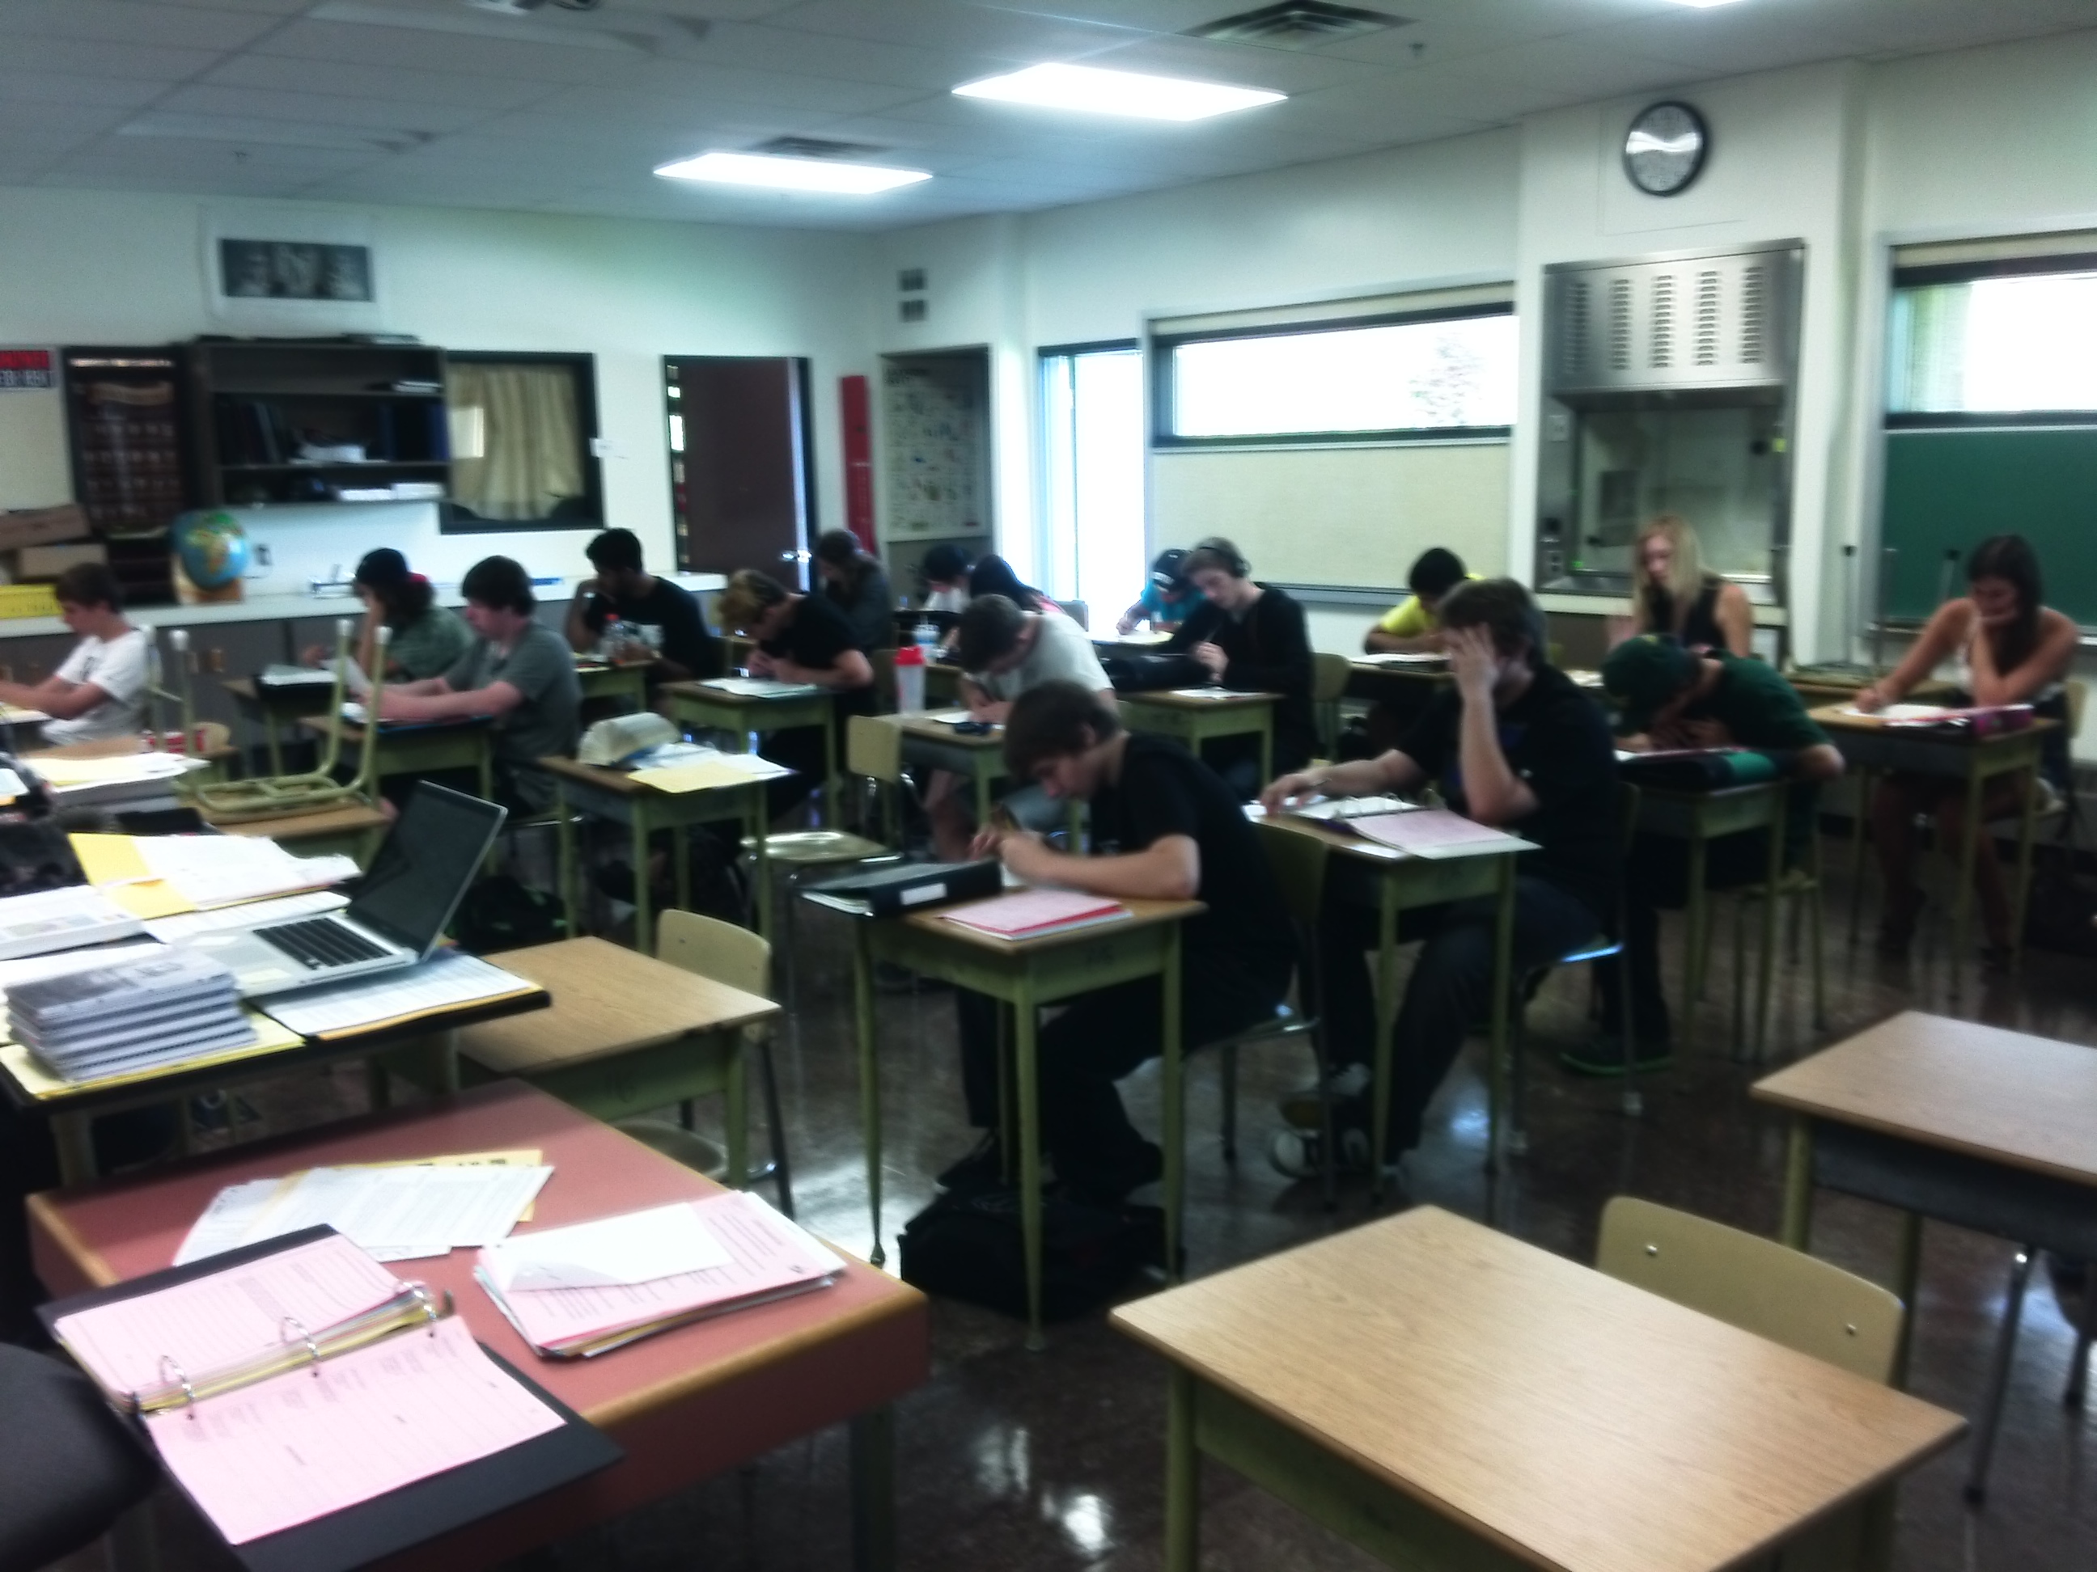 “Oh, you know, getting by.” Mason had been sullen and withdrawn ever since his hampster had died. Brooke was getting worried that Mason was not dealing well with the death.

Now you try:

1. Zach said, That's my coat.

2. Tana asked, Did you plant beans, peppers, and melons in your garden?
“My essay is Great,” said Chris.
“I respect your essay,” chirped Gary, who was proud of Chris.
3. Is the pizza here? asked Benjamin

4. This beach, said Prem, is more beautiful than ever.

5. Help! Shouted the English 12 class. We can’t live a whole class without our cellphones!
ASSIGNMENT:
GROUP
MEMBERS:

Please complete the dialogue assignment explained in class. Your group must submit the finished story with a minimum of 5 well-used examples of dialogue. They should be sophisticated and reveal that you are capable of adhering to the rules learned in the sheet above. You will practice this skill in your next composition.

_________________________________________________________________________________________________________________________________________________________________________________________________________________________________
_________________________________________________________________________________________________________________________________________________________________________________________________________________________________
_________________________________________________________________________________________________________________________________________________________________________________________________________________________________
__________________________________________________________________________________________________________________________________________________________________________________________________________________________________________________________________________________________________________________________________________________________________________________________________________________________________________________________________
_________________________________________________________________________________________________________________________________________________________________________________________________________________________________
_________________________________________________________________________________________________________________________________________________________________________________________________________________________________
_________________________________________________________________________________________________________________________________________________________________________________________________________________________________
_________________________________________________________________________________________________________________________________________________________________________________________________________________________________
___________________________________________________________________________

