Name: __________________
Anticipation Guide “Quitter’s Inc.” Stephen King Date:___________________
"The ends justify the means" is a phrase encompassing two beliefs:
- Morally wrong actions are sometimes necessary to achieve morally right outcomes.
- Actions can only be considered morally right or wrong by virtue of the morality of the outcome.
Directions: Read the statements below and decide whether you agree that “the ends justify the means” or whether you disagree and believe the scenario is immoral.

1. You tell your parents you were at a friend’s house studying when you were actually buying them a birthday present. Agree Disagree

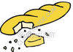
2. The pitcher on your softball team hits the other team’s best batter with a pitch to avoid a run scoring. Agree Disagree

3. A homeless person steals a loaf of bread and eats it. Agree Disagree

4. Laboratories run experiments on animals to come up with important medicines. But often the animals die in the process.
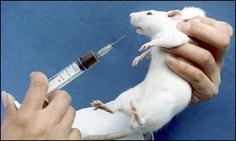
Agree Disagree

5. You are an intelligent student, but because of the flu you cannot complete the final English 12 essay on time. You can buy a research paper on the internet to get an A; otherwise you will not get into your desired university.
Agree Disagree

6. What if we could save the life of just one person, perhaps a child, by torturing an enemy or a convicted murderer.
Agree Disagree

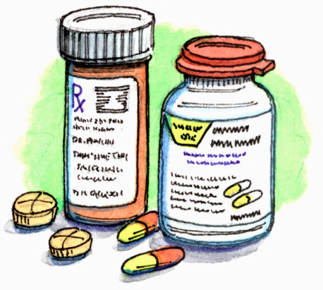
7. A woman, who recently lost her job because of alcoholism, steals food from a grocery store in order to feed her children
Agree Disagree

8. A Physician in the emergency room of a small hospital abandons a 91 year old woman having a massive stroke in order to attend a 30 year old obese man having a heart attack. Agree Disagree

9. A pharmacist company has a drug that will cure a rare disease; however the drug costs $750 000. A man needs this drug for his dying wife as it is the only thing that will cure her. He steals the drug to save her life.
Agree Disagree

10. Stalin killed millions of people modernizing Russia; however, many historians agree that industrialization was the sole reason that the Russian Army was able to defeat Nazi Germany.
Agree Disagree

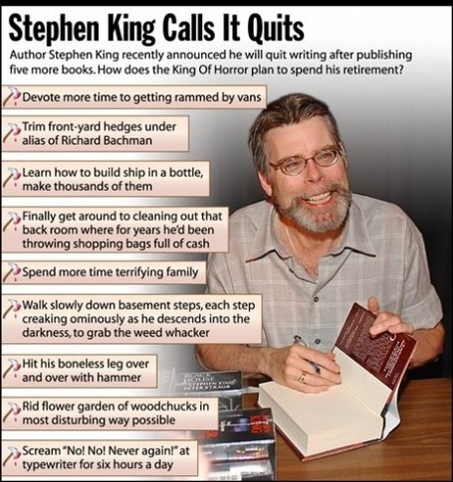
Quitter’s Inc. By Stephen King

1. Stephen King is known for his ability to create suspense. What are 2 ways that he creates suspense in this story?

2. What are some methods used by Quitter’s Inc. to “cure’ Morrison?

3. Did you expect Morrison’s wife to react the way she did in the story? Why/why not?

4. When it comes to breaking bad habits, do you think a punishment system or a rewards system is more effective? Explain your reasoning.

5. What is Donatti’s background? What kind of a person is he? Provide evidence.

6. In this story did the ends justify the means? Explain your answer.

7. Quitter’s Inc could never exist in our society. Why not?

8. If Quitter’s Inc. existed, would you recommend it to a friend/relative? Why/why not?

9. Would the Quitter’s Inc. method work for a heroin/cocaine/meth addict? Explain.

10. Do you believe there is ever a case where the “ends justifies the means” Explain your answer in at least 3-4 sentences.

Facts about Nicotine and Tobacco Products

About 62 million people in the United States ages 12 and older, or 29 percent of the population, are current cigarette smokers, according to the 1996 National Household Survey on Drug Abuse. This makes nicotine, the addictive component of tobacco, one of the most heavily used addictive drugs in the United States.
Effects of Nicotine
When a person inhales cigarette smoke, the nicotine in the smoke is rapidly absorbed into the blood and starts affecting the brain within 7 seconds. In the brain, nicotine activates the same reward system as do other drugs of abuse such as cocaine or amphetamine, although to a lesser degree. Nicotine's action on this reward system is believed to be responsible for drug-induced feelings of pleasure and, over time, addiction. Nicotine also has the effect of increasing alertness and enhancing mental performance. In the cardiovascular system, nicotine increases heart rate and blood pressure and restricts blood flow to the heart muscle. The drug stimulates the release of the hormone epinephrine, which further stimulates the nervous system and is responsible for part of the "kick" from nicotine. It also promotes the release of the hormone beta-endorphin, which inhibits pain.
People addicted to nicotine experience withdrawal when they stop smoking. This withdrawal involves symptoms such as anger, anxiety, depressed mood, difficulty concentrating, increased appetite, and craving for nicotine. Most of these symptoms subside within 3 to 4 weeks, except for the craving and hunger, which may persist for months

Levels of dependency
- Levels of dependency vary, but 80% of smokers have a cigarette every one to two hours throughout the day.
- A highly addicted smoker – smoking more than 25 cigarettes a day – ranks the first cigarette in the day as the most important, and will smoke within 30 minutes of waking up.

Withdrawal symptoms
- Nicotine addiction is a physical dependency. Withdrawal symptoms can be severe and many smokers might not be able to quit on their first attempt because of these symptoms, and a lack of preparation to cope with withdrawal.
- The most severe withdrawal symptoms occur within the first week although the craving for cigarettes can persist for months even years. The desire to smoke can be especially strong when a person is under stress although others crave cigarettes while socializing or when bored. The typical withdrawal symptoms are:
  - headaches
  - anxiety and irritability
  - difficulty concentrating and sleeping
  - hunger
  - decreased heart rate and blood pressure
  - craving for nicotine
- Other side effects such as fatigue and coughing are indications that the body is in a state of repair and is cleaning out the poisons associated with smoking.
- Your body uses food more slowly when you first stop smoking. You may eat more when you quit too, so there is a good chance you will gain weight. And, while the average weight gain is 5 pounds, not everyone gains weight when they quit smoking.

Benefits of quitting smoking
- Within 8 hours, the level of carbon monoxide in your body decreases and oxygen increases to normal levels.
- After just two days, the risk of heart attack begins to decrease.
- Within just 48 hours, your sense of smell and taste improve and return to normal.
- After three days, your lung capacity will have increased, making breathing easier.
- After the first year, the risk of heart attack is cut in half.
- Within 10 years, the risk of dying from lung cancer is cut in half
- Within 15 years, the risk of dying from a heart attack is equal to a person who never smoked.
- The health benefits of quitting occur for all types of smokers, men and women, young and old.
- Quitting smoking is the best thing smokers can do to improve their life and health. Former smokers live longer than those who continue to smoke

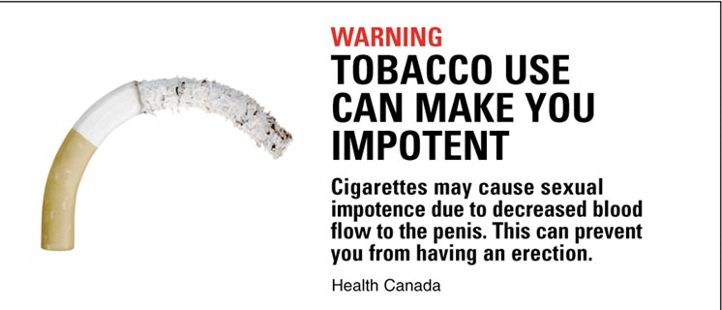

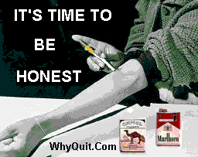

Mouth Cancer Victim

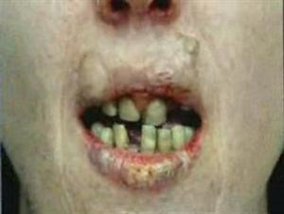

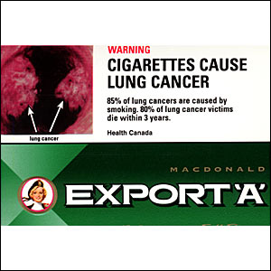

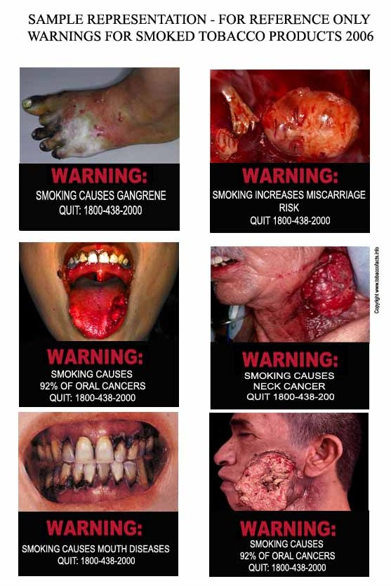

The Tipping Point “Suicide, Smoking and the Unsticky Cigarette” Malcolm Gladwell

-Teenage smoking has increased over the past 10 years (jumped 32%) despite a huge increase in antismoking campaign

-Anti-smoking campaign (discussing risks, making cigarettes harder to buy, increasing price, showing horrific pictures,) has been largely unsuccessful because teens don’t really care about the risks, in fact, they tend to overestimate them (when asked how much they thought it would shorten their lives by if they started at 21, most guessed 9 years when it is actually 5 or 6)

-Why do teens start smoking? Most of them report a fond memory of a person who used to smoke and was someone that they wanted to emulate, see that person as giving them permission to experiment with smoking

-anti-smoking campaigns see this and think that they need to make smoking seem less cool, however it is not the cigarettes that were cool, just the person smoking them.

-Why? Smoking type: extroverted, social, snap decision maker, higher sex drive, risk taker, defiant, honest, drinks more coffee. This type of person is generally considered “cool”

-another reason teens start: heavy smokers more genetically pre-disposed to tolerate higher levels of Nicotine (which is why children of people who smoke also tend to smoke)

-People with high sensitivity to nicotine (someone who tried smoking but never became addicted) report an adverse reaction to their first puff of smoke, while heavy smokers remember an initial pleasurable buzz from their first cigarette.

-of all teens that smoke only 1/3 go on to smoke regularly, those are the ones with low sensitivity, or high tolerance for nicotine.

-smokers in general also have a higher rate of depression and other mental disorders (alcoholism, schizophrenia)

-So how does The Tipping Point suggest we combat teen smoking?

-not nicotine patch (low dose all the time, where as any drug user (heroin or nicotine) wants a large dose at once to overwhelm the senses)

-change who teens take their social cues from

-treat depression, many people smoke because the chemicals in cigarettes raise levels of chemicals in the brain that help ease depression

-experiment does not equal addiction (only 18% of heroin users use it more than once, 0.9 of cocaine users), so let them experiment safely (maybe discover a safer way of smoking? Less nicotine?)

APK:

On a blank piece of paper and in least ½ a page, explain what your view is on why people start smoking or other drugs (alcohol, cocaine, etc.) What do you think the best way to cure people of their addiction?

