Mr. Fitton REGGIO INSPIRED PROVOCATION – LIT CIRCLE ACTIVITY Name:
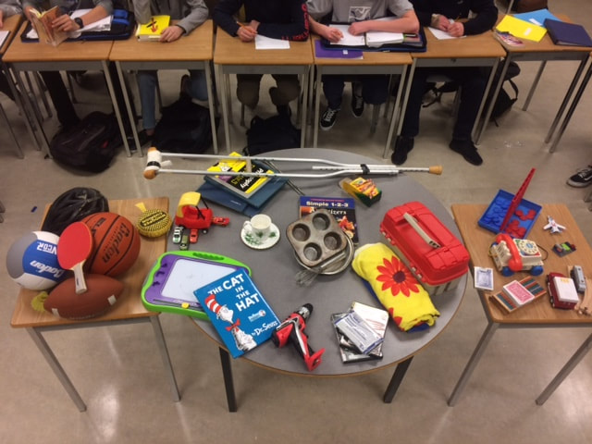
English Date

Activity: Students arrive in class to find a table with a variety of items. Some objects were arranged thematically, others were placed at random.

In a circle, students are asked to examine the items for a couple of minutes. Next, they are asked to make a circle around the “Provocation” and make one connection to an item on the tables and explain to the class.

Next, students are asked to step empathetically into the shoes of a character in their novel. They must then choose an object that their character would choose.

Assignment OPTION 1: Choose an item (or two if necessary) that your character would select. Then, using quotes, occurrences and major events in the story justify your response. You should use three quotes or examples from the story to provide a strong response (Or one described example and two quotes.)

Example:
The Glass Castle. Jeanette Walls would choose the 9-inch nails.

Jeanette would choose the 9-inch nails because they symbolically represent her childhood. Despite being consistently hammered down by circumstances, like her fathers alcoholism, her mother’s inconsistency/insanity and their constant moving, she remains steadfast like iron, never bending in a negative manner. Indeed, even though she endures trauma like her father throwing her into a pond and nearly drowning her, and another harrowing scene where he attempts to prostitute her for alcohol money, she won’t bend. Indeed, all of the harrowing strikes she receives in life, serve, like a nail being hammered into a piece of wood, to build a strong structure. Indeed, the strong structure being constructed is the stalwart and independent author, Jeannette Walls.

(Please note that this example contains evidence from the text, but not direct quotes; some of your examples should provide direct references to the text in the form of quotes/page numbers)

Assignment OPTION 2: Choose 3 objects on the table and write a connection to each one that a character would connect with. Make sure to work on a deeper metaphorical level. You may choose to select a different character for each object if you would like. Use quotes/detailed examples.

Grading: Out of 12 marks (4 marks per example/quote/explanation – graded based on the performance standards)

