Mr. Fitton Law 12
During our Comparative Prison Analysis Unit, you have learned a great deal of vocabulary. This assignment asks you to demonstrate an understanding of this key vocabulary in a way that works for you. This is meant to be an assignment lower on Blooms Taxonomy. As a result, you are demonstrating that you can DEFINE and provide an EXAMPLE of the term.

Key Vocabulary included:

Sentence Rehabilitation Restitution Retribution Psychiatric Assessment
Victim Impact Statement Mitigating Factors Probation Incarceration Suspended Sentence
Intermittent Sentence Parole Pardon Suspension of Privilege
Unescorted Temporary Absence Federal Prison Provincial Prison Jail
Prison Slang (various) Recidivism Concurrent Consecutive Punishment

Please demonstrate your understanding using any of the following options brainstormed by the class.

Crossword puzzle Story Quiz Mock trial Essay

Go to a trial Kahoot M/C Test Song / Poem Watch film; define/find examples

Skit A manner of your choosing.

Students will create the criteria for grading OR use IB MYP Rubric Criterion A.

To consider:
*How much should the project be out of?
*How much time should it take?
*How many terms should you demonstrate that you know?
*What should be the quality of the definition and the level of detail in the example? Mastery?

IN A GROUP – BRAINSTORM HOW WE SHOULD GRADE THIS ASSIGNMENT WHEN DONE.

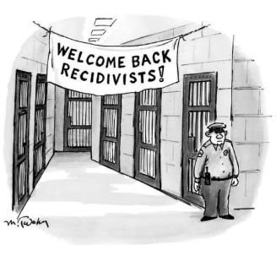
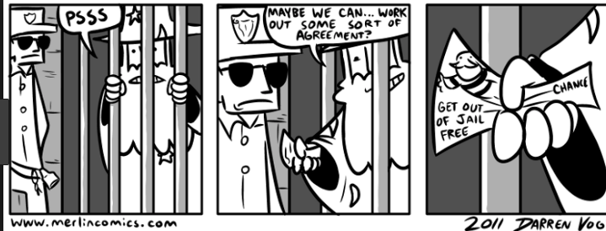

Criterion A: Knowing & Understanding
Achievement Level | Level Descriptor | Task-Specific Clarification
0 | The student does not reach a standard described by any of the descriptors below. | Add your own expectations here!
1-2 | The student:  - uses limited relevant terminology,  - demonstrates basic knowledge and understanding of content and concepts with minimal descriptions and/or examples.
3-4 | The student:  - uses some terminology accurately and appropriately,  - demonstrates adequate knowledge and understanding of content and concepts through satisfactory descriptions, explanations and examples.
5-6 | The student:  - uses a range of terminology accurately and appropriately,  - demonstrates substantial knowledge and understanding of content and concepts through accurate descriptions, explanations and examples.
7-8 | The student:  - consistently uses a wide range of terminology effectively,  - demonstrates detailed knowledge and understanding of content and concepts through thorough accurate descriptions, explanations and examples.

