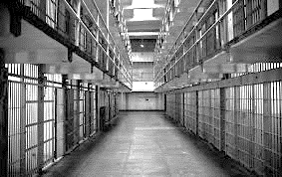
Law 12 Name

Shaping Questions:
1. What is the ideal Prison?
2. Where do certain prisons sit on the political spectrum?
3. What is the goal of a Prison?
4. Are there better alternatives than incarceration?

A. What do you think the purpose of a prison is (BEFORE UNIT)?

A. What do you think the purpose of a prison is (END OF UNIT)?

Political Spectrum (Please Label)

Justifications: Please write a justification for where you have placed each jail / prison on the political spectrum.
Use specific details/quotes/observations to justify your response.
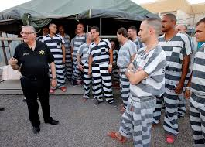
Sheriff Joe’s Maricopa County Prison:

Halden Prison (Most Humane Prison)

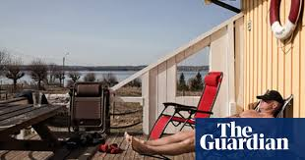
Bastoy Prison (Island)

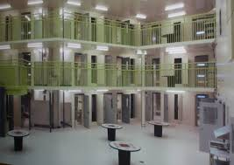
Oliver Correction Center

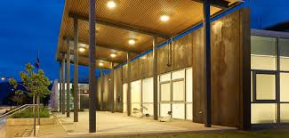
Summerland or Penticton Jail

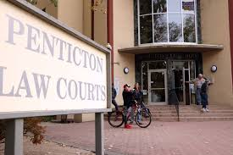

Penticton Courthouse Cellblock

