Communications 11/12 Name: ________________________
Descriptive Writing: Pizza

Assignment: Your job today is to eat a piece of pizza and then to write a 7-10 sentence descriptive paragraph about the experience you had (observing, eating or both). Try to think on a deeper level with this assignment; don’t just simply describe your pizza. Try to make connections/metaphors to the outside world and society while describing your experience. Please attach this sheet to your paragraph.

Brainstorm (Write down words, images, feelings, associations, sounds, tastes and emotions that come to your mind while observing and eating your pizza):

Name your pizza (be creative):

Simile or metaphor that describes eating/observing your Pizza

Personality (if your pizza was human, what kind of personality would it have?)

Sophisticated Vocabulary (replace at least 5 of the words you brainstormed with more sophisticated ones to use in your paragraph)

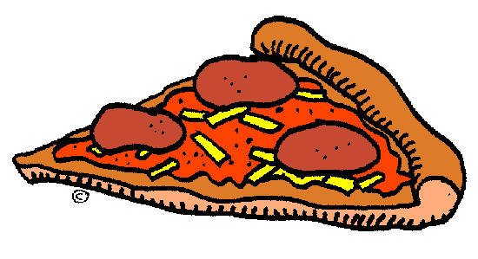

Symbol/metaphor (what larger idea does your pizza represent? Connect it to life etc.)

Sundae Paragraph (yours will be on a Pizza)

The Frozen Explosion. I had declared it. It was my attention demanding, rock filled, melting glacier. Overflowing with color, the rose-red juice of the cherry peak ran with the rivers of chocolate syrup, pooling artistically in the bottom of the bow. The smooth peanuts and werthers chucks crunch beneath my teeth, while the chilly blend of ice cream slips around my tongue, bewitching my taste buds. As I take another heart-stopping spoonful, a brain freeze strikes and numbs my mind almost painfully, revealing the cruel side of this taunting fragment of heaven. A whip cream cloud floats on top of my delightful dish. I mix it into the others ingredients, staining the pure, white cotton. Taking one more bite, I realize: This is more than a sundae, it plays twin to life it self. Soft, easy and sweet but laced with abrupt crunches and hard pieces that must be overcome in order to enjoy it. But as the revelation ends, so does my sundae, the Frozen Explosion. Staring at the last few drops in the bottom of the bowl, I wonder, would it taste the same? Will my craving be soothed?

