History 12 - Periodicals Assignment

Preamble: Researching intelligently from academic databases is a necessary skill in post-secondary education; moreover, thoughtful analysis is an important aspect of being a responsible citizen. Sources such as a google search or Wikipedia may not be peer reviewed (reviewed by academic professionals) and may not stand up to academic rigor or prove reliable. Accordingly, we will learn to research from periodicals.

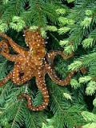
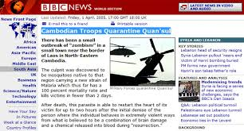

Mini-Lesson: The class will view the following sources and discuss the concept of “reliability”
1. https://www.youtube.com/watch?v=TijcoS8qHIE (House Hippo)
2. (BBC Hoax - Zombie Outbreak) .http://web.archive.org/web/20050428004220/http://65.127.124.62/south_asia/4483241.stm.htm
3. http://zapatopi.net/treeoctopus/ (Tree Octopus)

Pre-Activity: Teacher will demonstrate how to research using ebsco host on the class LCD. Please see the accompanying sheet from the librarian on how to refine a search when you search for your own article.

Skills:
A: This assignment seeks to familiarize you with the concept of proper citation, why it is important and how to do it (which varies by academic discipline.)
B. To teach you how to use a search engine like Ebscohost to find appropriate materials. Ie: How to refine a search; how to seek information/other sources via a periodical.
C. To sift through and determine which material is most current and best.
D. To determine the thesis of an article and whether it works for the argument you want to build, or help guide you towards a question.
E. Explore your curiosity on a topic.

Assignment:
(YOU WILL NEED TO FILL OUT THE ACCOMPANYING ASSIGNMENT SHEET WITH THIS INFORMATION.)

1. Practice using Ebscohost.
A. Go to the Princess Margaret Library Website. http://magglib.weebly.com or access via the school website. Then go to “Research Tools” tab select “Ebscohost (Research)” – NOT Ebscohost Magazines. AND OR: Use GALE Under “Research Tools”

2. Select a search for a topic about the cold war era (1945-1991)OR ANY topic that you are interested in. See next page for a list of topics, but you may choose something you are interested in. *Remember librarian’s tips for refining a search.

3. Find and print ONE article about the topic you’ve chosen. If you can find opposing texts/arguments, that is always good. However, this is not necessary.

4. Write a proper bibliography citation for the texts – Chicago Style.

5. Read the text and identify the thesis (argument). Highlight it and in the margins paraphrase what it is in your own words. Write the thesis of the article on the assignment sheet.

6. Find three quotes from the paper that would be useful in an essay and write them on the assignment sheet. Then, write a web of questions you would ask or a statement that you would make if you were asked to write about the quote.

7. Analyze the reliability of the text by explaining how it is reliable (why or why not). Refer to terminology and contents of “assessing reliability sheet” or the “CRAAP TEST”

8. On the last page of your article printouts, summarize the main points of the article in your own words in no more than five sentences. Copy the summary onto the assignment sheet.

Assignment Sheet: /18 Marks NAME:

1. You can choose to cite in any way you want. I would recommend “Chicago Style” since that is what Historians use. Go to: http://www.citationmachine.net However, if you are planning to go into Social Sciences, you may use APA style, if you are going into Humanities, you may use MLA style; if you are going into Sciences, you may use Turabian style.

Article Citation (1):

2. What is the thesis of your article (What is the argument it is proposing; note: not the topic). Provide a quote and then paraphrase in your own words. (3 marks 2 for thesis, 1 for quote)

Thesis:

Quote:

3. Write three quotes in the middle of the blank space below, where the Asterix is located(*). Then, ask questions, make comments or observations around it (3 marks for thoughtful responses to each quote – 9 marks).

Three Quotes:

*

*

*

4. Reliability: Assess the reliability and usefulness of the texts.
Please navigate the following page. http://www.wikihow.com/Evaluate-the-Credibility-of-a-Source OR better yet: http://campusguides.unr.edu/toolkit/evaluting-sources
Using the vocabulary in the page assess the reliability of each article. (Ie: your response should include terms like accuracy, peer review, authority, coverage, etc…) Or consult the CRAAP Test below.

Reliability of the Article 1 (3 marks):

5. Summary of the Content of your Article (5 Sentences or less) (2 marks):

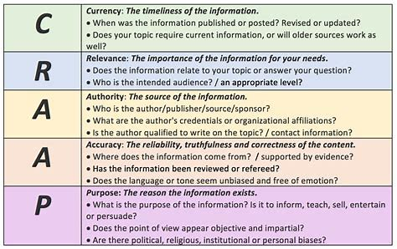
If you are having trouble picking a topic, here are some Cold War topics for research. You may choose any time period.

Truman Atomic Bomb Potsdam Yalta Hiroshima/Nagasaki Sputnik/Space Race
Gouzenko Affair Long Telegram French Indochine war Bi-Zonia (Berlin) Great Leap Forward
Berlin Wall Berlin Airlift/Blockade NATO Korean War Long March Cuban Missile Crisis Vietnam War Ho Chi Minh Pol Pot Gandhi Palestine War
Suez War Six Day War Yom Kippur War Ayatollah Khomeini Polish Solidarity
Saddam Hussein OPEC The Gulf War Chiang Kai Shek Mao Zedong Long March
Cultural Revolution Tiananmen Square Fall of Soviet Union Gorbachev Glasnost/Perestroika
Segregation Martin Luther King Malcolm X Apartheid Mandela

