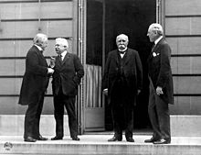
Mr. Fitton
Sounds like a Jolly good day to roast some Bratwurst if you ask me! *haughty and derisive French laugh
Paris Peace Conference Schedule
Day 1
(2-4 minutes) Woodrow Wilson welcoming address. Welcome delegations and speak about the aims of the conference.
(30 minutes) Smaller delegations to address the Conference (2-3 Mins each, MAX)
- Yugoslavia 9. Japan
- Rumania 10. Zionist/Jewish
- Bulgaria 11. Palestinian Arab
- Poland 12. Arab (Syria, Lebanon, Iraq)
- Czechs & Slovaks 13. Germany
- Austria 14. Turkey
- Hungary 15. USA
- Austria 16. Britain
17. France
(30 minutes) Separate Negotiation Meetings – what to do with Germany & Its Allies – See booklet with all of the options as well as the “Cost of War” sheet.
-war costs and reparations
-map of Europe and colonies
-War Guilt and prevention/military strength
Day 2
(2-4 minutes) Clemenceau welcomes people back for day two – shares hope and goals based on day 1.
(10 minutes) USA, Britain, and France meet separately to discuss specific goals and intentions. Smaller countries convene to list their goals.
(10 minutes) Separate negotiation meetings with a representative from Britain, France, and the USA to hammer out deals on the separate categories. Ie: A member of USA/BR/FR will come to your tables to listen to what you want.
(10 minutes) USA, Britain, and France meet separately once again to discuss final positions and arguments based on all they have learned and what they will decide.
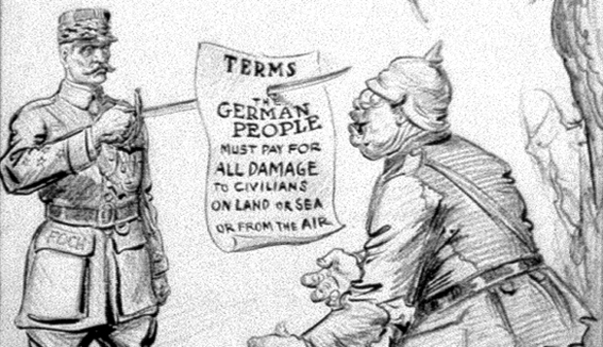
(20 minutes) Conference to hold a negotiation between the Big Three (France, Britain, USA) to reach an agreement on terms of the Treaty in front of everyone. Chief negotiators must speak at this time. Each of the major topics will be covered in order (listed below)
- War Costs & Reparations
- Who should pay for war damages?
- How much should be paid?
- Should all French financial claims be met?

- Map of Europe & Colonies
- What should be done with the Austro-Hungarian Empire?
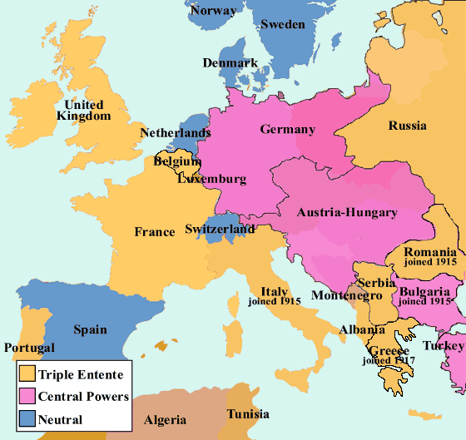
- Austria
- Hungary
- Czechs
- Sudetenland
- Slovaks
- Poland
- Italian Expansion?
- Romanian Expansion?
- Bulgarian Expansion?
- Yugoslavia
- Serbs
- Croats
- Slovenes
- What should be done about the German territory in Europe, as well as the question of the Treaty of Brest-Litovsk between Russia and Germany?
- Poland? Polish Corridor? Land returned to Russia?
- Alsace Lorraine, Rhineland, Saar
- What should be done about the former Ottoman Empire?
- Arabs lands – Syria, Jordan, Iran, Iraq, Saudi Arabia, Lebanon, Palestine
- What about the Jewish Zionism question? Palestine? Israel? Both? (Balfour Declaration vs. McMahon Letters)
- Africa – What should be done about German territory – German West Africa, German East Africa
- Asia – What should be done about Shandong (former German land)

3. War Guilt and Prevention/Military Strength
a. Who caused the war?
b. Should the League of Nations be created?
c. What should the rules of the League be (HOW will war be prevented?)
d. Disarmament – How large should armed forces be, and should all countries be subjected to the same rules?

(2 minutes) Lloyd George – summary of conference. Thank all delegates and explain what his thoughts, feelings and hopes for the future are.

Smaller Delegations:
Here are some things to consider covering during your two minutes:
1. Describe the people that you present:
A. Where do they live (USE A MAP)
B. Language
C. History
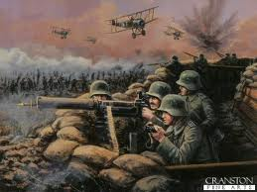
2. What did you do during WW1?
A. Did your people fight? If so, for who?
B. Were any promises made to you during the war?

3. How were your people impacted by WW1.
A. Damage? Deaths?
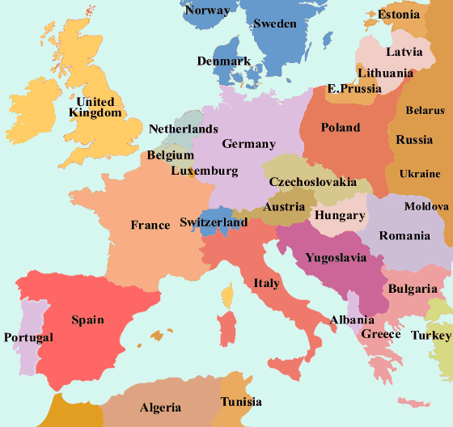
4. What do you want as an outcome from the Paris Peace Conference? Use a map to show the conference delegates if you want territory.
A. Territory
B. Financial Compensation?
C. Special Considerations

5. Which of the three major powers, if any, support your cause?
A. Do any of Wilson’s 14 Points Generally apply to you? (Ie: Self Determination)
B. Do any of Wilson’s 14 points Specifically apply to you? (Ie: Poland)
C. Has Britain stated support for your cause?
D. Could France’s desire for revenge on Germany Benefit you.

COUNTRY SIGN UP SHEET:
Please choose a country below that you wish to represent in the Paris Peace Conference being undertaken by our class. Please note that some countries only have two people and some have three.
Remember, if you are Hungary, you may want Turkey.

Yugoslavia (2) _________________ __________________
Rumania (2) _________________ __________________
Bulgaria (2) _________________ __________________
Poland (2) _________________ __________________
Czechs & Slovaks (2) _________________ __________________
Austria(2) _________________ __________________
Hungary (2) _________________ __________________
Japan (2) _________________ __________________
Zionist/Jewish (2) _________________ __________________
Palestinian Arab (2) _________________ __________________
Arab (Syria, Lebanon, Iraq) (2) _________________ __________________
Germany (2) _________________ __________________
Turkey (2) _________________ __________________
USA (3) _________________ __________________
Britain (3) _________________ __________________
France (3) _________________ __________________

