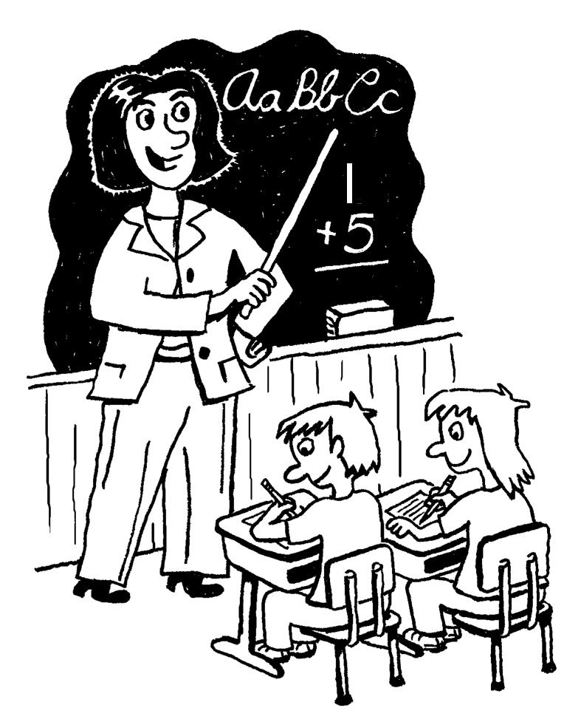 Five-in-One

Name:

Date:

Assignment
A Five in One requires you to combine several skills on one page. Students must demonstrate ability to: recall facts, think critically and display artistic effort.

After viewing a film, think of the main idea or moral of the story. This is the theme. To begin, write down the theme on a piece of blank white paper. You may write it anywhere you choose. Second, write out a quotation or describe an event from the story that relates to the theme you’ve selected. Third, draw an image that relates to the main idea/theme. Fourth, think of an original title (it cannot be the title of the movie). Fifth, write a 50 word explanation describing how your Five in One connects (how does the quote/event connect with theme (main idea)? How does the title connect with theme? How does your image connect with theme?). Et Voila done!

Element | Not Yet Within Expectations (0-1) | Minimally Meets Expectations (2) | Fully Meets Expectations (3) | Exceeds Expectations (4)
Theme Statement / moral of the story | Missing or not a theme of that movie | Not a proper theme statement, stated as one word (ie Love) | Almost a proper theme statement (full sentence,, includes title of the movie) | Proper theme statement. Interesting and thoughtful theme. Includes title of the story
Quote / Description of an event | Missing or does not back up your theme | Sort of backs up theme. | Fully backs up theme, | Fully backs up theme and is thoughtful.
Title | Missing | Unimaginative or does not reflect theme; is same as the movie. | Good title, reflects theme. | Creative and well thought out, supports theme.
Image | Missing | There, but no clear effort put into it. Looks like it took seconds | Good image. Appropriate for your theme. | Excellent image. Creative and appropriate for theme
Explanation | Missing or only one or two words | Explains some choices, but missing 2 or more | Explains most choices, but missing one | Fully explains all of your choices (theme, quote, title, image)
Layout/Overall/  Conventions | Messy and/or unreadable. More than four mistakes in spelling or grammar. Layout is not balanced (everything crammed into one section). | Parts are messy or unreadable. Three or four mistakes in grammar and spelling. Layout not balanced. (everything crammed into one section). | Looks professional. One or two mistakes in grammar or spelling. Layout is balanced | Looks professional. Justification has proper grammar and spelling. Layout is balanced

Total: /24
Comments from the teacher:

Step-by-Step Instructions (check off as you complete the assignment)

Note: You may choose to use this paper for your draft work. Blank spaces below are if you want to write down your thoughts before putting them to paper. Make sure you have all elements of the 5-in-1

1. Chose a theme and write it somewhere on a piece of blank paper. Make sure it is a proper theme/moral of the story statement (The theme of ______________________(title) by __________________________ (author) is that ________________________________________.

Ie: The theme of “A Child Called It” by David Pelzer is that no matter how dire the circumstance, never give up. (There are many themes in any movie/book/short story)

2. Choose a quote or describe a specific event that backs up that theme and write it somewhere on the piece of paper. “I vowed that day to never let mother win” (Pelzer, 96)

3. Chose an image to draw that you think represents the theme and quote. Draw it somewhere on the page. Ie: You could draw David in his POW pose, but thinking of sunshine, or David at the shopping center, disobeying his mother; you can also get more symbolic if you want.

4. Create a title for your five-in-one. ___________ Instead of it being the title of the story, choose something that you think represents your theme, image and quote. “Moral Victory Against All Odds.”

5. Explanation: In a 50 word paragraph: First explain how you know that your theme is a theme in the story, then, explain how your quote, image and title all serve to represent that theme. Use specific examples from the movie/novel/short story/short film to back up your justification

6. Colour/shade your five and one and make sure your white space is used effectively.

