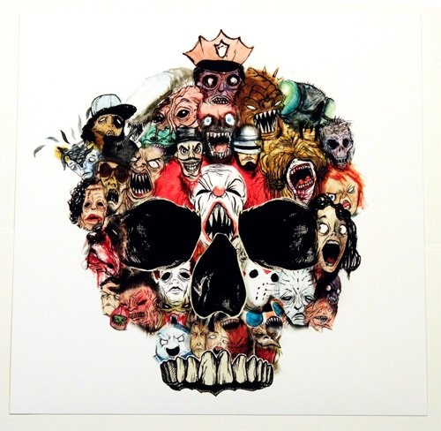
English 11 Name:
Monsters: Real and Imagined
Our unit has focussed on identifying monsters, debating plausibility and investigating which social fears they represent. As well, we’ve delved into why as a society we are fascinated by them. We have examined the following:
Factual— (What) - What types of monsters exist? What is the purpose of biological responses to fear? What are responses to fear?
Conceptual— (How or Why?) – Why do societies create monsters? Why do people like horror films?
Debatable— (Is, Should, Could, Does) – Monsters are necessary for society; People need monsters; the horror Genre is a necessary Genre for catharsis

Your mission: Examine the GRASP below and formulate your authentic task (real-world product) as the final assessment piece for this unit.

Goal: Your goal is to demonstrate how Character and Genre impact perspective and social constructions of reality.
Role: You are a psychologist who specializes in the concept of Monsters / Fear
Audience: A film producer or a TV/Live/Podcast/Radio Audience
Situation: You are a world famous psychologist hired by a film company to help them create a monster that represents/serves as a symbol/metaphor a societal fear or issue prevalent in society.
Product: You may create the monster using any medium you want; or you May create a theatrical trailer/short film/script/score/comic-storyboard to submit to the Producer or a focus group audience.
Standards: Criterion C – Producing Text; OR Criterion A – Analysing Text

Differentiation for Learning Styles.

Speaker: Set up a campfire and orally tell a few ghost stories to the class using powerful oratory techniques. Or do podcast/radio broadcast where people call in and tell ghost stories, or you tell them.

Writer: Write a story about a monster and provide an analysis of which fear it represents.

Creator: Make a film, poem, or art piece that involves monsters; analyze your work. Create an official “A&E Mini Biography” of a Monster (Real, Mythological, Hollywood, From Another Culture).

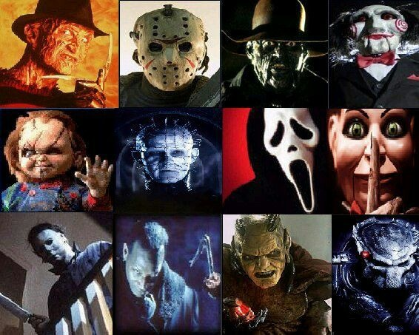
Analyzer: Learn how to write a film critique and view a monster film, then write a critique; post it online. Could also be done as a youtube video. (Criterion A Rubric)

Kinesthetic: Act out a famous horror scene; create your own; film it.

The task of creating a video/storyboard/trailer/script relates to the statement of Inquiry that “Character and Genre impact perspective and social constructions of reality.” It does because students will be able to fully understand the horror genre and how characters in the Genre often represent societal fears or anxieties. Students will be so adept at identifying and analyzing how Horror is created through atmosphere, lighting, sound, score, suspense and characterization that they will be able to proficiently create their own horror.

Level | Level Descriptor | Task-Specific Clarification
0 | The student does not reach a standard described by any of the descriptors below. | Add your own expectations here!
1-2 | The student produces texts that:  - demonstrate limited personal engagement with the creative process; demonstrates a limited degree of insight, imagination or sensitivity and minimal exploration of and critical reflection on new perspectives and ideas,  - makes minimal stylistic choices in terms of linguistic, literary and visual devices, demonstrating limited awareness of impact on an audience,  - selects few relevant details and examples to develop ideas.
3-4 | The student produces texts that:  - demonstrate adequate personal engagement with the creative process; demonstrates some insight, imagination or sensitivity and some exploration of and critical reflection on new perspectives and ideas,  - makes some stylistic choices in terms of linguistic, literary and visual devices, demonstrating adequate awareness of impact on an audience,  - selects some relevant details and examples to develop ideas.
5-6 | The student produces texts that:  - demonstrate considerable personal engagement with the creative process; demonstrates considerable insight, imagination or sensitivity and substantial exploration of and critical reflection on new perspectives and ideas,  - makes thoughtful stylistic choices in terms of linguistic, literary and visual devices, demonstrating good awareness of impact on an audience,  - selects sufficient relevant details and examples to develop ideas.
7-8 | The student produces texts that:  - demonstrate a high degree of personal engagement with the creative process; demonstrates a high degree of insight, imagination or sensitivity and perceptive exploration of and critical reflection on new perspectives and ideas,  - makes perceptive stylistic choices in terms of linguistic, literary and visual devices, demonstrating good awareness of impact on an audience,  - selects extensive relevant details and examples to develop ideas with precision.
Criterion C: Producing Text

Criterion A: Analysing
Level | Level Descriptor | Task-Specific Clarification
0 | The student does not reach a standard described by any of the descriptors below. | Add your own expectations here!
1-2 | The student:  - provides limited analysis of the content, context, language, structure, technique and style of text(s) and the relationship among texts,  - provides limited analysis of the effects of the creator’s choices on an audience,  - rarely justifies opinions and ideas with examples or explanations; uses little or no terminology,  - evaluates few similarities and differences by making minimal connections in features across and within genres and texts.
3-4 | The student:  - provides adequate analysis of the content, context, language, structure, technique and style of text(s) and the relationship among texts,  - provides adequate analysis of the effects of the creator’s choices on an audience,  - justifies opinions and ideas with some examples and explanations, though this may not be consistent; uses some terminology,  - evaluates some similarities and differences by making adequate connections in features across and within genres and texts.
5-6 | The student:  - competently analyses the content, context, language, structure, technique, style of text(s) and the relationship among texts,  - competently analyses the effects of the creator’s choices on an audience,  - sufficiently justifies opinions and ideas with examples and explanations; uses accurate terminology,  - evaluates similarities and differences by making substantial connections in features across and within genres and texts.
7-8 | The student:  - provides perceptive analysis of the content, context, language, structure, technique, style of text(s) and the relationship among texts,  - perceptively analyses the effects of the creator’s choices on an audience,  - gives detailed justification of opinions and ideas with a range of examples, and thorough explanations; uses accurate terminology,  - perceptively compares and contrasts by making extensive connections in features across and within genres and texts.

