The Palace of Versailles
- Versailles was the royal residence of France for a little more than a century--from 1682 until 1789, when the French Revolution began.
- Louis XIII built a hunting lodge at the village outside Paris in 1624. This small structure became the base on which was constructed one of the most costly and extravagant buildings in the world.
- It became home for Louis XIV, the Sun King
- About 37,000 acres of land were cleared to make room for tree-lined terraces and walks and thousands of flowering plants.
There were 1,400 fountains and 400 pieces of new sculpture.

Louis as a child
Louis got along well with his brother Philippe. Philippe grew up bisexual with a partiality for handsome young men and for dressing like a girl.

Louis loved playing war games, drilling older children of the court, march around the grounds beating on his drum

he inherited the throne at the age of 4 years and 8 months after his father, King Louis XIII died of tuberculosis

Louis XIV almost died of smallpox at the age of 9, but he recovered despite the doctors’ bloodletting

he attended his coronation at the age of 15

rumour has it that his mother, Anne, selected one of her own ladies of the bedchamber, a 40 year old widow, Madame de Veauvais, to “deflower” her son.

Louis love life

Louis sexual appetite would become one of his characteristic traits. He had many mistresses (official and unofficial) – Madame de Vallieres, Madame de Montespan, and would spend a daily hour in their boudoir along with 2-3 conjugal visits with his wife. At the age of 70, his 2nd wife complained to her doctor that “twice a day is a bit excessive, isn’t it?” Not surprisingly, the King suffered from gonorrhea at a young age.

Philippe’s first wife was Queen Henrietta Anne, sister of Charles II of England. Her marriage was a disaster as her homosexual husband had little interest in her. Rumours began to circulate that she may have had a love affair with Louis XIV

Louis married the Spanish Infanta Marie Therese. This alliance would give him a claim to the Spanish throne.

a strange “ménage a quatre” developed at court. Montespan dyed her hair blonde to match the Queen’s and Valliere’s. The Queen adopted Montespan’s hairstyle as she realized Louis admired it. Valliere dressed and curled Montespan’s hair. The 3 women went everywhere all vying for the King’s attention. This lasted for 6 years!

poisonings seemed to be common at court, if not just suspected. Philippe’s wife was suddenly struck down with stomach cramps. Her brother Charles II refused to believe she died of natural causes.

Philippe was compelled to marry again. He chose Princess Elisabeth-Charlotte of Bavaria.

despite being homosexual, Philippe managed to have 2 wives, an official mistress and several legitimate children. Every Roman Catholic royal family has Philippe d’Orleans among its ancestors! He was aptly remembered as the Grandfather of Europe.

another poisoning was suspected when a new young mistress of Louis’ dropped dead. Madame de Montespan was suspected.

rumours began to circulate that Montespan was practicing strange rituals involving aphrodisiacs, abortions and the sacrifice of babies.

Louis’ political life

Although the Edict of Nantes had ensured Protestant Huguenots freedom of worship, Cardinal Richelieu forced them to accept the Peace of Alais which gave them no political independence. Many of them would leave the country

Jules Mazarin acted as Louis’ Prime Minister until Mazarin died. At this point Louis decided to rule alone, breaking tradition. The famous phrase “l’etat c’est moi” likely wasn’t actually said by Louis, rather an expression that portrayed the way he dealt with the state

several “frondes” (literally “a sling” to fling missiles and stones at the rich carriages) erupted during his reign as discontent over taxes arose. 2 in particular were waged by the Parlements and the nobility

SS9 Name: _____________________
The French Revolution

Louis XVI and Marie Antoinette

Task: Read pages 64, 66 and 67 in Crossroad and make a list of reasons why Louis and Marie were unsuitable to govern France in 1774.

Louis | Marie
Louis  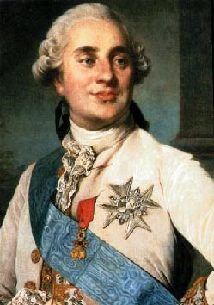  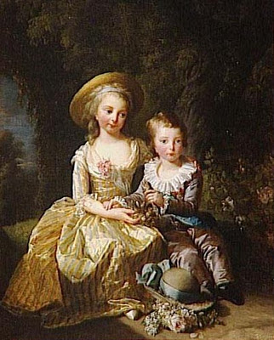 | 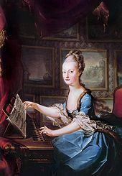  Their Children  Marie

