Mr. Fitton The History of LAW Group:
Law 12

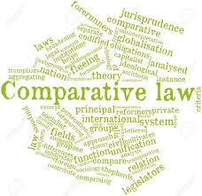
Preamble: Throughout the world, regardless of culture, religion or geographic location, societies large and small develop laws. Interestingly, many societies, without ever communicating, come up with similar laws and punishments. We will examine societies throughout history and their approach to regulating human behavior.

Groups: Please choose partners. Groups of 3.

Goal: To determine the roots of our legal system and to draw conclusions about the society where the laws were created.
Role: You’ve been hired to teach very basic legal history to new Canadians for their citizenship test.

Audience: Immigrants to Canada who want to learn about law History.

Situation: You are at a night class for prospective immigrants who need to know the basics of Canadian legal influences to be citizens.

Product: A simple and easy to understand, but aesthetically pleasing poster, lesson, short video, or presentation.

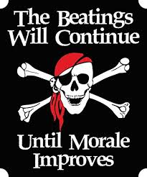
Standard: Criterion A – Knowing and Understanding
​Additional Criteria:
A. Title
B. Picture/Aesthetics
C. Include necessary detailed points about the type of law
D. The "BIG IDEA" in a conclusion
The class will then take all of the finished work and put them on a board and use chalk to draw lines of linkage between laws. Each group will present and then post on chalkboard.
OPTIONS:
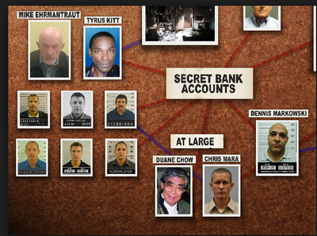
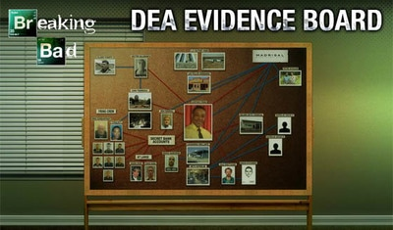
First Nations (P. 33 -34)
Hammurabi (P. 21-22)
Mosaic Law (P. 23-24)
Greek Law (P. 24-25)
Roman Law (P. 26)
Justinian Code (P.27)
Napoleonic Law (P.27)

Knowing & Understanding Key Legal Concepts
Achievement Level | Level Descriptor | Task-Specific Clarification
0  Incomplete | The student does not reach a standard described by any of the descriptors below. | Incomplete, missing many key elements or not submitted.
1-2  Emerging | The student:  - uses limited relevant terminology,  - demonstrates basic knowledge and understanding of content and concepts with minimal descriptions and/or examples. | -Attempts to document sources with APA. Overall, incorrectly.  -Has a title and visuals (little effort)  -Has a conclusion but may lack insight or unable to note big idea.
3-4  Developing | The student:  - uses some terminology accurately and appropriately,  - demonstrates adequate knowledge and understanding of content and concepts through satisfactory descriptions, explanations and examples. | -Documents sources of information using a recognized convention (APA format) With many errors  -Has a title and visuals  -Has a conclusion that recognizes there is a big idea. Not much detail.
5-6  Proficient | The student:  - uses a range of terminology accurately and appropriately,  - demonstrates substantial knowledge and understanding of content and concepts through accurate descriptions, explanations and examples. | -Documents sources of information using a recognized convention (APA format) With errors  -Has a title, visuals that are well chosen  -Has a conclusion that shows big idea
7-8  Proficient and Extending | The student:  - consistently uses a wide range of terminology effectively,  - demonstrates detailed knowledge and understanding of content and concepts through thorough accurate descriptions, explanations and examples. | -Consistently documents sources of information using a recognized convention (APA format bibliography of sources)  -Has a title, visuals that are aesthetically well chosen  -Has an insightful conclusion
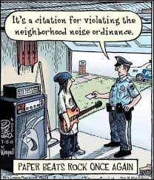
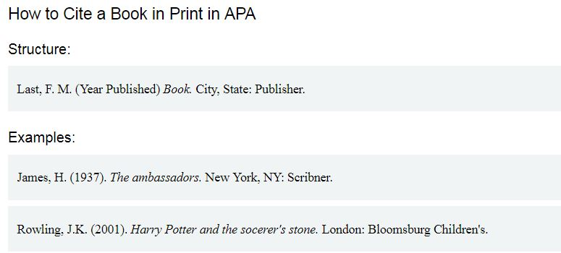

Three to Seven Authors
List by last names and initials; commas separate author names, while the last author name is preceded again by ampersand.

Kernis, M. H., Cornell, D. P., Sun, C. R., Berry, A., Harlow, T., & Bach, J. S. (1993). There's more to self-esteem than whether it is high or low: The importance of stability of self-esteem. Journal of Personality and Social Psychology, 65, 1190-1204.

