Law- Prison Unit
Vocab project
By: Krystal B.
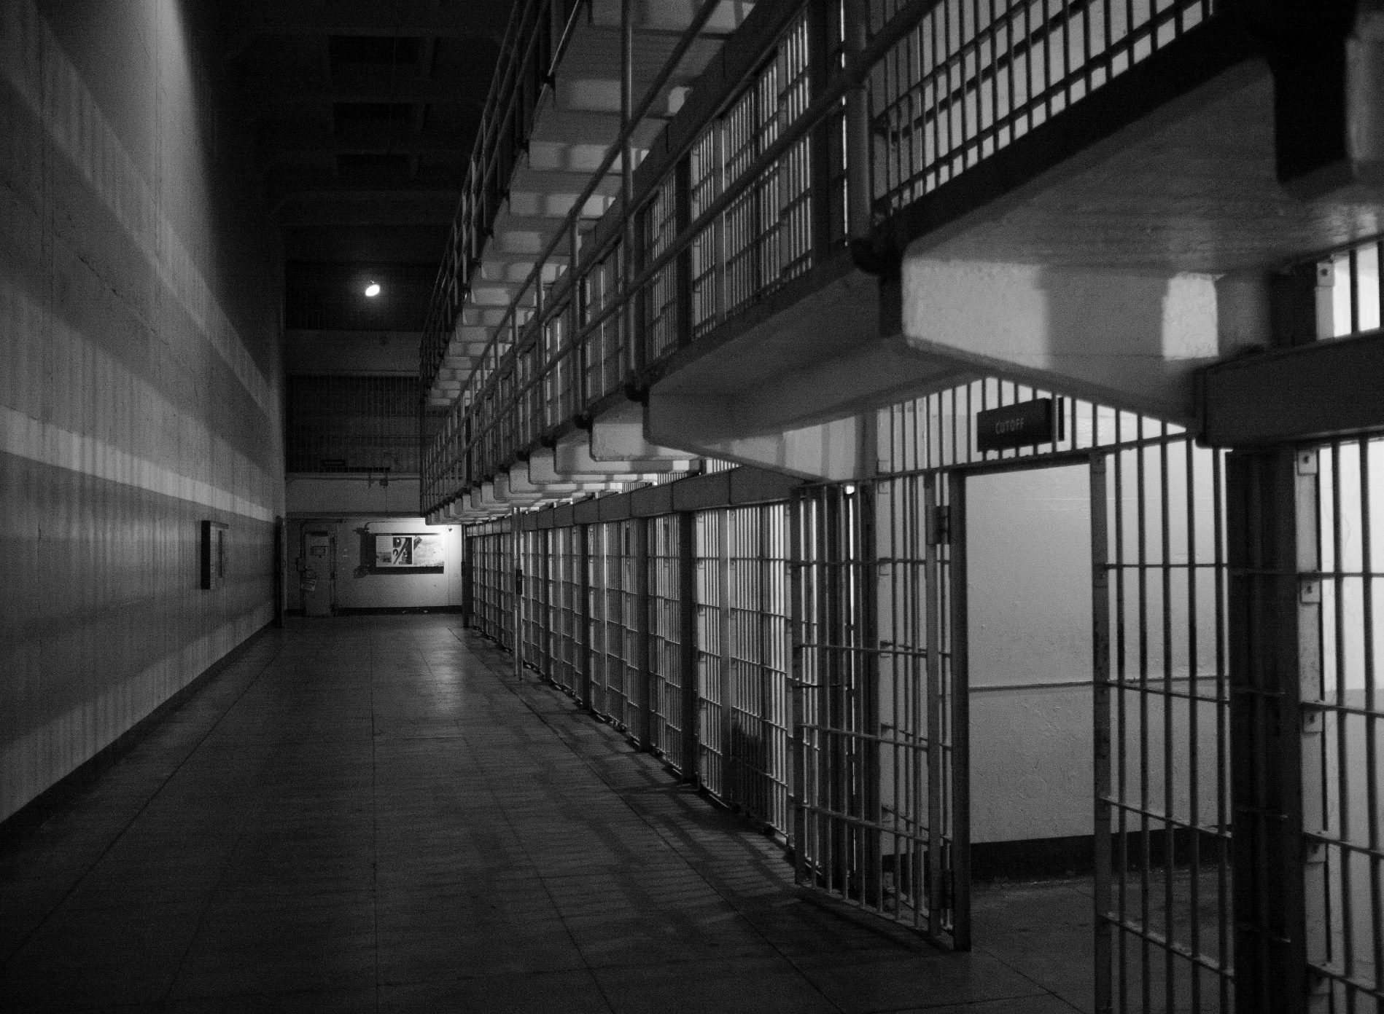

Recent Crimes- 15 Stories
This Photo by Unknown Author is licensed under CC BY-SA-NC
Story #1 -Sentence |  |  | Story #2-Recidivism  The local thief, Erik Thompson was spotted stealing jewelry from a small boutique downtown after spending five years in prison. Thompson was sentenced for five years in prison after breaking and entering and has now gone back to his old ways only a week later after stealing $500 worth of jewelry.  -Recidivism means returning to a crime after release from prison. In this example, Erik returned to crime after being released for only a week. |  |  | This past year has been great for helping inmates discover life with balance and knowledge. Natasha Humphrey newly released has found herself starting afresh with her new job. “I was helped a great amount while serving my sentence. I learned what it is like to have a solid routine and am now able to support myself in a healthy way, and for that, I am truly grateful”, Natasha reports.  -Rehabilitation prepares a prisoner for a productive life by providing them the chance to gain skills while spending time serving their sentence in jail.  Story #3-Rehabilitation
Last night the local grocery shop was robbed leaving the customers confused and overwhelmed. After the police had discovered the robber was John Evans, he then received a sentence of imprisonment for less than two years. This decision was based on the severity of the crime.  -A sentence is the punishment imposed on a person convicted of committing a crime. In this case, Johns sentence was spending two years in prison. |  |  |  | After a long trial, it has been decided that murderer, Thomas Bart will face a life sentence for his crime. After the murder, the entire community felt a great loss and a large amount of people feeling unsafe. This decision has been controversial but has left many people feeling assured and safer within the community.  -Retribution ensures that there is a punishment to avenge a crime, in this case, the offender suffers the consequences of his actions.  Story #5-Retributon | After two teens were assaulted with a weapon last week, this case was brought up in court. However, the family of the offender claimed that he was not mentally stable during the time of this crime. A psychiatric assessment was then completed to reveal the mental history of the offender to back his case.  -A psychiatric assessment is a report that describes the mental history of the offender.
The destruction of the local playground has left many parents and children confused and upset along with the rest of the community. However, the vandalizer was found at 8:38 this morning. It was decided that this young man would have to pay for the destroyed property in order to make up for the damage caused by his actions. The playground will soon be restored to its normal state in the months to come.
-Restitution is a punishment that includes making up for the damage or loss the victim might have suffered by paying the amount to fix or solve the damage.
Story #4- Restitution

Story #6-Psychiatric Assessment

Story #15

Story #13

Story #14

Story #12

Story #11

Story #10

Story #9-Probation

Story #8- Mitigating Factors

Story #7-Victim Impact Statement

After one of our local banks was robbed of $5000, the owners were hoping for a severe punishment. However, it was recently found out that the robber was a twelve-year-old boy. Due to this mitigating factor, the consequences were significantly less than if the robber were a grown man over the age of 18. Instead of serving time in prison, the young boy will have to spend a large amount of his time in community service.
-A mitigating factor is a circumstance that may lessen the severity of the case. In this case, the offender was very young, and a more suitable punishment was decided on.
In the past couple of months, there have been a few cases of people on probation. This has been a great option for majority of the offenders however, last Thursday at 11:35pm, thirty-year old Jake Ryan was spotted drinking and had possession of drugs. This went against the certain conditions that he had to follow. Now, he will be serving his sentence in prison as a result of misusing this advantage.
-Probation is when an offender can remain in the community but is closely watched and under the supervision of a probation officer.
The two victims mentioned in the previous story were severely injured and the family of the victims were furious. After the event, the victims along with their families completed a victim impact statement. This mentioned which weapons were used, the damage it caused and the severity of their injuries.
-A victim impact statement is a statement prepared by the victim or the victims family describing the harm done or the loss suffered as a result of the offence.

Story #10-Suspended Sentence

Story #12-Suspension of Privilege

Story #11-Intermittent Sentence

After trespassing several times, it was decided that Tiana May would be placed on a period of probation. Although she has not directly caused anyone harm, she is constantly violating others by not respecting their property. She will now have to follow certain conditions such as not leaving her house after nine and so on.
-A suspended sentence is a judgement carried out provided that certain requirements are met.
After many accounts of reckless driving, numerous different people have now reported a suspension of privilege. After receiving one too many tickets, you too may have your licence suspended like many others. Drive safely.
-A suspension of privilege is a sentence that withholds a privilege for a certain amount of time.
There have been a couple more intermittent sentences in the past yar. An intermittent sentence allows one to serve their sentence on weekends and at night. George Richards, recently receiving an intermittent Sentence claims to be extremely grateful. “After committing a break and enter, I felt as if my life was over. I figured I would lose my job, lose my wife and lose my kids. However, after receiving an intermittent sentence, I was able to continue to support my family while still making up for my mistakes. For this, I am extremely grateful.”

Story #15-Pardon

Story #13-Incarceration

James Young is a twenty-five-year-old man who was wrongfully convicted of murder. The record of this crime will no longer exist under Youngs ‘name as he has not committed the crime. The record of conviction will be erased, and James Young will now be free and around the community as he has the right to freedom.
-Pardon is the setting aside of a persons’ record of conviction.
After Jake Ryan committed a crime during probation, it was decided that he would be incarcerated for 5 years. He will be serving his sentence in jail this time and will be away from the rest of society/ the community.
-Incarceration is imprisonment for a specified period.

Story #14-Parole

If you look around, you will see that there are quite a few of inmates on parole around the community. This is no reason to worry because an inmate is only granted parole if they cause no trouble, listen and follow rules within the prison first.
-Parole is the release of an inmate on a promise of good behavior, into the community before the full sentence is served.

