Law 12
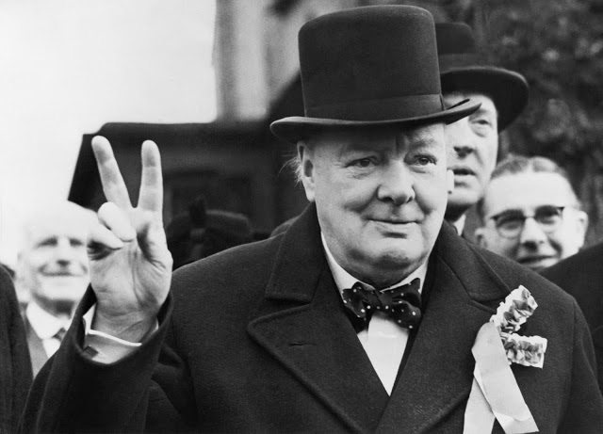
Introduction: Citizens should know their legal rights and responsibilities. Knowledge of the law is presupposed in our legal system, as illustrated by the maxim, “ignorance of the law is no excuse.” Students are more likely to become active, informed, and productive citizens, and are better equipped to participate effectively in a democratic society through their knowledge of law. Law 12 will provide the student with the opportunity to study and learn the Canadian legal system. It fosters skills and attitudes that enhance students’ abilities to address legal, social, and ethical issues, and reflect critically about the law.
Skills and Processes. Students will develop the ability to:
* Identify, interpret, and evaluate principles of Canadian Law
* Analyze issues – develop and defend legal positions using the Canadian Constitution and the Criminal Code of Canada
* Research from appropriate sources. * Use technology to enhance learning
* Assess the reliability of evidence * Express appropriate responses to issues.
* Present – use oral presentations and visual media to communicate in a group setting
“Those who do not remember the past are condemned to repeat it.” ~ G. Santayana

Learning Outcomes (Students will be able to: )
*Demonstrate an ability to analyze criminal cases and evidence; Assess reliability.

*Demonstrate the ability to research from print and online resources.

*Develop an ability to understand the law and its significance with cause and effect relationships.

*Develop and present logical arguments stemming from a basis of learned facts.

*Evaluate the significance of economic, social, political, military, cultural & geographic influences on law.

Assessment and Evaluation
-Conducted on an ongoing basis; with chances to improve work after it has been graded
-Criterion referenced (students know in advance how they will be marked)
-Tests, Quizzes, Projects, Analysis of Material, Essays, Seminars, Mock Trial Simulations.

Mark Breakdown
Assignments/Simulations = 70% Tests = 30%

Materials – Bring to EVERY class: Binder with dividers; Paper; Pencil/ Pen
Suggestions - Label Dividers: *Handouts *Notes *Assignments

Attendance: Regular attendance is the most important predictor of success in this course. Arrive on time and prepared. Chronic lates will result in a conference with the teacher, meeting with admin, phone calls home and face-to-face meetings with parents. Anything for your success!

Law 12 Commitment: Essential keys to success in Law 12 are 1) developing good study habits; 2) Developing your own reading and note-taking skills; 3) completion of assignments based upon readings; 4) practice of written questions and essay development; 5) preparation for seminar discussions and student-led presentations; and 6) continual review of content. Indeed, a thorough commitment to the course is needed; however, the fascinating content and knowledge make the obligation is worth it!

Course Content – The Big Ideas
#2

Laws can maintain the status quo and can also be a force for change
“Be the change you want to see in the world”
#1

Understanding legal rights and responsibilities allows citizens to participate more fully in society

#4
Laws are interpreted and these interpretations may evolve over time as a society’s values and worldviews change

#3

A society’s laws and legal framework affects many aspects of people’s daily lives

Course Content – Options for Investigation

Throughout the course we will spend time examining legal issues, looking at Law in the news and discussing a variety of legal questions as they arise in class. Expect guest speakers, field trips and hands-on experiences!

History of Law (P. 10-153): In this background unit we will test your observation skills, solve a crime and learn where laws come from – get ready for a hands on surprise!

Constitutional Law/Charter of Rights and Freedoms: (P. 10-153):“I have Rights” – well get ready to learn them in detail; We’ll learn when police can search your bag, and what responsibilities/rights you have under the law. You get to make a film or creative project where you take away peoples rights! Get ready for pepper spray!

Crime Scene Investigation: Wear your hazmat suit, because there’ll be bloody splatter crime scene in this unit; we’ll examine decomposing bodies (through film) and learn how maggots make great detectives. #psychokiller

The Prison System: We will visit two prisons in this unit and learn about what it’s like to be incarcerated – one guest speaker will argue that we need to abolish the prison system; we’ll examine one prison where inmates eat chef-prepared food and sun tan on a tropical island! In another, they dance to Michael Jackson Music – cruel and unusual punishment or rehabilitation? We will also see the worst prison in the world! (And its not our class)

Policing/Corruption/Body Cameras: It’s tough being the Police; you’ll get to wear the uniform and do some scenarios. Cuff your classmates; do actual police drills; tackle that cutie you’ve always wanted to ask on a date!

Criminal Law: (P.157-378) Want to know how to prosecute a criminal and run a trial from crime all the way to punishment? You’re in for a hands-on journey through the court system! Will you be the Criminal? The CSI Investigator? Judge? The Jury? Or the Executioner? Get ready for a trip to the courthouse!

Famous Criminals: Want to investigate a psychopath? You’re no longer a student, you are deputized as a CSIS agent in charge of creating an intelligence dossier on a famous criminal! A student once chose a family member!

Family Law: (P. 468-518) A hands on unit where a young couple meets, falls in love, has kids and divorces! Then they die! The circle of life in one unit! We plan a real wedding in class. Hands on -- you betcha! Right down to the catering. Invite your crazy uncle to the wedding to make it official!

Law Through Film Students will have the chance to overview all of the concepts of Law 12 through “Making a Murder” a Netflix original series. Throughout the course, we may examine a series of Hollywood titles as ways to reinforce learning. Possible options include “A Few Good Men,” “Erin Brockovich,” “End of Watch,” “L.A. Confidential,” “Law and Order” – I’m also open to your suggestions!

