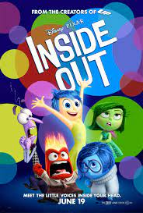
Inside Out: 4-Corners Debate Activity

Looking for a vibrant activity that involves movement, discussion and controversy? Try a 4-Corners debate/discussion with your class!

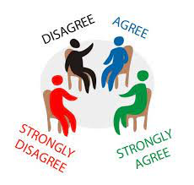
Low Prep – Set up four corners with Strongly Agree (SA); Agree (A); Disagree (D) or Strongly Disagree (SD).; read the controversial statements below and have students stand where their beliefs lay. Have students justify and debate.

Medium Prep – Have students fill out the sheet below prior to the debate; then conduct the four-corners debate by reading each statement and having kids debate/discuss standing in their corner.

High Prep – Have students read the handout, write out their initial thoughts; read an article/do some online research about each issue/statement, then engage in the debate above while standing where their beliefs lay.

The prompt statements below represent issues relating to “Inside Out.” Read the statements in the column on the left and select whether you Strongly Agree (SA); Agree (A); Disagree (D) or Strongly Disagree (SD). Justify your statement and prepare to hear from others.

When the teacher reads out each statement, stand in the corner of the room that corresponds to your beliefs. Often the teacher will have whiteboards or paper with Strongly Agree, Agree, Disagree or Strongly Disagree in each corner. Debate and defend your views.

*If someone makes a point that encourages you to rethink your position, feel free to move to a new location*.

Statement Your Opinion
1. Emotions Control Our Decisions More Than Logic: This statement explores the balance between emotional and rational decision-making, a key theme in "Inside Out." | SA A D SD (Circle)  Explain:
2. It's Essential to Express Sadness to Maintain Mental Health: This statement can lead to discussions about the importance of acknowledging and expressing emotions, as shown through the character of Sadness in the film. | SA A D SD (Circle)  Explain:
3. Suppressing Negative Emotions is Beneficial for Overall Happiness: This can spark debate about the consequences of ignoring or suppressing feelings like sadness or anger, as seen in the movie. | SA A D SD (Circle)  Explain:
4. All Emotions, Positive or Negative, are Equally Important in Shaping Who We Are: This statement reflects the film's message about the value of a wide range of emotions in personal development. | SA A D SD (Circle)  Explain:

Statement Your Opinion
5. Parents Should Shield Their Children from Negative Emotions to Promote a Happier Childhood: This prompts discussion about the role of parents in emotional development and whether protecting children from negative emotions is beneficial or harmful. | SA A D SD (Circle)  Explain:
6. Personality is Largely Influenced by Innate Emotions Rather Than Life Experiences: This statement invites debate on the nature vs. nurture theme and how it relates to emotional development and personality formation. | SA A D SD (Circle)  Explain:
7. It's Unhealthy to Have One Dominant Emotion That Controls Us: This can lead to discussions about the importance of emotional balance and the risks of being dominated by a single emotion, as seen in the characters of the film. | SA A D SD (Circle)  Explain:
8. Understanding and Managing Emotions is More Crucial Than Academic Success in School: This statement can spark a debate on the importance of emotional education versus traditional academic subjects in school curricula. | SA A D SD (Circle)  Explain:

“After all, the purpose of learning isn’t to affirm our beliefs; it’s to evolve our beliefs.”
― Adam M. Grant, Think Again: The Power of Knowing What You Don't Know
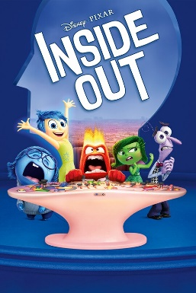
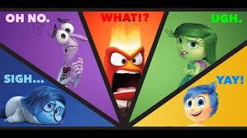
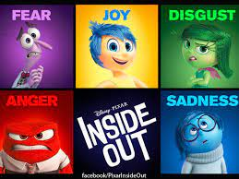

Possible other debate topics:
9. True Friendship Requires Understanding and Accepting Each Other's Emotions: This statement can lead to a conversation about the role of empathy, understanding, and emotional support in relationships, as depicted in the film.
10. People Are Solely Responsible for Their Happiness or Unhappiness: This statement challenges the idea of external factors playing a role in one's emotional state, focusing on personal responsibility for emotional well-being.
11. Children Should Be Taught to Prioritize Happiness Over Other Emotions from a Young Age: This can lead to discussions about the value of a range of emotions in child development and whether emphasizing happiness could lead to unrealistic expectations or emotional suppression.
12. High Emotional Sensitivity is a Sign of Weakness Rather Than Strength: This controversial statement challenges the view that emotional sensitivity can be a strength, opening up discussions about perceptions of emotional expression in different cultures and contexts.
13. Society Benefits More from Individuals Suppressing Negative Emotions for the Greater Good: This statement can spark debate about the individual vs. collective emotional expression and whether suppressing negative emotions is beneficial or harmful to society as a whole.

