Law Inquiry Cycle Name:
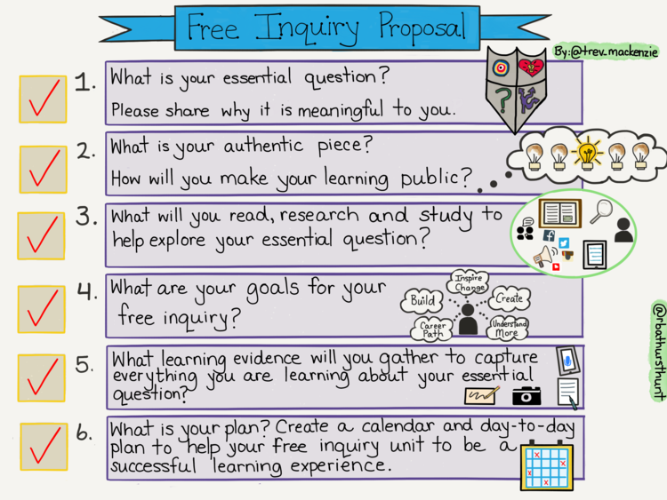
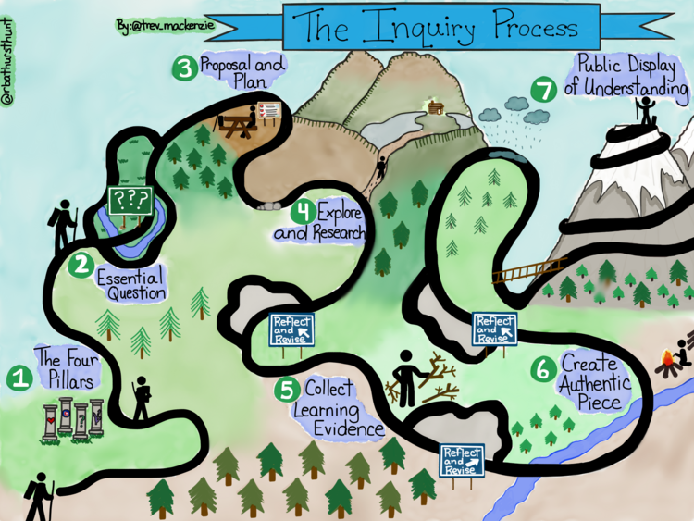

1. What is your topic?

2. What is your essential question?

Why is it meaningful to you?

3. What is your authentic piece (real-life); how will you share your work?

4. What will you read, research, study or what expert will you contact to help explore your question?

5. What are your goals for the inquiry / passion project / geek out blog project?

6. What learning evidence will you gather (a journal, photographs, video, blog) to capture the process of your learning?

7. What is your plan? Use a calendar to create goals.

