WELLNESS 11/12 Name:
LITERATURE CIRCLES FOR NON-FICTION

Please note, you will submit a piece of paper / video or whatever format you choose with your work on it for 12 marks.
Then, we will have a discussion in groups which will be worth an additional 6 marks. (18 marks total)

CHOOSE ONE OF THE FOLLOWING EIGHT OPTIONS TO COMPLETE WITH AN ARTICLE THAT YOU CHOOSE FROM THE ONES PROVIDED BY MR. FITTON.

1. Discussion Director: Your job is to develop a list of questions that your group might want to discuss about the article or section of the book. Don’t worry about the small details; your task is to help people talk over the big ideas in the reading and share their reactions. Usually the best discussion questions come from your own thoughts, feelings, and concerns as you read. They should be open-ended questions that promote deep discussion. Provide possible answers to you questions (detailed please). Usually 5.

2. Important Passages: Your job is to locate and highlight 3-5 significant sections of the text. The idea is to find interesting, powerful, thought-provoking or important sections of the text to share with your group. You decide which passages or paragraphs are worth hearing, and then jot down plans for how they should be shared. You can read passages aloud yourself, ask someone else to read them, or have people read them silently and then discuss. Annotate with great detail, please. (5 Ws, connections, vocab, commentary, themes) Basically, deeply explain why they are important and worth sharing. (Do they relate to central ideas, philosophy, themes, major issues - justify your responses).

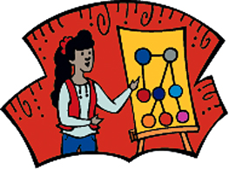
3. Graphic Presentation: Your job is to take key ideas and present them graphically in a sketch, cartoon, diagram, flow chart, or stick-figure scene. During the discussion, show your graphic and let the others talk about it before you say what it represents to you. There should also be a written component where you analyze in detail your drawing and explain how it broadens the understanding of the passage. Drawings should often have a symbolic, metaphorical or explanatory element to them. Don’t just draw an object or person from the text. It should be deep and significant.

4. Summarizer (maximum score possible is 4/6): Your job is to prepare a brief summary of today’s reading. The other members of your group will be counting on you to give a quick (one- or two-minute) statement that conveys the gist, the key points, the main highlights, the essence of today’s reading assignment.

5. Vocabulary: Your job is to find important words in today’s reading. If you find words that are puzzling or unfamiliar, highlight them while you are reading, and then later jot down their definitions, either from a dictionary or some other source. You may also run across familiar words that stand out in the reading-words that are repeated, used in an unusual way, or words key to the meaning of the text. Mark these special words too and be ready to point them out to the group. Be sure to jot down page numbers so when your circle meets, you can help members find the words. After the definition, have a written explanation that explains how knowing the term/definition is crucial to your groups understanding of the overall article. (Basically – the “so what” or “Why” of you choosing them.)

6. Bias Finder Your job is to examine the text for evidence of bias. Look for signs of the author’s bias, and bias in the statements of any key people quoted in the reading. 1. Make a list of the assumptions the author seems to be making. Provide textual evidence for these assumptions. 2. Find 2 or more examples of bias in the reading (either the author’s or a quoted person’s). Explain, using textual evidence, how you know that this author or person is biased in this way. 3. Determine how trustworthy the author is. Do you believe the author despite his/her biases? How objective can this author be? How persuasive? How does the trustworthiness of the quoted persons affect the trustworthiness of the author?

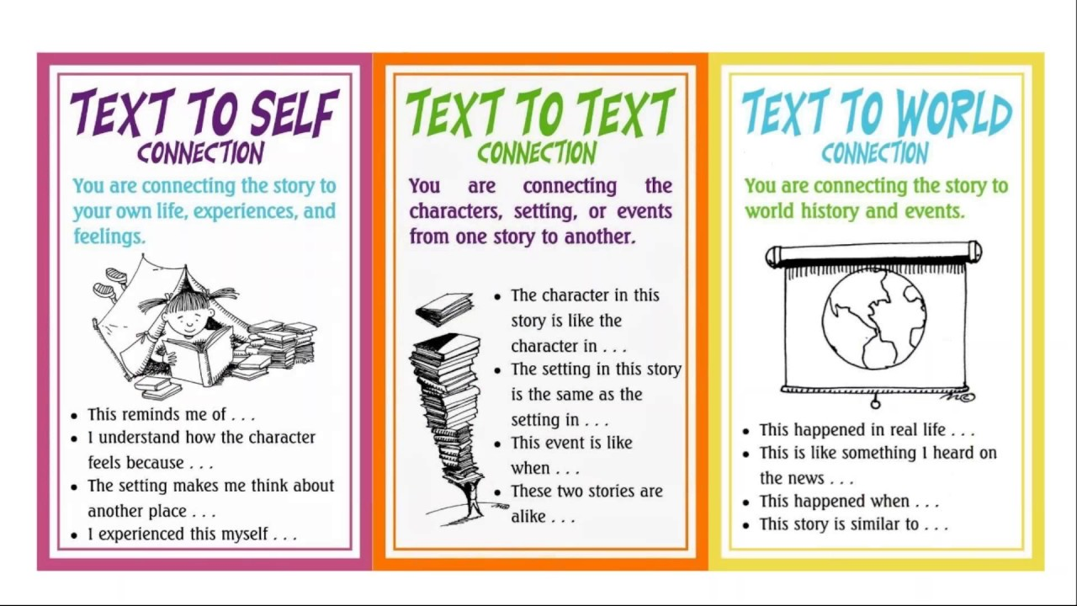
7. Connector Your job is to find connections among this reading and the texts we have read or the world outside. This means connecting the reading to your own life, to happenings at school or in the community, to similar events at other times and places, to other people or problems that you are reminded of, to the principles of a religion or philosophy, to the characters or themes in a work of literature, or to the ideas in another nonfiction text. You might also see connections between this book and other writings on the same topic, or by the same author. There are no right or wrong answers here – whatever the reading connects you with is worth sharing. 1. List and explain 3-5 connections you found between the reading and the outside world or between the reading and other texts. Details please.
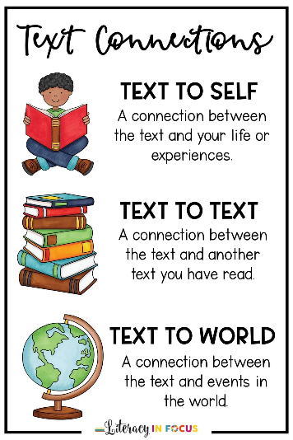

8. Rhetorician: Examine the text for rhetorical appeals (appeals to ethos, logos, or pathos). Find the examples – if you can’t find one of each, you can do multiples of one of them. Choose 3 total.

1. Find at least one place where the author appeals to pathos (the reader’s emotions). Write down the passage and explain how the author appeals to pathos in that passage. If you do not think the author appeals to pathos at all, why do you think the author chose to avoid appeals to pathos?

2. Find at least one place where the author appeals to logos (logic). Write down the passage and explain how the author appeals to logos in that passage. If you do not think the author appeals to logos at all, why do you think the author chose to avoid appeals to logos? Or explain why they did use it and whether it was effective.

3. Find at least one place where the author appeals to ethos (the reader’s sense of the author as credible and trustworthy OR the reader’s morals or ethics). Write down the passage and explain how the author appeals to ethos in that passage. You should be able to find at least one place where the author tries to establish his/her credibility (even if you do not find any places where the author appeals to the reader’s morals and ethics). If you feel that the author fails to establish their credibility, why do you think they fail? May want to research the author. Also, write down the impact of using this strategy or why the author uses ethos.

Note: With some readings you might want someone to find connections between the reading and other readings, people, and/or events-current or in the past. Someone else might research the subject for additional information to add to the discussion.
Information borrowed and adapted and added to by J. Fitton, Jane Hancock, UCLA Writing Project, from Literature Circles: Voice and choice in the student-centered classroom by Harvey Daniels, Stenhouse Publishers, York, ME.

