Mr. Fitton HUMANS OF PENTICTON ADVENTURE ENGLISH
Criterion C: Producing Text
Level | Level Descriptor | Task-Specific Clarification
0 | The student does not reach a standard described by any of the descriptors below. | Add your own expectations here!
1-2 | The student produces texts that:  - demonstrate limited personal engagement with the creative process; demonstrates a limited degree of insight, imagination or sensitivity and minimal exploration of and critical reflection on new perspectives and ideas,  - makes minimal stylistic choices in terms of linguistic, literary and visual devices, demonstrating limited awareness of impact on an audience,  - selects few relevant details and examples to develop ideas.
3-4 | The student produces texts that:  - demonstrate adequate personal engagement with the creative process; demonstrates some insight, imagination or sensitivity and some exploration of and critical reflection on new perspectives and ideas,  - makes some stylistic choices in terms of linguistic, literary and visual devices, demonstrating adequate awareness of impact on an audience,  - selects some relevant details and examples to develop ideas.
5-6 | The student produces texts that:  - demonstrate considerable personal engagement with the creative process; demonstrates considerable insight, imagination or sensitivity and substantial exploration of and critical reflection on new perspectives and ideas,  - makes thoughtful stylistic choices in terms of linguistic, literary and visual devices, demonstrating good awareness of impact on an audience,  - selects sufficient relevant details and examples to develop ideas.
7-8 | The student produces texts that:  - demonstrate a high degree of personal engagement with the creative process; demonstrates a high degree of insight, imagination or sensitivity and perceptive exploration of and critical reflection on new perspectives and ideas,  - makes perceptive stylistic choices in terms of linguistic, literary and visual devices, demonstrating good awareness of impact on an audience,  - selects extensive relevant details and examples to develop ideas with precision.

TO CONSIDER:

Content & Ideas
- Did you choose a powerful quotation that engages the reader and captures the main idea of the person’s story?
- Did you pick a story that was interesting and cohesive?
- Does the quote(s) capture the essence of the person being interviewed?
- Is the story acceptable in length (long enough to delve deeply into their story, but not too so long that it is re-telling your entire interview? (10-20 sentences)

Organization:
- Did you have a strong introductory and concluding sentence?
- Did you present the story in a logical order?

Style:
- Did you tell the story from the “I” voice?
- Did you clearly indicate when you asked a question (if you ask a question in the midst of the interview and you want to include it, write it in Italics to show its your question and go down to a new paragraph)
- Are the photo and story formatted in a way that is visually appealing?

Grammar and Spelling:
- Did you use proper spelling, sentence structure and punctuation?

Timmothy Lezard
“I changed their minds in the first 30 seconds of meeting them”

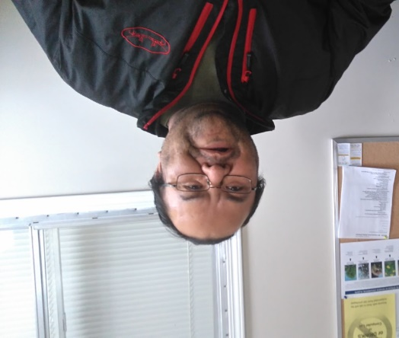

“My first class at South Okanagan Secondary School was honors science 10. The teacher asked me 3 times if I was in the right class. Can you believe it? 3 times. Each time I answered ‘well is this Science honors 10’ and he’d said ‘yes’ and then ask me again. Once he finally believed that I was in his class, he started asking us all questions. The first one was something like ‘What do you call an energy releasing chemical reaction?’ I waited for a while to see if anyone was going to answer but no one did. Everyone was just looking at one another thinking each other had the answer. After a few seconds I said to the teacher ‘well, it’s an exothermic reaction isn’t it?’ Suddenly the whole class started muttering to each other in stun. Then the teacher asked another question and again no one answered so I did and this time the class was silent. All of them had already made up their minds before I arrived about what I was going to be like because I had long hair and was an Aboriginal.”

“Did their minds change after they met you that day?”

“I changed their minds in the first 30 seconds of meeting them.”

