Mr. Fitton’s Weekly History Through Film Learning Bulletin

Week 4 – May 4th May 11th

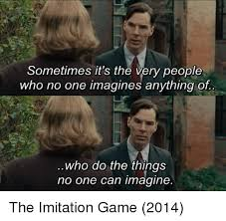
1. I’ve enjoyed reading your blogs!

2. HOW TO START.
-Check your student email; our school communication is through there.
-Go to my website at:
https://mrfitton.weebly.com/online---ww2.html
Please click the link above or go to the website to start learning.

2. GO TO: LESSON 5 “TO BE DONE BETWEEN May 4th – May 11th

Checkmark  When Done | Task – Assignments, Learning Activities
 | 1. Go to: https://mrfitton.weebly.com/online---ww2.html
 | 2. Watch the Trailer for “Fury” https://youtu.be/SKu5lGfRBxc
3. Watch the film “Fury” on Netflix.
‘
 | 4. Read the online article: https://www.theguardian.com/film/filmblog/2014/oct/24/fury-movie-tank-veteran-sherman-verdict-realistic About Historical Accuracy in Fury
 | 5. NO ASSIGNMENT: Just Watch the Film.

*If you can’t access your blog, please email me your assignments

