Mr. Fitton’s Weekly History Through Film Learning Bulletin

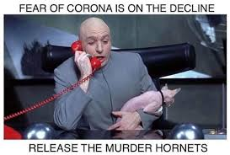

Week 5 – May 11th May 18^{h}

1. I hope you enjoyed Fury!

2. HOW TO START.
https://mrfitton.weebly.com/online---ww2.html
Please click the link above or go to the website to start learning.

2. GO TO: LESSON 5 “TO BE DONE BETWEEN May 11th – May 17th

Checkmark  When Done | Task – Assignments, Learning Activities
 | 1. Go to: https://mrfitton.weebly.com/online---ww2.html
 | 2. Watch the Trailer for Hacksaw Ridge https://youtu.be/RdjO0p4GJPA
 | 3. Read the article: “Fact VS Fiction in Hacksaw Ridge: https://www.historyvshollywood.com/reelfaces/hacksaw-ridge
 | 4. Optional: Read Trivia about the film: https://www.uselessdaily.com/movies/hacksaw-ridge-facts/
5. Choose 1 of 3 assignments. You can do them on either FURY or HACKSAW RIDGE
Here’s a youtube video of Mr. Fitton Explaining the Options. https://youtu.be/APuYpXL3pR4
6. Option One: Information Circle Role (Choose 1 of 8 options)
Option Two: 5-in-1 Assignment
Option Three: Connections Assignment
Every option can either be emailed to me or posted on your blog.
DUE: MAY 20^{th,} 2020
 | *If you can’t access your blog, please email me your assignments

