Mr. Fitton’s Weekly History Through Film Learning Bulletin

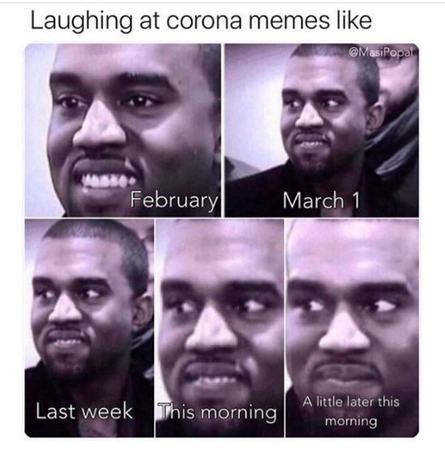

Week 8 – June 7st -June 17th

- Go to: https://mrfitton.weebly.com/online-post---war-era.html

2. GO TO: LESSON 4 – Vietnam War and the Music of the 1960s and 1970s

Checkmark  When Done | Task – Assignments, Learning Activities
1. Choose the either the 1960s or 1970s Music Assignment. Click on the link on my
website for either one or click the link of your choice below:
- 1960s: https://forms.gle/PQHHQE8nRP6tCWCo8
- 1970s: https://forms.gle/ZfDcVFiEwsGGD2uf6
If you cannot do a google doc, there is a word doc on my website too.
 | 2. WATCH: The Cold War in Asia: https://www.youtube.com/watch?v=Y2IcmLkuhG0
 | 3. WATCH: The Vietnam War Simplified: https://www.youtube.com/watch?v=exVKd-x5QVc
 | 4. WATCH: The Preview for “We Were Soldiers” https://www.youtube.com/watch?v=wYK4jrhepdU
 | 5. Go to Netflix – Watch “We Were Soldiers”
6. We will have a TEAMS Meeting about “We Were Soldiers” and the Vietnam War
On Wednesday, June 17th at 1pm.
 | Have a safe and healthy week!

