Mr. Fitton’s Weekly History Through Film Learning Bulletin
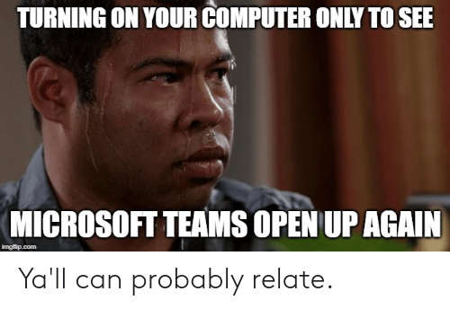
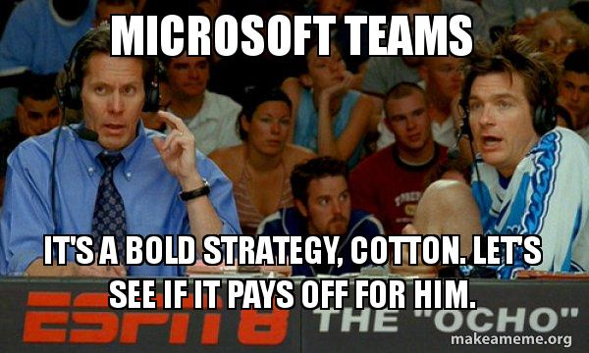

Week 3 – April 20th – April 27th

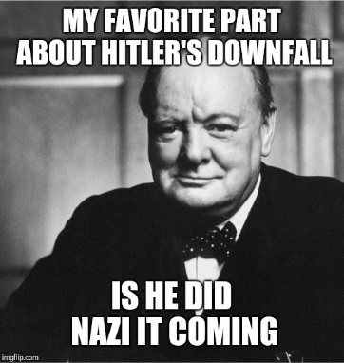
1. I have enjoyed reading your “Darkest Hour Blogs” and questions. I have already begun commenting! Bravo on creating thought provoking questions!

2. HOW TO START.
-Check your student email; our school communication is through there.
-Go to my website at:
https://mrfitton.weebly.com/online---ww2.html
Please click the link above or go to the website to start learning.

2. GO TO: LESSON 3 “TO BE DONE BETWEEN APRIL 13th-20th”

Checkmark  When Done | Task – Assignments, Learning Activities
 | 1. Go to: https://mrfitton.weebly.com/online---ww2.html
 | 2. Watch Mr. Fitton’s Powerpoint or Video on Battle of the Atlantic https://youtu.be/FlxeqnNiFY8
 | 3. Review “The Battle of the Atlantic” from WW2 from Space (11:02-19:55) https://youtu.be/IhjgbllewUM
 | 4. Watch “Imitation Game Trailer” https://www.youtube.com/watch?v=nuPZUUED5uk
 | 5. Go to Netflix and watch “Imitation Game”
 | 6. Read and Complete “So you wanna be a critic” assignment; post to blog
 | 7. Get ready for live “Teams” discussion MONDAY APRIL 27th – 12:00-12:30

*If you can’t access your blog, please email me your film critique.

* See Joke below if you want!

