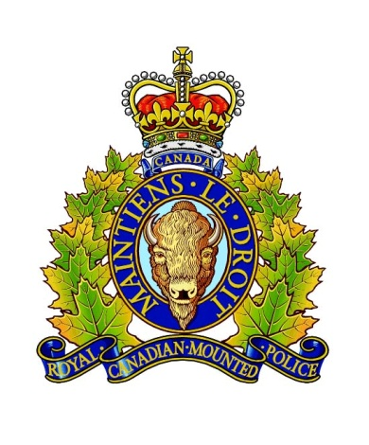
Oliver RCMP
Watch Report / Pass-On

Date: 2023-01-09 Shift: 0730-1730
Members: VILLENEUVE (OT), STANGL (OT)
Total Files:
2023-110 – Fail to Stop – Grey 2000s model Mazda SUV
On January 9th, 2023 at approximately 1320hrs, Cst. VILLENEUVE was making patrols on the OIB when he observed a vehicle driving down the driveway from 200 leaf Road. The vehicle stopped when the driver saw member's police vehicle, began reversing back towards the property, then drove away again down leaf Road towards McBurney Road. The vehicle stopped at the stop sign at McBurney Road, then turned westbound. Cst. VILLENEUVE observed BCLP Z87216 and noted that the vehicle was a red early 2000s model Mazda SUV (Mazda Tribute maybe?). A query of the license plate showed that it was unattached and registered to a company out of Kelowna. Member closed the distance and attempted to conduct a traffic stop with the vehicle on McBurney Road jut east of Greypoint Rd, however the vehicle failed to stop and accelerated well over 100km/h. Member deactivated his emergency equipment and pulled over and did not pursue. Unknown number of occupants and unknown who was driving.
2023-113 – UL Driving Prohib / No Insurance
On January 9th, 2023 at approximately 1355hrs, Cst. VILLENEUVE observed a grey van with front end damage and a non-functioning driver's side headlight turn south on Grey Rosemary Road from Main Road in Oliver. Cst. VILLENEUVE conducted a traffic stop with the vehicle, bearing BCLP VN721N. Member queried the license plate and learned that the insurance was inactive. Member spoke with the driver and lone occupant, who provided an Ontario driver's license identifying her as Susie SMYTHE. Cst. VILLENEUVE queried her Ontario DL learning that she has an indefinite license suspension in the Province of Ontario. Member queried her BC license as well and confirmed that she was unlicensed. UL Prohibition and 7-day vehicle impoundment served. MILLER served VT for no insurance and no driver's license. Collision Craft attended and towed vehicle
2022-5904 – Recovered “Frosty”

On 2023-01-09 at 1030 hrs Sgt. WRIGGLESWORTH was on patrol and noticed a Christmas decoration snowman (with flat top-hat) in the front yard at 2416 Nelson St., Oliver, BC. He recalled a stolen snowman file from over a month ago and returned to the office to query it. He found this file where Karl MEINHOFF reported his snowman stolen on 2022-11-22 and reported that it would have a flat top hat because the support pole was missing. At 1300 hrs MEINHOFF attended the Oliver Det and went with Sgt. WRIGGLESWORTH to 2416 Nelson St. where he positively ID'd the giant snowman as his as he had the metal support rod on hand that was obviously missing from the top hat. he identified certain tears and spots on it and this was confirmed by Sgt. WRIGGLESWORTH. Sgt. WRIGGLESWORTH knocked on the door and was met by Magdelene STREISAND and Jacob FRANZEN who claimed that they had purchased it via Facebook Marketplace for $50 and then $75. Their story appeared fabricated but not enough evidence to proceed with PSP. Snowman put in Police truck and driven to MEINHOFF residence where his wife Rebeccah was ecstatic to have it returned. Concluded.
File Concluded.
Sgt. Wrigglesworth
Oliver RCMP
000175345

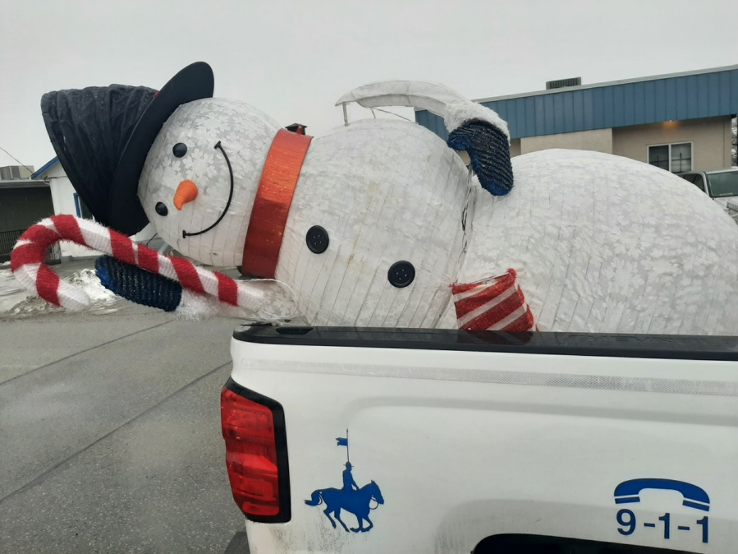
Pass-On :

