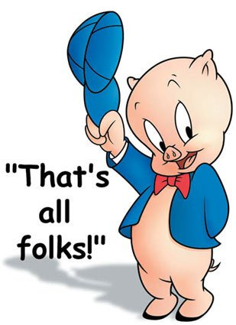Mr. Fitton Name:
(Capitalist Pig)
/60 MARKS
History 12 Date:

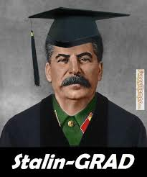
Final Exams are only one way to cumulatively assess what you’ve learned this year. Since you will shortly become a “Stalin-grad” of the BC Education System, the final project allows you to choose your own destiny! As a class, we have decided to have a “Science Fair” style final project. You will research a cold-war era topic of choice, create a definitive thesis (argument) and present using a medium that is suited to your talents and passions. On the day of the final exam we will meet and as a class do a science fair where you are welcomed to bring food that somehow relates to the topic you’ve explored. It is a final farewell to our historian community.
DUE DATE: The completed project is due on ________________________________.

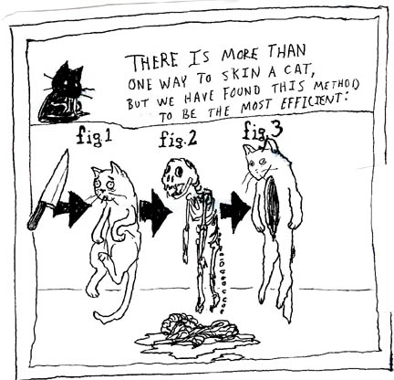You must be half done and show Mr. Fitton on _______________
If you have not made substantial headway at this point, you will be required to work with Mr. Fitton at lunch to ensure your success.

The Project: The project aims to determine your understanding of concepts and related to the cold war, your emergent skills as a historian, and to familiarize you with how to research and express yourself as graduate of History 12. As a result, we will be reviewing academic journals, learning citation and using the University of Ottawa History Department Handbook.

Suggested Project Ideas:
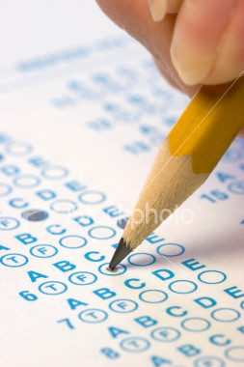
Create A Term Paper
- Research several articles on a topic of your choice
-Create and refine a thesis
-Follow proper format of a term paper
-Use the University of Ottawa History Student handbook to guide you
-Proper use of quotes/citations
-800-1500 words maximum.

Unit Mind Map / Pictorial Matrix
-Draw a Matrix or artistic piece that shows your knowledge
-Include Key terms and points
-Pictures or Drawings
-Must demonstrate an argument/research
-Needs proper citation
-Reveals a depth of understanding enhanced by your artistic abilities.

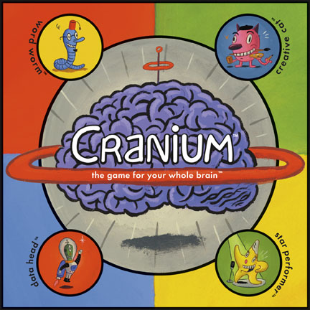
What will help you in your Career?
-In this class we have future police officers, nurses, lawyers, army personnel, secretaries, parents, construction workers, etc.
-Create your own type of demonstration of learning where you research and present in a way that will help you gain skills / present knowledge in a way you would in your future career.

Video/Animation - Anything
- Create a video newscast, Rick Mercer Rant, Horrible Histories, Histeria, or anything using the medium of video that helps you articulate your thesis and viewpoints.
-Must reveal grade 12 level of research
-Must somehow include citations
-Must demonstrate a superior level of understanding.

Documentary
-Using film or pictures gathered from the internet, create a documentary with an overdub that explains the your argument.
-Post to youtube for final evaluation.
-You may download and show archival footage or re-enact key scenes yourself.
-Should also include evidence of research and citations
Science Fair Poster
- Create a research project poster
- Must contain a relevant thesis
- Must display variety of arguments / viewpoints about the topic
- Must synthesize various viewpoints and eventually reveal important conclusions
-Aesthetically appealing
-Requires evidence of research/citations

ASSESSMENT PAGE:

These are only a few suggestions. You may show your learning in an alternate fashion (ie. police report, radio show, Rick Mercer Rant, Crash Course in History, Epic Rap Battle of History, Musical Score or any idea you have, but consult with me first and I will be happy to discuss the viability of your idea. Remember, you will likely have to support your creative work (if you choose to do something that is not written) with additional written analysis to ensure that you have submitted a project that demonstrates a grade 12 level of understanding.
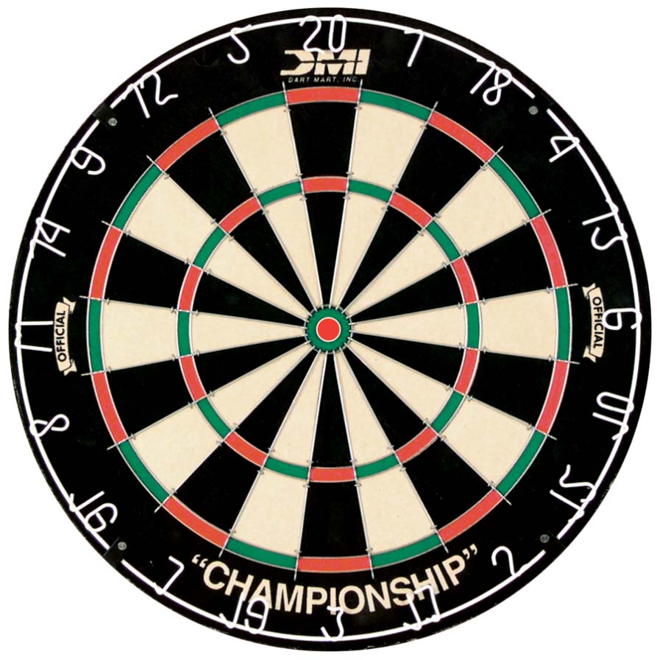
Tips to stay on target: Think of your topic Read Howarth, Demarco or 20th Century History on that topic Create a thesis (argument) Find academic articles to support highlight examples to support your argument start the writing / creative process Done!

Assessment: Due to the extremely personalized nature of this assignment and due to the variety of choices of expression, it is incredibly difficult to assess. As a result we will be using a 6-point generalized scale.

6
A relevant thesis (argument) is evident and clearly developed throughout the project/paper
Superior use of factual content; organized in a purposeful and effective manner
Precise selection of supporting details; evaluation/analysis is exemplary
Expression is clear and fluent; errors may be present but do not interfere with meaning

5
A relevant thesis (argument) is evident and provides direction throughout the project/paper
Proficient use of factual content; organized in a clear and thoughtful manner
Accurate selection of supporting details; evaluation/analysis is sound
Expression is generally fluent; errors may be present but do not interfere with meaning

4
A relevant thesis (argument) is evident
Competent use of factual content; organized in a purposeful manner
Appropriate selection of supporting details; evaluation/analysis is satisfactory, but basic
Expression is generally fluent; errors may impede meaning at times (some sections unclear due to writing)

3
A relevant thesis (argument) is attempted, but unclear
Adequate use of factual content; organization attempted or parts organized, but parts disorganized
Simplistic selection of supporting details; evaluation/analysis is weak, or at times there is a lack of evaluation/analysis
Expression is simplistic; errors impede meaning

2
A relevant thesis is absent, inaccurate or student has simply listed their topic
Limited recall of factual content; lack organization or disorganized in many places
Inappropriate selection of supporting details; Inaccurate supporting details, evaluation/analysis are absent
Expression is flawed and errors impede meaning

1
A relevant thesis is absent
Deficient recall of factual information; lacks organization
Absence of supporting details
Expression is unclear and makes understanding difficult

0
Writing is evident, but no attempt has been made to discuss/argue an event from the cold war era
Plagiarized
Cut and Pasted information from the internet is all that is provided

