History 12 Name:
Russian Revolution Historical Hot Seat / Panel Discussion
Concept: After learning about the Russian Revolution in class you will get the opportunity to work in a group to focus on one major character. Research and become the character. Know them so well inside and out, that you could answer questions AS them.
Simulation: As a panel of expert characters, our class will come together as ordinary Russians to pepper you with questions about the revolution, your beliefs/values, your stories, and will ask you tough questions about how you would react/respond to their questions about the Russian Revolution / Russian Society, Politics, Economics, etc.
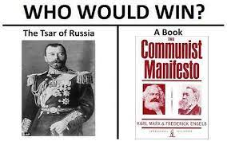
Task: In Groups of 3-4
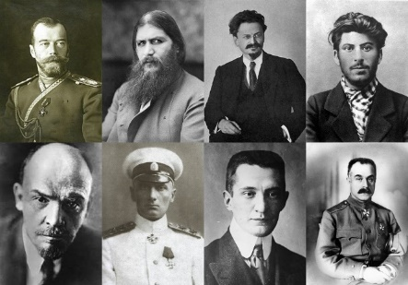
1. Choose a Major Figure of the Russian Revolution
Czar Nicholas II Rasputin Trotsky
Stalin Lenin Kolchak
Kerensky Kornilov Bolshevik
Menshevik Russian Soldier Anyone Missing

2. Using course knowledge and your own research, become intimately familiar with the character. We will visit the library and become familiarized with Gale Power Searches and Searching reliable reviewed academic databases for biographies of your characters. Thanks to our Librarian!
3. As a group design a 2–3 minute speech outlining the chosen characters beliefs about Russia, their response to the conditions/activities occurring in Russian between 1900-1922, their suggestions for policies/actions. We will start the panel simulation with each character delivering their timed speech.
4. Design a series of questions that could be asked of your character and other characters. Some will be basic and some should be higher level (please see Webb’s depth of knowledge and examples below). The second part of the panel simulation is peppering the panelists with your questions!
Example Questions: What would you do for the workers? What would you do to stabilize the economy? What is your stance on the current war against Germany. Do you have a slogan – if you could make up a slogan for yourself, what would it be? What would the impact of your belief in ______ be on Russia or the World. What caused you to believe in / create your policy of _____ and what will be the consequences?
5. You may direct your questions at specific panel members, a few panel members, or all of the panel members.
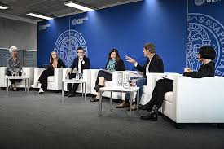

A note on stories:
Humans hold a prized position for narrative. Be sure to include a powerful story either in your response to a question or in your introductory speech. These are all hugely fascinating characters, so be sure to dig deep for a fun, engaging, and interesting story from their past! Remember, your group may ask you questions that lead to answers you want to share.
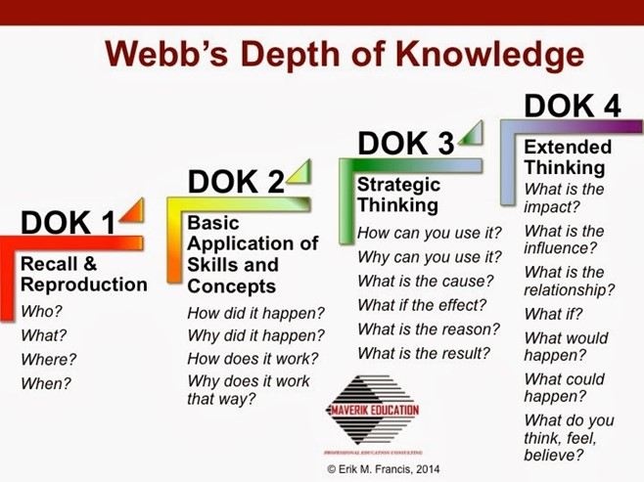
Webb’s Depth of Knowledge – To Help you Design High Quality Questions

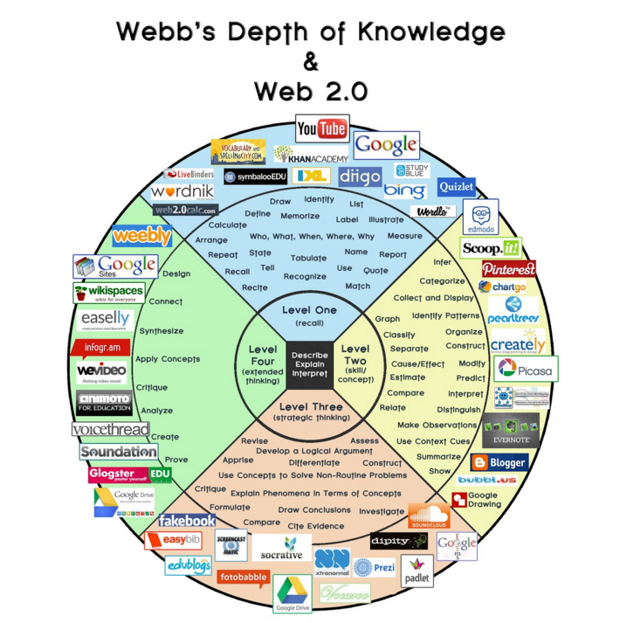

Guidelines – Checklist Group Members: _________________________
Check | Choose someone in the group who will become that character. The other members will help with research, speech writing, and responses to questions.
 | Develop a 2-minute opening speech about who you are and what you stand for! Include what you want out of the Russian Revolution; what led you to your beliefs; some biographical details; use some actual Historical Quotes. In character!
 | Develop a series of basic questions (who, what, when, where and why to ask YOUR character – character should be prepped and able to answer).
 | Develop a series of basic questions (who, what, when, where and why to ask OTHER characters on the panel– they should be prepped and able to answer). This is way to use key terms and specific vocabulary to demonstrate your understanding.
 | Come up with a variety of questions that are both lower and higher on Webb’s Depth of Knowledge to ask your panel member and other people on the panel. Questions that will help us come to a greater understanding of History and the time.
 | Include at least one powerful or well-told story
 | Include APA bibliography of works consulted to design speech/questions

Proficiency Scale:
Not Yet Meeting | Developing  2 | Proficient  3 | Extending  4
- The Speech/Biography effectively summarizes someone’s life and their beliefs, opinions, strategies.
- Your basic questions are well-designed and lead to helping the class understand the character and their story, their views and background in a way that is historically accurate, curious, and engaging (provides us with a foundational background).
- Your upper-level questions are thoughtful, thought-provoking and help the class gain a deeper understanding of the person, as well as social, political and economic trends and the History of the Russian Revolution/ Russian History.
- Have included a powerful, well told, well chosen story that engages the audience.
- Uses key vocabulary, terms, dates, and concepts – not vague generalities during speech and in response to questions.
- Clearly prepared/Practiced– notes, references, in character– not “winging it” or being vague/general
- Have included a bibliography in APA format

TEACHER COMMENTS:

/50

