Law 12 – Famous Criminals / Murderers Unit
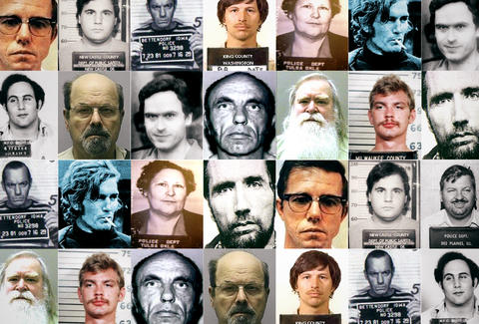
Goal: You are to assemble a top-secret dossier on a famous criminal
Role: You are a spy working for the Canadian Security Intelligence Service or CIA
Audience: The Director of CSIS and the Director of the CIA
Situation: As the Intelligence Services top criminal analyst, you are being put in charge of assembling an intelligence dossier on a famous criminal.
Product: You will submit a top secret file folder complete with biography of the criminal, known associates, movements, residences, motives, crimes, relevant photographs and other pertinent information. Should be arranged in a meaningful way – the Director is incredibly busy and needs the information presented in a clear and concise manner. The Director is also interested in you showing your sources.

To consider including: Biographical details, crimes, newspaper clippings, police reports, eye witness interviews, news video/photos, interviews with associates, autopsy info if dead, wanted posters. You must include an analysis portion where you make comments / recommendations or provide a synopsis of your info.

Standards: Criterion C – MYP Rubric Year 5 with additional criteria.

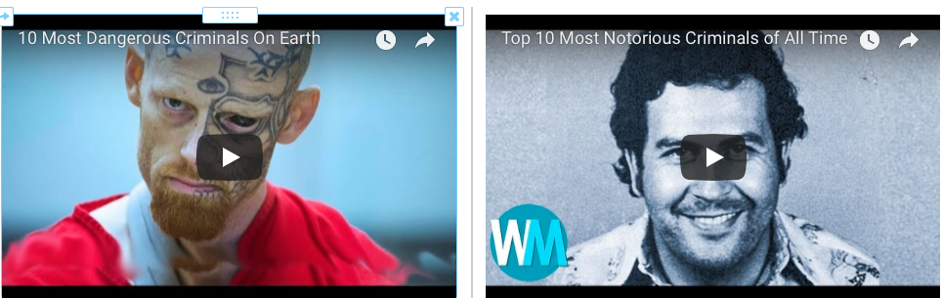
Lesson: Watch these youtube videos and websites below to start your research and choose your criminal.

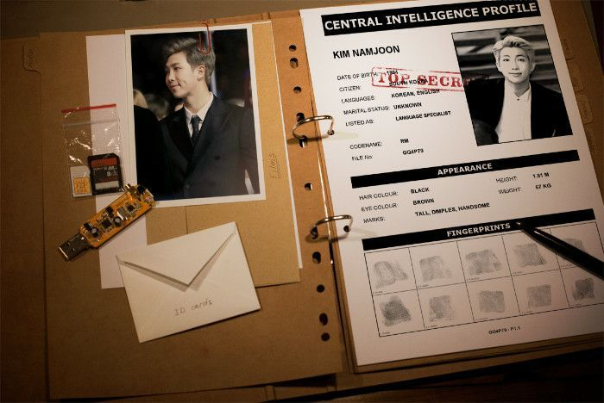
1. https://www.huffingtonpost.ca/entry/americas-most-notorious-criminals_n_3761487 (American Criminals)
2. https://www.thefamouspeople.com/criminals.php (Huge list of international criminals)
3. http://www.wright.edu/~jim.adamitis/FamousCriminals/criminals.html
4. https://www.fbi.gov/history/famous-cases FBI website - famous cases and criminals​
5. https://list25.com/25-most-brilliant-criminals-in-history/ Most brilliant criminals
​6. https://www.criminaljusticedegreeschools.com/criminal-justice-resources/famous-criminals-and-outlaws-in-the-justice-system/
You may also wish to use youtube biographies

To learn how to do Proper Citations, please go to the following site. http://www.easybib.com/guides/citation-guides/apa-format/

Criterion C: Communicating
Achievement Level | Level Descriptor | Task-Specific Clarification
0 | The student does not reach a standard described by any of the descriptors below. | Add your own expectations here!
1-2 | The student:  - communicates information and ideas in a limited way, using a style that is limited in its appropriateness to the audience and purpose,  - structures information and ideas according to the specified format in a limited way,  - documents sources of information in a limited way.
3-4 | The student:  - communicates information and ideas satisfactorily by using a style that is somewhat appropriate to the audience and purpose,  - structures information and ideas in a way that is somewhat appropriate to the specified format,  - sometimes documents sources of information using a recognized convention. | -Attempts to use APA Format in bibliography  -Includes few visuals  -Demonstrates some research  -Selects few details
5-6 | The student:  - communicates information and ideas accurately by using a style that is mostly appropriate to the audience and purpose,  - structures information and ideas in a way that is mostly appropriate to the specified format,  - often documents sources of information using a recognized convention. | -Uses APA Format in bibliography  -Includes some well-chosen visuals  -Demonstrates good research  -Good selection of details
7-8 | The student:  - communicates information and ideas effectively and accurately by using a style that is completely appropriate to the audience and purpose,  - structures information and ideas in a way that is completely appropriate to the specified format,  - consistently documents sources of information using a recognized convention. | -Uses APA Format in bibliography  -Includes excellently chosen visuals  -Demonstrates superior research  -Superior selection of details

