Communications 11/12 Name: _______________
“Genius Hour”

“Explore your passions and Creativity.” Start by viewing:
https://www.youtube.com/watch?feature=player_embedded&v=NMFQUtHsWhc
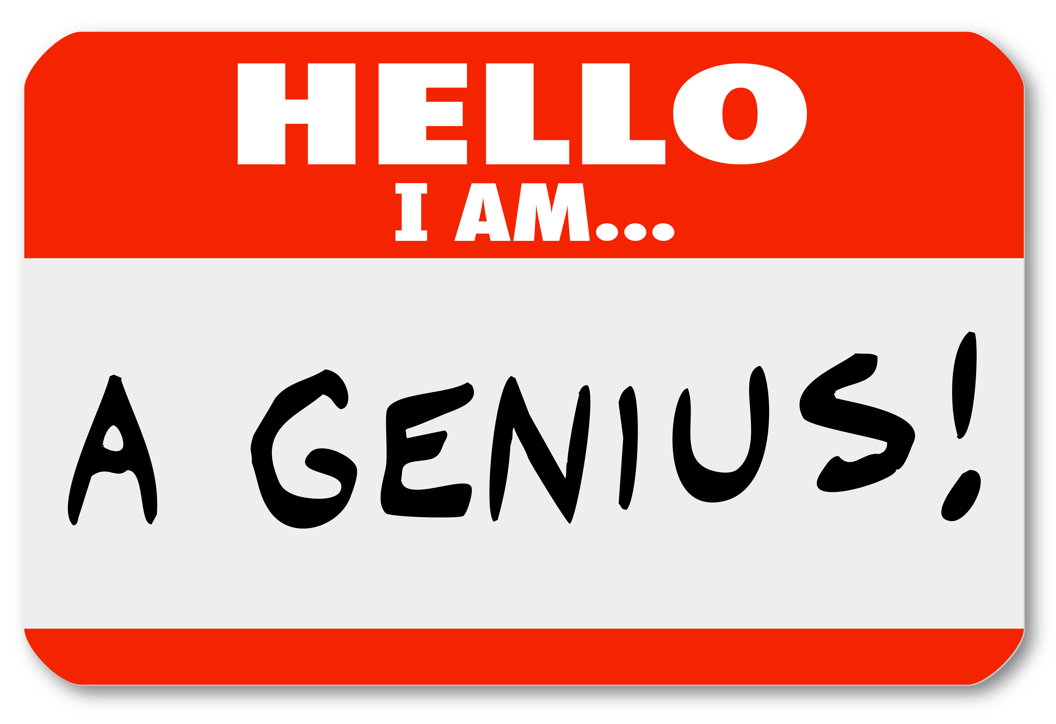
*Did you know that Google gives employees 20 percent of their time (one day a week) to pursue their own passions? This has led to increased productivity and new inventions for Google.

Directions: Pick topic or subject or project that you are interested in pursuing. We will research it, and have fun.

Rules: 1. Must have a driving question (what do you want to learn) 2. Project must involve research (if you want to build a rocket, show me resources used to create it) 3. Project can be shared via poster, video, explanation, photo-essay or anything that is appropriate to your creation (especially if you learn a new skill).

My choice of something to research/create:___________________________________

You will have to find a few categories to discuss and organize on your poster.
Requirements (Subjects = Flexible) | Research notes
WHO

WHAT

WHEN

WHERE

WHY

Any other interesting information

You must also have the following:

1. Research notes/printouts/URLS
2. Find at least 4 visuals to include in your presentation piece (video / posters / etc)
3. Present your information somehow – but most likely needs to include the following:

A. centralized title B. headings for your information
C. captions for your pictures D. visually balanced
E. error-free
F. Information must be paraphrased (in own words) NO CUTTING AND PASTING

Marking Criteria:

EXCEEDS EXPECTATIONS (90-100%)  - the work exceeds grade 11/12 expectations in significant ways  - the student may benefit from extra challenge; excellent work overall  - Student includes most major concepts and important DETAILS from the subject matter  - Presentation is excellent | FULLY MEETS EXPECTATIONS (70-89%)  - the work meets grade 11/12 expectations  - there is evidence that relevant prescribed learning outcomes have been accomplished  - Includes many major concepts and important DETAILS from the subject matter  - Presentation is very good
MINIMALLY MEETS EXPECTATIONS (50-70%)  - the work may be inconsistent, but meets grade 11/12 expectations at a minimal level  - there is evidence of progress toward relevant prescribed learning outcomes  - the student needs support in some areas; Some major concepts and important DETAILS from the subject matter are vague at times  - Presentation is ok | NOT YET WITHIN EXPECTATIONS (0-49%)  - the work does not meet grade-level expectations  - there is little evidence of progress toward the relevant prescribed learning outcomes  - the situation needs intervention  - Difficult to understand, perhaps lists major concepts and important DETAILS but shows no depth in their explanation.  - Presentation not there YET, but will be with teacher intervention / student alterations

Sub-Total for content: /20

Poster / Project Layout: (May not apply depending on your medium of presentation)
Information is paraphrased /4 Conventions (spelling/grammar) /2
Title /2 Headings /4
Visually balanced /4 Graphics /4

Total for presentation piece: /20

Total for Entire Project: /40

Teacher Comments:

