English 9 Name:

Passion Project / Learn Something New / Interest Blog
(Make Your Own Project Project)

Intro: What IS this project? Great question. That’s up to you. It should be completed using approximately 10 in class working days. Your project will be created by you, defined & generated by you, and approved by you and me while working with you to finalize your project. Share your work ANY way you want.

Your project “challenge” should be geared towards solving a problem or exploring a passion that is of great interest to you! If you stick true to this goal of creating that challenge for yourself, your project will be something that you’ll not want to stop working on and will result in something VERY useful to you and likely others! Think about a time when you lost track of time because what you were doing was so interesting!
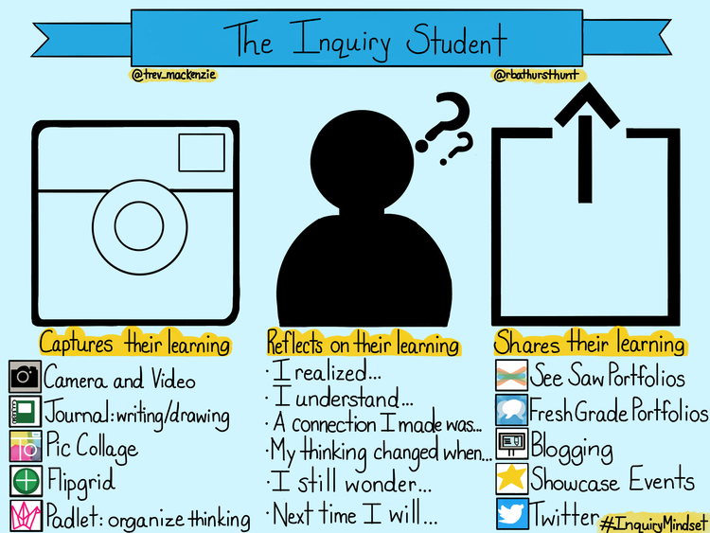
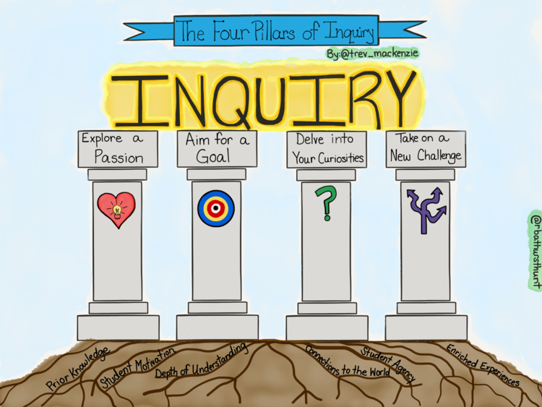
Getting Started:
Brain-Storm #1
Write down the topic you are MOST interested in:
__________________________________________________________________

Write down THREE questions about that topic that you’d like to find out more about / learn more about how to do it!

- _________________________________________________________________

- _________________________________________________________________

- _________________________________________________________________
Brain-Storm #2
Write down a second topic that you are VERY interested in: __________________________________

Write down THREE questions about that topic that you’d like to find out more about / learn more about how to do it!

- _________________________________________________________________

- _________________________________________________________________

- _________________________________________________________________

Driving Challenge Time!
Passion / Goal / Curiosity / Challenge: What I’ll “do” to explore or solve this problem:
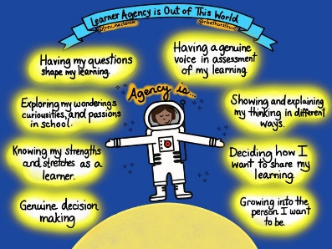
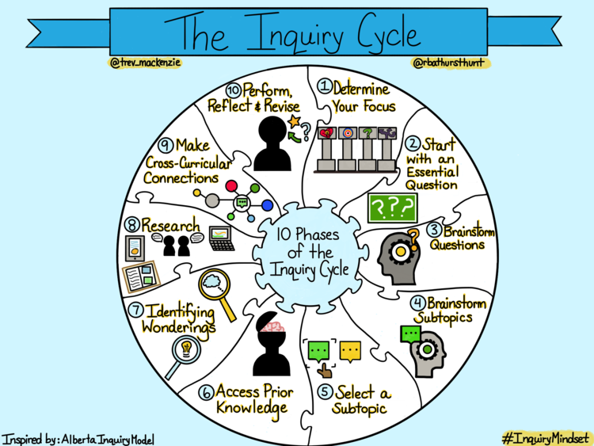

Challenge Sentence: I will (design, construct, plan, produce, invent, devise, create) a ______________________ to (critique, detect, discover, judge, monitor, evaluate, Learn, explore) (why, where, when, how, what) ________________________________________

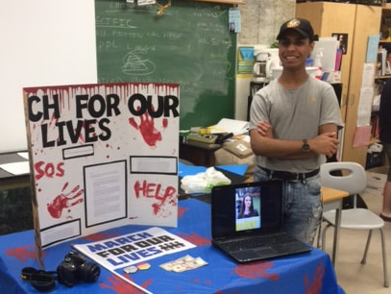
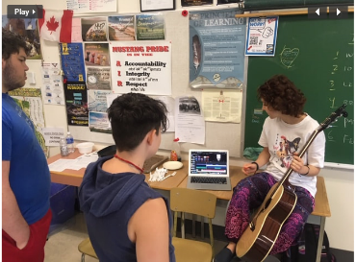
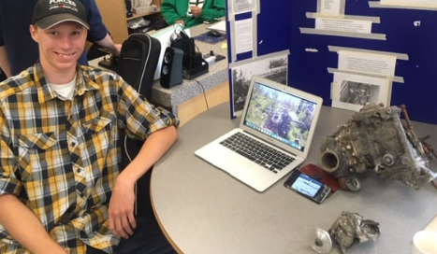
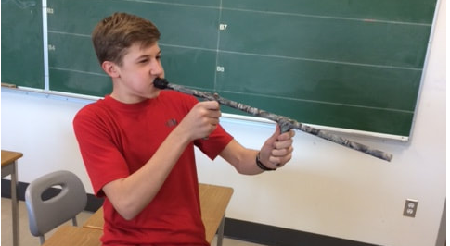
PAST STUDENT PROJECTS:
TOPICS: How to spread and promote kindness; How to Sleep Better, How to Play Guitar, How to Rebuild an Engine, How to rewire a Porsche with electrical problems, Creating a Fitness/Diet Plan; Writing a Cookbook, Skin and Butcher a Deer; Teaching Martial Arts via Comics; How to Bake several difficult recipes, create a website to help people with anxiety; website teaching Swahili, build a model plane.
Ways to show learning: Websites, hands-on, Gardens, Photo Essays, Blogs, Podcasts, Poster boards, Videos, Demos,
BLOG SHOW WHAT YOU KNOW OPTION IN MORE DETAIL
https://spencerauthor.com/geek-out-projects/ (for more details)
If you choose the Blog option (summarized from John Spencer’s Website):
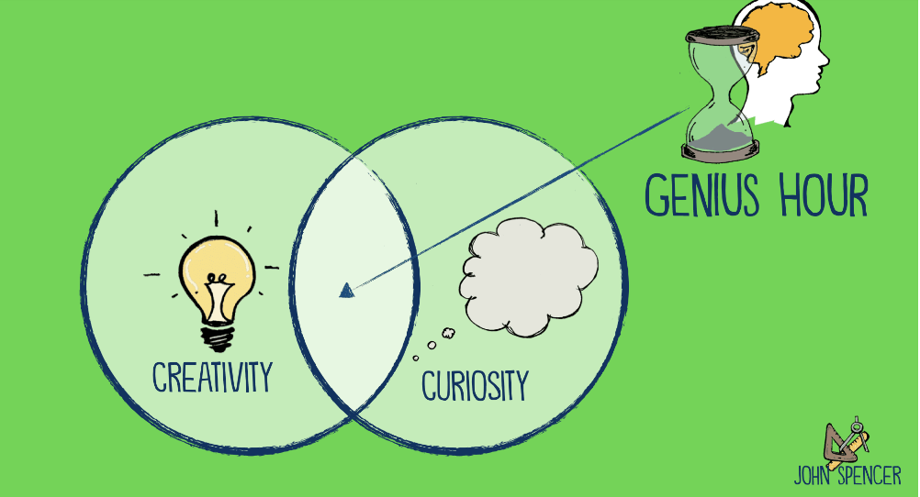
HOW TO PROCEED:
1. Read some blogs to see the style.
2. Make a T-Chart (good blog vs ineffective blog) Ie: Titles, Dates, Graphics, Headings, Organized, spacing
3. To think about what you will write about / research / share, consider the following questions:
- What do you really care about? Why?
- What is something that you’re passionate about?
- What is something you know inside and out?
- What are some things you believe deeply in? What are some convictions you have about life?
- What do you love to do?
- What do you know a lot about?
- If you could invent your own course, what would it be?
4. Then find a blog website to host your writing: weebly, or scholantis, or another one, or a v-log on youtube,
Possible ideas / Headings / Make your Own
*Research Topic: “7 Things you may not know about ________”
*Write a persuasive post about a strong opinion on your topic.
* “The Surprising Story Behind _______”
* Create Q & A Post on your topic
* Write intro post for newbies to the topic.
* History and Timeline of the topic
* Best and Worst of topic
Criterion B: Organizing
Level | Level Descriptor | Task-Specific Clarification
0 | The student does not reach a standard described by any of the descriptors below. | Add your own expectations here!
1-2 | The student:  - makes minimal use of organizational structures though these may not always serve the context and intention,  - organizes opinions and ideas with a minimal degree of coherence and logic,  - makes minimal use of referencing and formatting tools to create a presentation style that may not always be suitable to the context and intention.
3-4 | The student:  - makes adequate use of organizational structures that serve the context and intention,  - organizes opinions and ideas with some degree of coherence and logic,  - makes adequate use of referencing and formatting tools to create a presentation style suitable to the context and intention.
5-6 | The student:  - makes competent use of organizational structures that serve the context and intention,  - organizes opinions and ideas in a coherent and logical manner with ideas building on each other,  - makes competent use of referencing and formatting tools to create a presentation style suitable to the context and intention.
7-8 | The student:  - makes sophisticated use of organizational structures that serve the context and intention effectively,  - effectively organizes opinions and ideas in a sustained, coherent and logical manner with ideas building on each other in a sophisticated way,  - makes excellent use of referencing and formatting tools to create an effective presentation style.

Criterion C: Producing Text
Level | Level Descriptor | Task-Specific Clarification
0 | The student does not reach a standard described by any of the descriptors below. | Add your own expectations here!
1-2 | The student produces texts that:  - demonstrate limited personal engagement with the creative process; demonstrates a limited degree of insight, imagination or sensitivity and minimal exploration of and critical reflection on new perspectives and ideas,  - makes minimal stylistic choices in terms of linguistic, literary and visual devices, demonstrating limited awareness of impact on an audience,  - selects few relevant details and examples to develop ideas.
3-4 | The student produces texts that:  - demonstrate adequate personal engagement with the creative process; demonstrates some insight, imagination or sensitivity and some exploration of and critical reflection on new perspectives and ideas,  - makes some stylistic choices in terms of linguistic, literary and visual devices, demonstrating adequate awareness of impact on an audience,  - selects some relevant details and examples to develop ideas.
5-6 | The student produces texts that:  - demonstrate considerable personal engagement with the creative process; demonstrates considerable insight, imagination or sensitivity and substantial exploration of and critical reflection on new perspectives and ideas,  - makes thoughtful stylistic choices in terms of linguistic, literary and visual devices, demonstrating good awareness of impact on an audience,  - selects sufficient relevant details and examples to develop ideas.
7-8 | The student produces texts that:  - demonstrate a high degree of personal engagement with the creative process; demonstrates a high degree of insight, imagination or sensitivity and perceptive exploration of and critical reflection on new perspectives and ideas,  - makes perceptive stylistic choices in terms of linguistic, literary and visual devices, demonstrating good awareness of impact on an audience,  - selects extensive relevant details and examples to develop ideas with precision.

Criterion D: Using Language
Level | Level Descriptor | Task-Specific Clarification
0 | The student does not reach a standard described by any of the descriptors below. | Add your own expectations here!
1-2 | The student:  - uses a limited range of appropriate vocabulary and forms of expression,  - writes and speaks in an inappropriate register and style that do not serve the context and intention,  - uses grammar, syntax and punctuation with limited accuracy; makes errors that often hinder communication,  - spells/writes and pronounces with limited accuracy; makes errors that often hinder communication,  - makes limited and/or inappropriate use of non-verbal communication techniques.
3-4 | The student:  - uses an adequate range of appropriate vocabulary, sentence structures and forms of expression,  - sometimes writes and speaks in a register and style that serve the context and intention,  - uses grammar, syntax and punctuation with some degree of accuracy; makes errors that sometimes hinder communication,  - spells/writes and pronounces with some degree of accuracy; makes errors that sometimes hinder communication,  - makes some use of appropriate non-verbal communication techniques.
5-6 | The student:  - uses a varied range of appropriate vocabulary, sentence structures and forms of expression competently,  - writes and speaks competently in a register and style that serve the context and intention,  - uses grammar, syntax and punctuation with a considerable degree of accuracy; makes errors that do not hinder effective communication,  - spells/writes and pronounces with a considerable degree of accuracy; makes errors that do not hinder effective communication,  - makes sufficient use of appropriate non-verbal communication techniques.
7-8 | The student:  - effectively uses a range of appropriate vocabulary, sentence structures and forms of expression,  - writes and speaks in a consistently appropriate register and style that serve the context and intention,  - uses grammar, syntax and punctuation with a high degree of accuracy; makes errors that are minor and communication is effective,  - spells/writes and pronounces with a high degree of accuracy; makes errors that are minor and communication is effective,  - makes effective use of appropriate non-verbal communication techniques.

