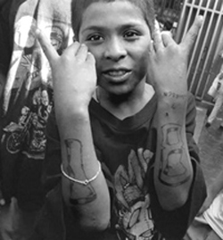
Communications 11/12 Name: _______________
“The Wars”

Directions: Pick a gang that you think will be interesting to you and in pairs create a poster about the gang filling the requirements below:

Choices: Red Dragons, Decepticons, Latin Kings, Crips, Bloods, MS 13, Hell’s Angels, Rock Machine, Independent Soldiers, Russian Mafia, Italian mafia, Native Syndicate, Ardwick Blood crew, White Aryan Resistance, or any other gang you find interesting.

My choice of gang to research:_____________________________________

Requirements | Research notes
History of the Gang

Symbols and what they mean

Where are they concentrated/are they a threat in Canada

What kind of things is the gang involved with?

Beliefs

How are members inducted (let into the gang)

Any other interesting information

You must also have the following:

1. A newspaper article about the gang or connected to the gang
2. Find at least 3 pictures of the gang or anything connected to the gang
3. Present your information on a poster board. The board must have
-a centralized title
-headings for your information
-captions for your pictures
-visually balanced
-mistake free
-information must be paraphrased (in own words)

Marking Criteria:

Content:

History /3 Symbols /2 Beliefs /3

Interesting info /2 Induction /3

Involvement/Concentration/threat in Canada /2

Sub-Total: /15

Poster Layout:

Information is paraphrased (1)
Conventions (spelling/grammar) (2)
Title (gang name) (1)
Headings (3)
Visually balanced (2)
Graphics (3)
Newspaper article (3)

Sub-Total: /15

Total for Poster: /30

Teacher Comments:

