Active Pedagogy Name:
Games in the Classroom Date:

WHY USE GAMES/ACTIVE PEDAGOGY IN THE CLASS?

To teach Supported by brain research As a Memory Aid
To build community To associate fun with learning It’s fun
Builds may skills If the bum is numb, can learning happen?
Hidden Curriculum Fits with curricular competencies in new curriculum

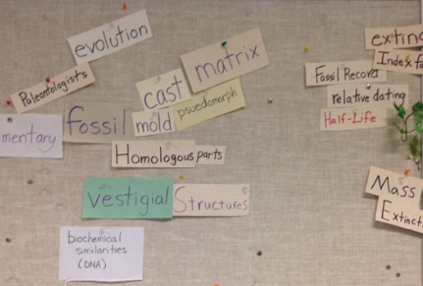
Below are some screenshots from this presentation. Please feel free to write in the box beside the photo. Jot down any ideas you have, reminders that will help you if you plan to try the game with your class!
Words on the walls:

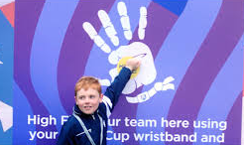
Full contact review

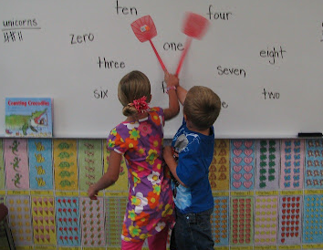
Swat

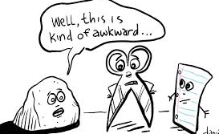
Paper, Rocks, Scissors Game

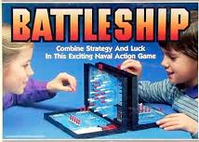
True or False Battleship:

Sticky note on back game / Headbandz

RESEARCH COMPONENT – HOW DOES THE SCIENCE SUPPORT THESE GAMES?
ACTIVITY: At this point we will take a moment to go over any questions you may have and provide you with some research on the topic of using games/novelty in the classroom and why it is important.
Activity: Read the research article and meet up with a partner:
1. Read the line you highlighted
2. Say what you think about the passage (interpretation, Connection, to past experience, etc)
3. Say what you see are the implications for your work
(take two – three minutes and then switch and have other partner do the same).

Review Musical Chairs
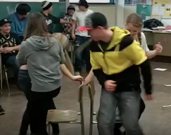

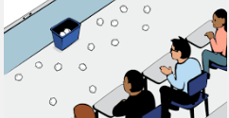
Ball Toss Game

Most research on professional development reveals that a person will not use ideas they’ve learned unless they use them immediately. How could you use this in your class tomorrow or within a week?

All material/handouts are available at: http://mrfitton.weebly.com/after-school-pro-d.html

Have any questions, suggestions, comments or ideas? Please feel free to contact us below
Kent, Grade 4/5 – kpercevault@summer.com Jeff, Grade 6, 8; 9-12 – jfitton@summer.com
What ideas did I receive that I will try tomorrow or later this week?

