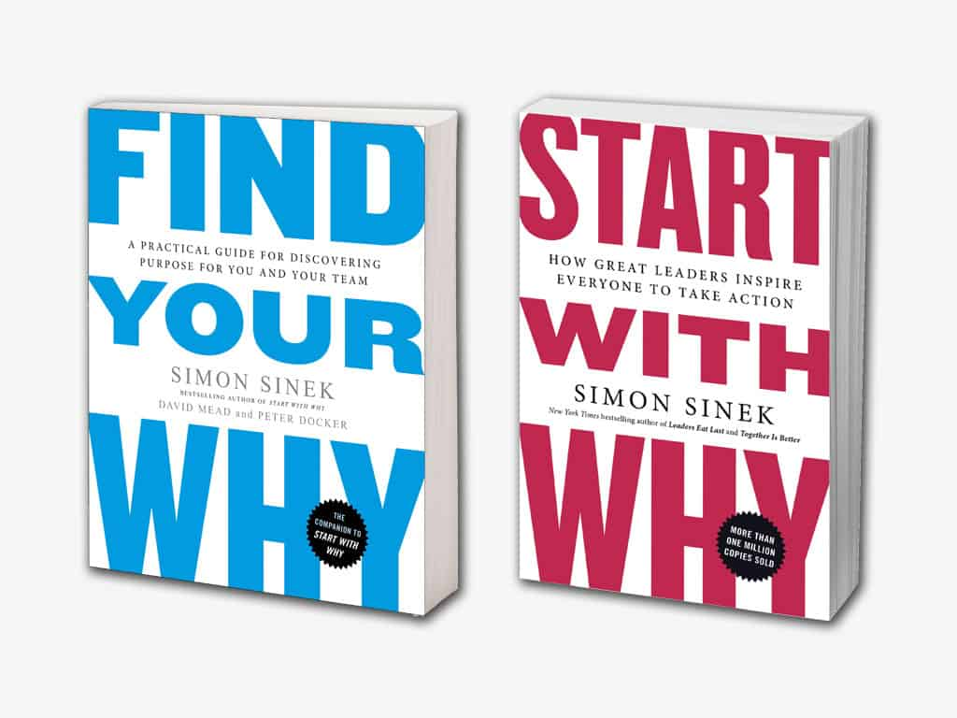
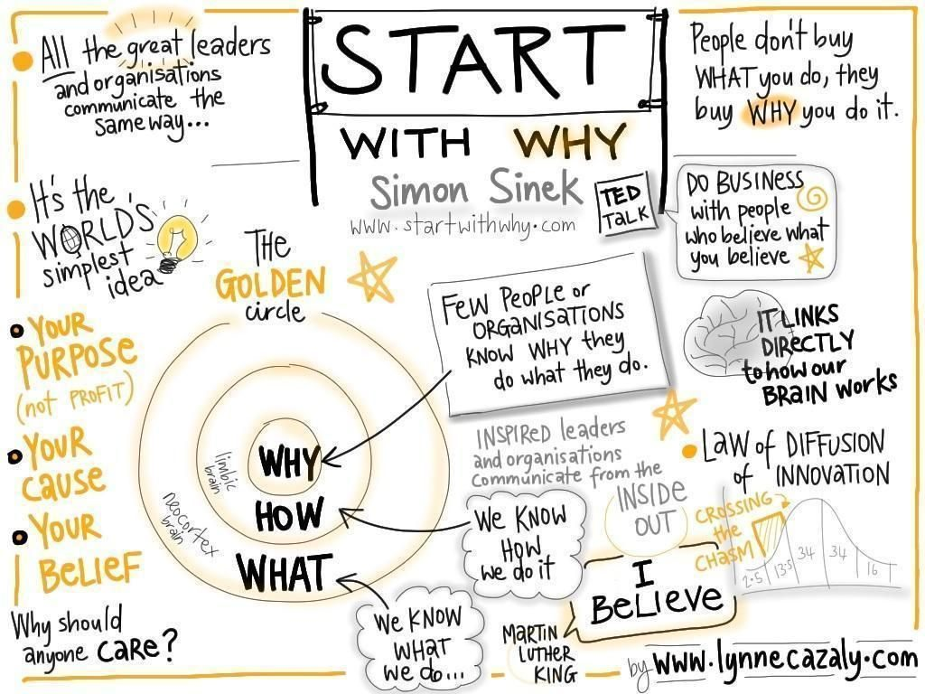
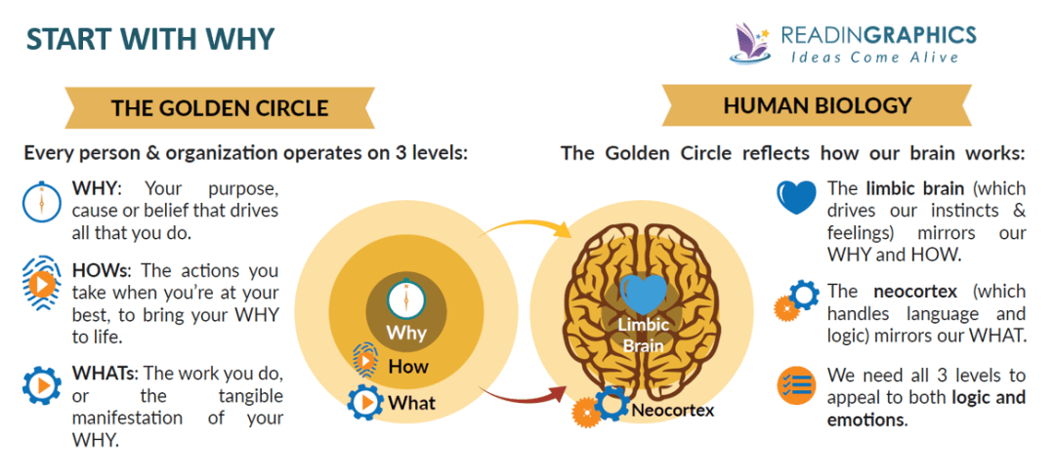

Who made me the Person I am today What is your Earliest Happy Childhood Memory Describe a Day at Work or School that you would do for Free

Describe an experience you loved What is a pivotal moment where life would never be the same? What happened that changed the way you think about the world?

What is the worst day at work or school? A Time I Helped Someone and it felt good, like it mattered When is a time you did something where you completely lost track of time?

PEAKS AND VALLEYS
Stories above the line are happy memories that you would gladly and enthusiastically relive. Stories below the line are events that you wouldn’t necessarily relive but they impacted your life and shaped who you are today. Write a few words to encapsulate each story as you fill out the chart. The higher you plot the stories above the line, the more fulfilling and positive they were, The lower you plot the stories below the line the more challenging and difficult they were. You’ll probably end up with stories at various levels.

