Final Assessment – Short Stories Unit NAME:
Empowerment: This year, my goal has been to empower students to take control of their learning. As a result, students have designed an alternative to a traditional summative test for our thematic unit on “Understanding how authors in different contexts manipulate our beliefs in a text.” Students developed the task to show an understanding of key concepts from the unit.

Statement of Inquiry: Critical readers understand that the historical context and the author’s perspectives affect a readers’ interpretations of literary texts and the concept of truth.

Key Concepts / Related Concepts: Perspective, context, point of view, corroboration, style
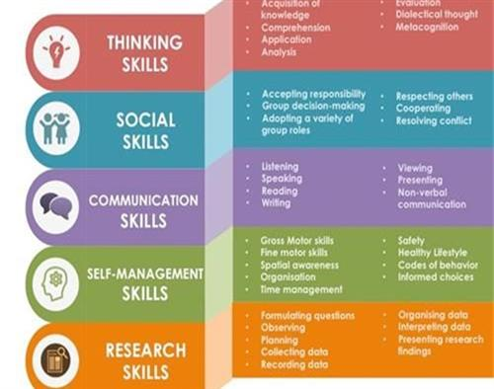
Global Context: Orientation in Space and Time.

Skills and ATLS that we have covered:
- Show an understanding of key short story terms
- How to write a proper theme statement and support it
- How to have a conversation about a text / film
- How to produce text effectively in creative writing (using an editing worksheet)
- How to apply knowledge by finding examples of short story terms in a text / film
- Applying effective story telling from our texts to their own produced text.
- Communicate effectively in writing / speaking

Summative Assessment

A. Watch a film. The class has selected ____________________________________ because it involves understanding how historical context and the authors perspectives affect a readers’ interpretations of literary texts and the concept of truth.

B. Identify 10 short story terms from the film and write a detailed example from the film. You must show that you understand the term through your response. Ie: Batman is the protagonist because he is the main character who fights against the Antagonist, Joker, to save Gotham City. If it is easier, you choose to define it first, then provide your example.

(Criterion A – Analyzing: strand i and strand iii OR ATLS – Thinking Skills)

1. Protagonist 6. Conclusion 11. Climax 16. Falling Action
2. Antagonist 7. Conflict 12. Stereotype 17. Suspense
3. Theme 8. Complication 13. Rising Action 18. Point of View (identify)
4. Foreshadowing 9. Setting 14. Round Character 19. Static Character
5. Narrator 10. Flat Character 15. Dynamic Character 20. Theme

OPTION 3

C. Identify one theme of the story in a FULL theme statement. The theme of _____________ (Film Title underlined) by ____________________________ (author) is that _______________________________________________.

D. Explain how the movie represents our Statement of Inquiry. Point form for later class discussion.

E. We will write our “A Day in the Life” paragraph to demonstrate our ability to write a good short story, which will include all the elements of the editing checklist (Hooks, adjectives, adverbs, sentence variety, good conclusion). Assessed using Criterion C (Producing Text) and Criterion D (using language)
This section will be recorded for ATL skills under “Thinking” and “Communication”

1. Literary Term Chosen Examples / Explanation

A.

B.

C.

D.

E.

F.

G.

H.

I.

J.

2. Write a Full Theme Statement for the film:

ATL THINKING SKILLS SCORE______

3. In Point Form Below (for later in class discussion): Explain briefly how the historical context (when the text / film was made) and the author’s perspectives affect your interpretation of the text and what you think the “truth” is.
In easier to understand terms: (Explain how the filmmaker’s perspective affects how you interpret the movie.

ATL COMMUNICATION SCORE_____

