Final Assessment – Ethics and Morality Unit NAME:
Empowerment: This year, my goal has been to empower students to take control of their learning. As a result, students have designed several possible alternatives to a traditional summative test for our thematic unit on “Ethics and Morality.” Students developed the following options. Please choose one to complete to show your understanding of key concepts from the unit.

Key Concepts / Skills that we have covered:
-Ethics/Morality and ethical decision-making
-How to incorporate quotes correctly into our writing
-How to support your view with evidence from a Short story/ non-fiction text/film/song
-How to write a proper theme statement and support it
-Show an understanding of key short story terms

OPTION 1

A. Read the Short Story “The Test” and view the Twilight Zone Episode “Examination Day.” Go onto your blog and write a synthesis essay where you identify a common theme in both stories. Argue using at least three examples. Follow the S.E.E formula and demonstrate your ability to integrate quotes. Also, comment on three other student blogs in detail to help them increase their grade.

B. Identify 10 short story terms from the list below and provide detailed examples from either story (or you can identify some from both – as long as you identify 10.)

OPTION 2

A. Write your own creative story wherein you include a moral dilemma.

B. Once written, please annotate your story to identify 10 short story terms see below for some terms to identify. Remember to explain (ie: John is the protagonist because….)

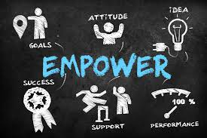
C. Identify and explain at least one of the moral dilemmas using Rushworth Kidder’s work (our slideshow on Ethical and Moral Decision Making) and explain.

Right Versus Wrong Decisions
Tests: The legal test The professional standards test
The front page test The role model test The gut-feeling test

Right Versus Right Decisions
Dilemma Paradigms: Truth vs. Loyalty Individual vs. Community
Short Term vs. Long Term Justice vs. Mercy

SHORT STORY TERMS TO CHOOSE FROM. YOU MAY ALSO ADD ANY YOU BELIEVE ARE MISSING.

1. Protagonist 6. Conclusion 11. Climax 16. Falling Action
2. Antagonist 7. Conflict 12. Stereotype 17. Suspense
3. Theme 8. Complication 13. Rising Action 18. Point of View (identify)
4. Foreshadowing 9. Setting 14. Round Character 19. Static Character
5. Irony 10. Flat Character 15. Dynamic Character 20. Genre

OPTION 3

A. Watch a film. The class has selected ____________________________________ because it involves moral dilemmas.

B. Write a theme paragraph where you identify the theme of the work, and support your view with detailed examples, evidence and quotes from the film

OR if you want a challenge, you can choose to
-Do a synthesis wherein you choose another story/work we’ve studied and identify a common theme and write how they both share that theme.

-Choose a character we’ve studied and create a synthesis where you explain how the character would respond to the film being studied (use some of their background or quotes from that text to corroborate your ideas).

-Characters could include: Lt. Commander Oram, Zaroff, Rainsford, The Characters from Button, Button, Rushworth Kidder (from the moral dilemmas), The Hitchhiker from Bloodsuckers or Dr. Philip Zimbardo from the Ted Talk.

C. Identify 10 short story terms from the film and write a detailed example from the film. You must show that you understand the term through your response. Ie: Batman is the protagonist because he is the main character who fights against the Antagonist, Joker, to save Gotham City.
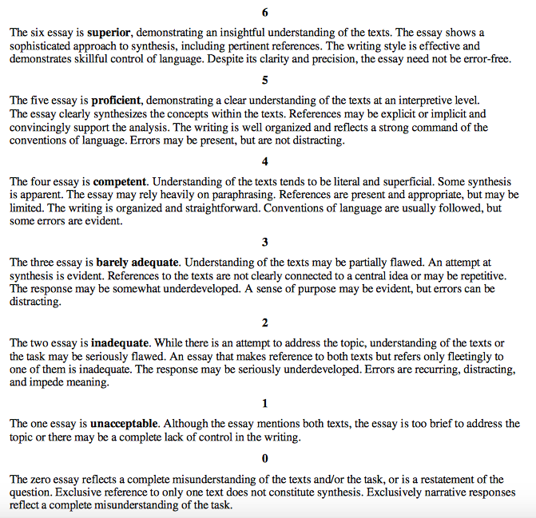

STAND-ALONE TEXT SCORING GUIDE

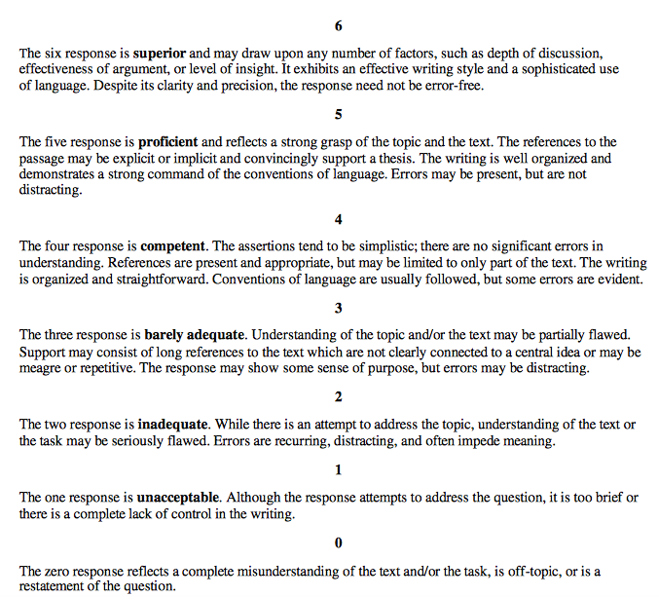
SYNTHESIS TEXT SCORING GUIDE

